The Mangold Basic Braille Program, from tactual perception to learning the Unified English Braille Code
by Stephanie A. Herlich

Over 40 years ago, Dr. Sally S. Mangold, Ph.D. published The Mangold Developmental Program of Tactual Perception and Braille Letter Recognition. The following paper illustrates the time proven effectiveness of Dr. Mangold’s research driven teaching techniques and the current educational research that continues to support her program. Dr. Mangold’s methods and ideologies have been incorporated into the expanded Mangold Basic Braille Program described in this paper.
Background: Sally Mangold's Legacy
Dr. Sally Mangold, author of The Mangold Developmental Program of Tactual Perception and Braille Letter Recognition, taught students who were blind or visually impaired students for 16 years. She then trained teachers of the visually impaired at San Francisco State University for 18 years. Dr. Mangold wrote dozens of books, articles and produced several videos that have helped and continue to help innumerable teachers and parents. The teacher's manual for The Mangold Developmental Program of Tactual Perception and Braille Letter Recognition, now known as The Mangold Basic Braille Program, has been translated into seven languages and used around the world.
Dr. Mangold’s 45 books, articles, videos and technological innovations raised national and international awareness of the importance of braille literacy (Tuttle & Tuttle, 2008). She was an effective communicator and popular speaker; she presented the keynote address at the Annual Meeting of the American Printing House for the Blind (APH) in 2004. Among her many honors and awards are the Association for Education and Rehabilitation of the Blind and Visually Impaired (AER) Josephine L. Taylor Leadership Award in 1996, the Holbrook-Humphries Literacy Award in 2001, the American Foundation of the Blind (AFB) Miguel Medal in 2003, and APH’s Creative Use of Braille Award in 2003. She was inducted into the APH Hall of Fame: Leaders and Legends of the Blindness Field in 2008.
Dr. Mangold has been described as having grace and humor, with an upbeat, positive, energetic genuine love of people. She was gifted with what has been described as a pragmatic approach to instruction especially her techniques in teaching braille reading (Tuttle & Tuttle, 2008). She was a creative, energetic teacher who had high standards for her students and she never ran out of ideas or ways to help struggling students. Her frequent advice was "listen to your students, ask them what it is they want to learn."
Dr. Mangold and her husband, Phil Mangold, founded Exceptional Teaching Aids, Inc. (Exceptional Teaching, Inc.) in 1973 with the Mangold Basic Braille Program as their flagship product. Exceptional Teaching, Inc. remains committed to Dr. Mangold’s passion for providing teachers, students and families with high quality curricula and products to enhance the education of students with visual impairments and other special needs. Exceptional Teaching, Inc. has built on Sally's work and recent educational research to expand the original program into an entire set of materials that teach not only the braille code but also promote reading fluency, writing practice, and contain assessments to monitor student progress.

Mangold Developmental Program of Tactual Perception and Braille Letter Recognition
In September 1978, Dr. Mangold published her research, Braille Perception and Braille Letter Recognition: Effects of Developmental Teaching which provided research-based evidence on the efficacy of the Mangold Developmental Program of Tactual Perception and Braille Letter Recognition (hereafter known as Mangold Basic Braille). Dr. Mangold’s research showed that significantly fewer errors in tactile perception, braille letter recognition, backtracking behaviors, and scrubbing behaviors occurred when students were taught using Mangold Basic Braille (Mangold, 1978).

Dr. Mangold’s research focused on two subgroups, remedial braille readers and new braille readers. The students involved in the study were put into pairs based on age, beginning or remedial reading level, visual acuity, and pretest scores. To participate, students had to meet with their Teacher of the Visually Impaired a minimum of one hour each day. One student of each pair was randomly assigned to a control group or experimental group. At the conclusion of the study, 90 percent of the beginning readers and 90 percent of the remedial readers within each pair showed marked improvement in braille letter recognition, backtracking, and scrubbing behaviors as compared to the control group. Similar results were achieved across age levels (Mangold, 1978).
Precision Teaching
The first two books of the Mangold Basic Braille Program are based on the concept of Precision Teaching. The idea of Precision Teaching was launched by Ogden Lindsley in the 1960’s (Lindsley, 1991). The tenants of Precision Teaching, which are still widely used in today’s classrooms and curricula, focus on directly observable behavior, frequency as a measure of performance, the standard celeration chart, and the “learner knows best” policy. (“Precision Teaching, n.d.) During Precision Teaching, the learning task, such as tracking across braille symbols or letters, must be observed behaviors that can be counted and recorded. The frequency of the behavior is the number of responses during each minute of the behavior (White, 1986). The celeration chart employs the use of a specific x-y axis to record the behavior. The “learner knows best” philosophy ensures that the students’ performance determines and evaluates the efficacy of the teaching strategy (Lindsley, 1991).
Each lesson within Unit 1: Tracking and Unit 2: Alphabet employs the Precision Teaching Method. The lessons begin with clearly defined and measurable goals by stating the number of lines, symbols, or letters that need to be identified within one minute and the percentage accuracy. The student’s progress is measured frequently to determine mastery of the skill and to determine when the student is ready to move to the next skill level. Students chart their own progress and if progress is not being met, the onus is on the teacher to modify the teaching strategy to ensure student success. Precision Teaching is a perfect avenue for teaching braille as speed, tactual recognition and utilizing the proper mechanics of braille reading have been proven to result in effective and efficient braille readers.

The Value of Educational Research
Two major pieces of national legislation have shaped educational policy and the role of research in the United States. The Individuals with Disabilities Act (IDEA) of 1975 and the No Child Left Behind Act (NCLB) of 2001 require that schools use programs, curricula, and practices based on scientifically-based research (PACER Center, 2011). Dr. Mangold was ahead of her time; she knew the importance of basing the Mangold Developmental Program of Tactual Perception and Braille Letter Recognition on research. Educational research is considered scientific when the outcomes of students receiving a tested teaching strategy or intervention are compared to similar students who do not receive the intervention, when it is based on high quality data analysis, and when the study is reported in a journal for other professionals to review and repeat (PACER Center, 2011). Educational research uses a variety of methods to answer the question being asked which results in the development of new teaching tools and methods (American Educational Research Association, 2002).
There are several characteristics endemic to evidence-based research that educators have determined make research reliable. The data must be objective so that any evaluator would be able to identify and interpret the data in a similar manner. The data must be valid so that it adequately represents the task children need to accomplish to be successful. The data must be reliable so that if the task is repeated on a different day or by a different person it will remain essentially unchanged. The data must be systematic; based on a rigorous design of experimentation or observation. And the data must be refereed; approved for publication by a panel of independent reviewers (American Educational Research Association, 2002).
Other important research has had an effect on reading instruction in the United States for both print readers and for braille readers. The Mangold Basic Braille Program has expanded to not only align with IDEA and NCLB, but also reflects the findings of other studies that will be identified in this paper.
National Reading Panel
Unit 3: UEB Contractions of the Mangold Basic Braille Program teaches students the contractions in Unified English Braille (UEB). Unit 3: UEB Contractions is not considered to be a full reading curriculum; however, it incorporates several of the components that the National Reading Panel has determined are necessary for a strong reading program. The five necessary components are phonics, phonemic awareness, vocabulary, reading comprehension, and fluency (Report of the National Reading Panel, 2000). Throughout Mangold Basic Braille, Unit 3: UEB Contractions fluency, reading comprehension, and vocabulary are practiced and explored to help students become successful braille readers.
Alphabetic Braille and Contracted Braille Study (ABC Braille Study)
In 2001, through major funding from the American Printing House for the Blind and substantial support from the Canadian Braille Literacy Foundation, the Alphabetic Braille and Contracted Braille Study (The ABC Braille Study) began. From 2002-2007, the ABC study followed the literacy experience of 38 children from the United States and Canada who were learning braille either through an alphabetic approach or a contracted braille approach. One of the primary research questions was, “Are there differences in the reading rates, comprehension, vocabulary, word recognition, and reading achievement levels of children who are initially taught contracted braille and those who are initially taught uncontracted braille?” After analysis of the study data, researchers concluded that introducing contractions early in a student’s reading program is directly associated with higher literacy performance and skills. (Wall Emerson, Holbrook, & D’Andrea, 2009).
Reading instruction for all students must occur on a daily basis. The evolution of how educational services to students who are visually impaired is being provided has directly impacted the acquisition of literacy skills for braille readers. Students are being taught in residential settings and mainstream settings with both “push-in” and “pull-out” models. Students are being taught by credentialed teachers of the visually impaired and paraeducators who may or may not be proficient in the braille code or best literacy practices. One of the outcomes of the ABC Braille Study concluded that it is the consistency of structured instruction that leads to higher literacy performance by young children who are blind. (Wall Emerson, Sitar, Erin, Wormsley & Herlich, 2009).
Structure of the Mangold Basic Braille Program
Mangold Basic Braille is the foundation for which students can become proficient braille readers. Studies on effective classrooms in which all students learn to read and write have concluded that exceptional teachers provide balance by teaching skills and strategies and by giving children ample time each day to read and write (Cunningham & Allington, 2007). Reading speed is extremely important as braille reading students advance through elementary school, middle school, high school and on to college if applicable. Unfortunately, individuals tend to read braille at a slower rate than print readers read print (Wall Emerson, Holbrook, & D'Andrea, 2009; Harley, Truan, & Sanford, 1997; Wetzel & Knowlton, 2000). For example, a comparison of reading rates between sighted students and students with visual impairments showed visually impaired students in 5th-7th grade were 60-68% slower than their sighted peers. The same study showed that visually impaired students in 8th-10th grade were 52-60% slower than their print reading peers (Tellefson, 1999). Teachers of the visually impaired must attempt to diminish this discrepancy through daily braille instruction and independent daily practice so that braille reading students can learn side-by-side and at the same rate as their sighted peers.
Students who are sighted are exposed to print throughout their day via markings on food containers in the kitchen, books in their room, street signs, store signs, ads on computers, games on electronic devices, etc. Students who are visually impaired have exponentially less exposure to braille. Braille is not surrounding them daily and they must be in physical contact with it in order to read. It is the job of teachers, parents and caregivers to make sure as much braille as possible is in a beginning reader’s environment via braille books, labels, activities, games, tactile pictures, notes and any other creative use of braille. Students need to be exposed to the beauty of braille and the limitless enjoyment that reading provides.
Unit 1: Tracking and Unit 2: Alphabet
Unit 1: Tracking is designed to develop tactile discrimination, proper hand position, and rapid tracking. Unit 2: Alphabet systematically introduces the letters of the alphabet. See Tables 1 and 2 for the instruction sequence.
Table 1
Unit 1: Tracking Sequence of Instruction
- Tracking from left to right across like symbols that follow closely without a space.
- Tracking from left to right across unlike symbols that follow closely without a space.
- Tracking from left to right across like symbols that have one or two spaces between them.
- Tracking from left to right across unlike symbols that have one or two spaces between them.
- Tracking from top to bottom over like symbols that follow closely.
- Tracking from top to bottom over like symbols that follow closely without a space.
- Tracking from top to bottom over like symbols that have one blank space between them.
- Tracking from top to bottom over unlike symbols that have one blank space between them.
- Identifying two geometric shape as being the same or different.
- Identifying two braille symbols as being the same or different.
- Identifying two braille symbols as being the same or different.
- Identifying the one symbol that is different in a line of like symbols using l and c.
- Identifying the one symbol that is different in a line of like symbols using similar braille symbols.
- Identifying the one symbol that is different in a group of three symbols.

Table 2
Unit 2: Alphabet Sequence of Instruction
- Teaching letter names g, c, and l.
- Review the letters g, c, and l. Introduce the letters d and y.
- Review the letters g, c, l, d, and y. Introduce the letters a and b.
- Review the letters g, c, l, d, y, a, and b. Introduce the letter s.
- Review the letters g, c, l, d, y, a, b, and s. Introduce the letter w.
- Review the letters g, c, l, d, y, a, b, s, and w. Introduce the letters p and o.
- Review the letters g, c, l, d, y, a, b, s, w, p, and o. Introduce the letter k.
- Review the letters g, c, l, d, y, a, b, s, w, p, o, and k, Introduce the letter r.
- Review the letters g, c, l, d, y, a, b, s, w, p, o, k, and r. Introduce the letters m and e.
- Review the letters g, c, l, d, y, a, b, s, w, p, o, k, r, m, and e. Introduce the letter h.
- Review the letters g, c, l, d, y, a, b, s, w, p, o, k, r, m, e, and k. Introduce the letters n and x.
- Review the letters g, c, l, d, y, a, b, s, w, p, o, k, r, m, e, k, n, and x. Introduce the letters z and f.
- Review the letters g, c, l, d, y, a, b, s, w, p, o, k, r, m, e, k, n, x, z, and f. Introduce the letters u and t.
- Review the letters g, c, l, d, y, a, b, s, w, p, o, k, r, m, e, k, n, x, z, f, u, and t. Introduce the letters q and i.
- Review the letters g, c, l, d, y, a, b, s, w, p, o, k, r, m, e, k, n, x, z, f, u, t, q, and i. Introduce the letters v and j.

Each lesson includes benchmark tests, braille worksheets, and games. The print teacher's manual includes step-by-step instructions and print replicas of each braille worksheet (see Samples 1-5).

Sample 1
Unit 1: Tracking (sheet 22)

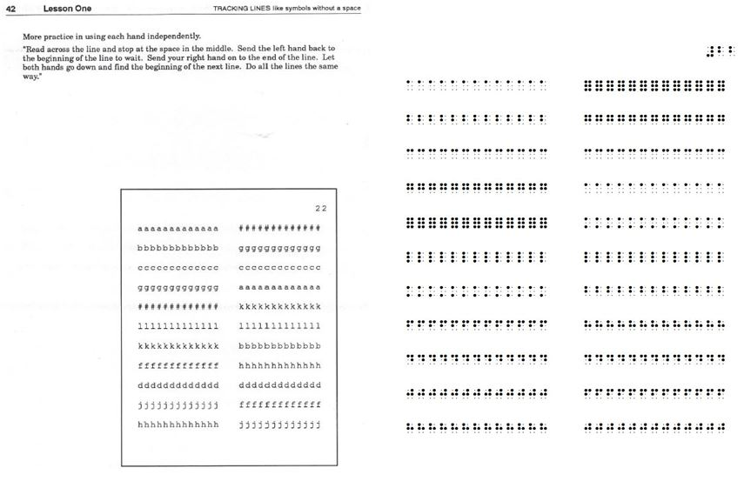

Sample 2
Unit 1: Tracking (sheet 23)

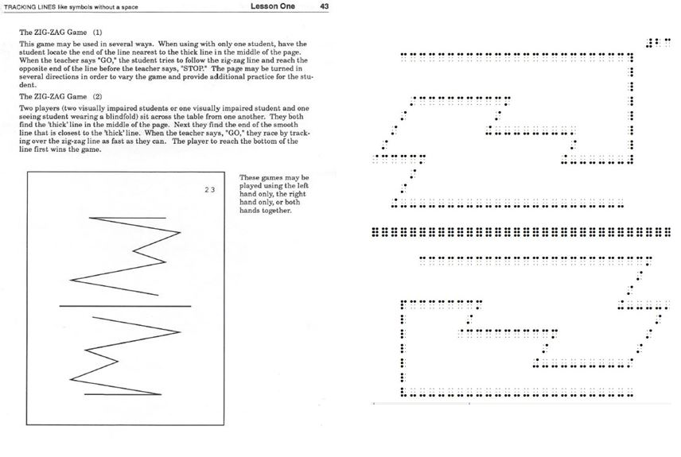

Sample 3
Unit 1: Tracking (Sheet 77)

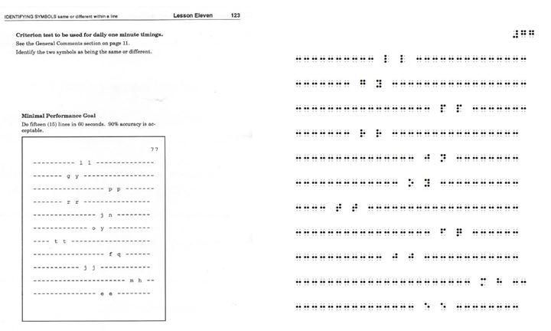

Sample 4
Unit 2: Alphabet (sheet 145)

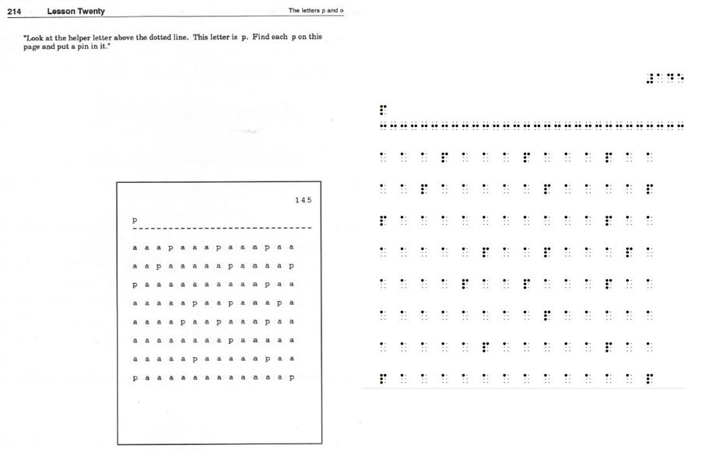

Sample 5
Unit 2: Alphabet (sheet 151)

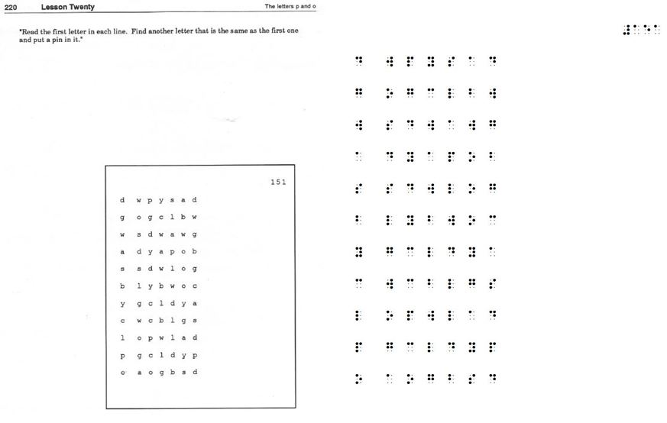
One benchmark test is provided at the beginning of each lesson. The benchmark test is used for daily one-minute timings. Exercise worksheets are not timed. The same benchmark test should be given daily until the student is able to meet a minimal performance goal and maintain that rate for at least two consecutive days. When the goal is met the student will be ready to move to the next lesson.
Initially the goal should be set about thirty percent higher than the entry rate taken on the first day of a new lesson. Teachers are encouraged to use embossed Progress Charts and High Dot markers to track student progress for each lesson. The student will enjoy watching his/her line graph go up as he/she gets better after daily practice. Teacher judgment is still the crucial element in using this program most efficiently.
The teachers who have previously used Unit 1: Tracking and Unit 2: Alphabet report that an average of four completed work sheets per day seemed most advantageous for the majority of their students. The amount of time required to complete this program has ranged from six weeks to sixteen weeks. The majority of students complete Units 1 and 2 in thirteen or fourteen weeks.
Unit 3: UEB Contractions
Unit 3: UEB Contractions was written for new readers who already know the braille alphabet. It is divided into 5 parts so that teachers are better able to tailor the program to individual student needs. The parts are designed to be taught in order, but a teacher of the visually impaired may have a student skip a part if the student has already mastered the contractions introduced in that part.
In 1944, Lorge and Thorndike conducted a 4.5 million word frequency count taken from American magazine articles. These researchers found that there was a list of 25 words that accounted for 33.4% of the words an adult American would read in printed texts such as magazines (Thorndike & Lorge, l944). All 25 words are taught by the end of Unit 3: UEB Contractions. See Table 3 for the progression of contractions.

Table 3
Unit 3: UEB Contractions Progression
PROGRESSION OF CONTRACTIONS
PART 1 | PART 2 | PART 3 | PART 4 | PART 5
#;s (0-9) | period, question mark | letter, friend, great, also | knowledge, quite rather | ought
hyphen  can, go like, period, capital | i-n sign | ar, er | ow, gh | thyself, its, itself
but, do you | your, him, could would | time, work, where, part | yourself, yourselves, themselves,  myself, herself | ourselves, oneself
so, will, people | w-h sign | sh | enough, en | parenthesis, colon
us, that, more | t-h sign | first, must, should, shall | underline, bold | immediate, neither,  either, necessary
every, have, not | which, this | ever, question, some, young | out, ou | ence, ful, ness
it, as, from | about, after, again | paid, quick, | bb, cc, ff, gg | against, almost, already
 | apostrophe | his, was, were | tion, ment | according, across,  although, always
very, just | s-t sign, comma, exclamation | today, tomorrow, tonight | ity, ong | these, word
and, for, of, the, with | one, right, here | had, their | be | ance, ound, ount
said, little, good | under, day | cannot, many | because, before,  behind, below | receive, receiving,  rejoice, rejoicing
 | e-d sign, i-n-g sign | blind, braille, above, himself | beneath, beside, between, | deceive, deceiving,  declare, declaring
 | mother, father, time | ch sign | beyond | sion, less
 | name, know, there | child, still | children, much, such | character, lord, through
 | quotation marks | ea sign | con, dis | spirit, world
 | grade 1 word indicator | together, altogether,  afternoon, afterward | conceive, conceiving | whose, upon, those
 |  | italics, dash |  | perceive, perceiving, perhaps

Unit 3: UEB Contractions is designed to help teachers of the visually impaired teach reading skills while teaching the braille code. Each of the 5 parts of Unit 3: UEB Contractions are controlled for contractions and contain both reading and writing exercises. Common words and contractions, that beginning readers encounter, are introduced early in the program to help facilitate early reading. Punctuation and common math symbols are also introduced. The reading exercises include repeated readings, sentence tracking, multiple choice questions and clue activities. Popular trade books with picture descriptions are included in each part. The writing exercises include sentence copying, sentence starters and open-ended questions. Assessment sheets are included at the end of each part to help determine student readiness to advance.
Samples 6-12 below provide an example of exercises included in Unit 3: UEB Contractions.

Sample 6
Unit 3: UEB Contractions (Reading Practice)
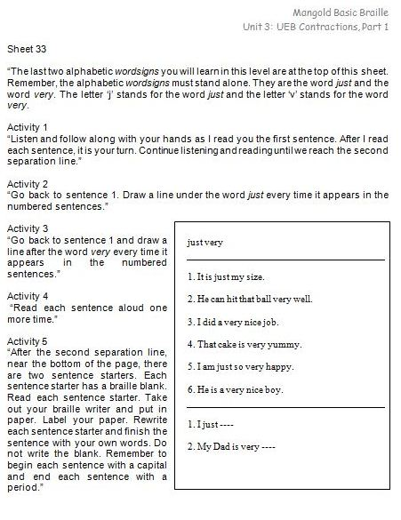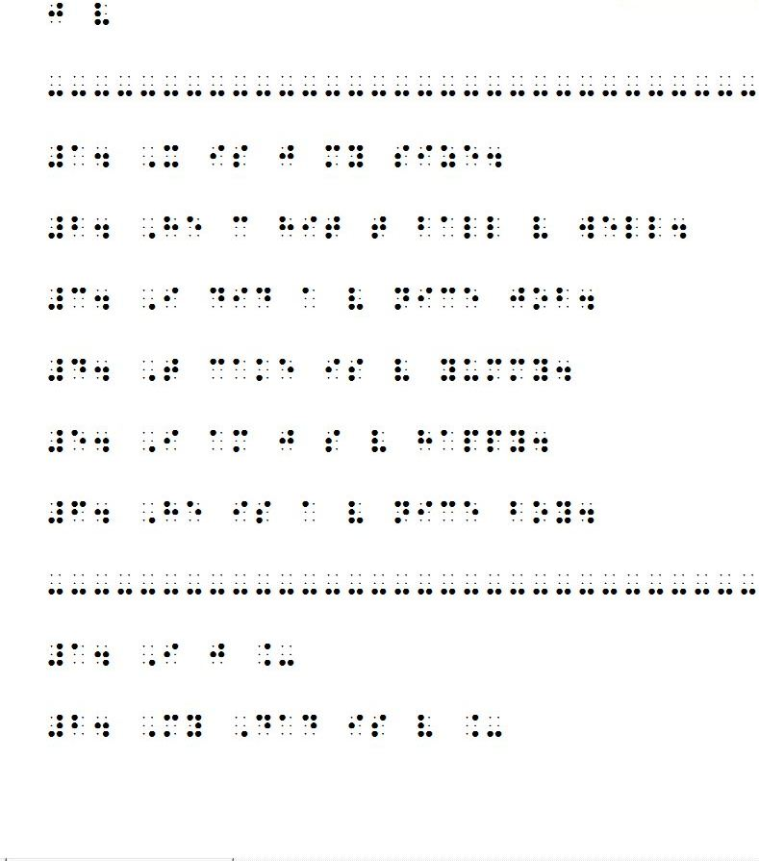

Sample 7
Unit 3: UEB Contractions (Fill in the Blank)
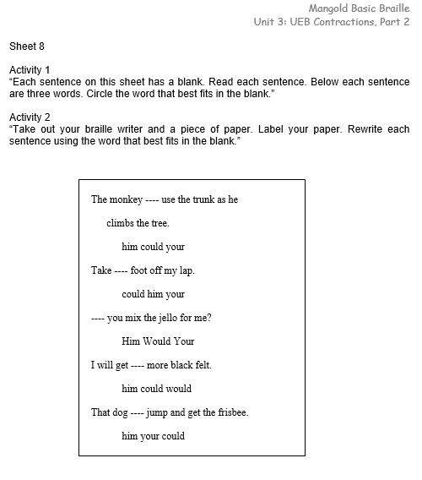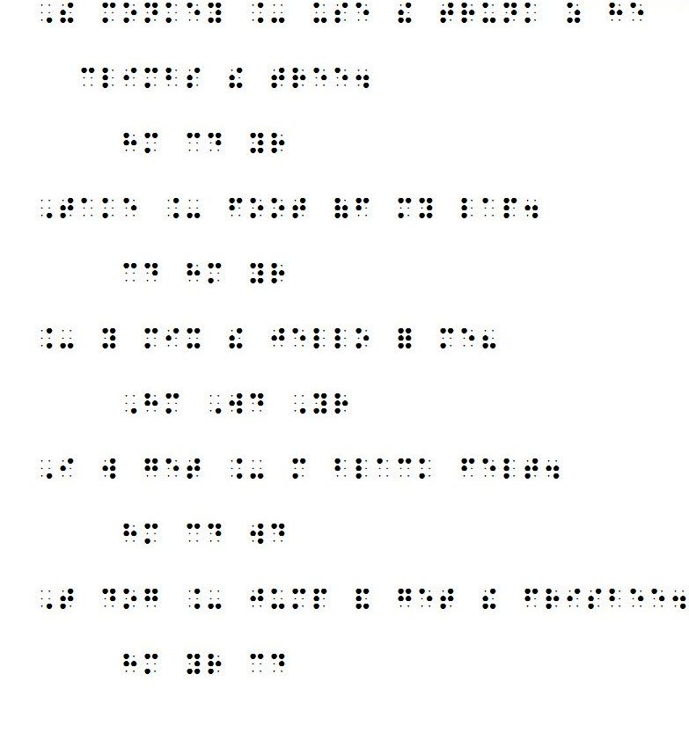

Sample 8
Unit 3: UEB Contractions (Multiple Choice)
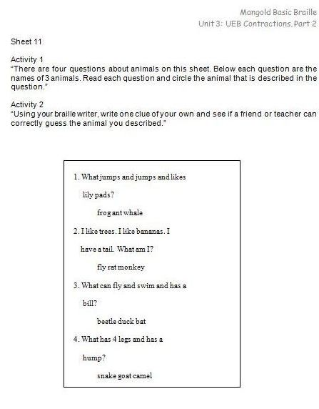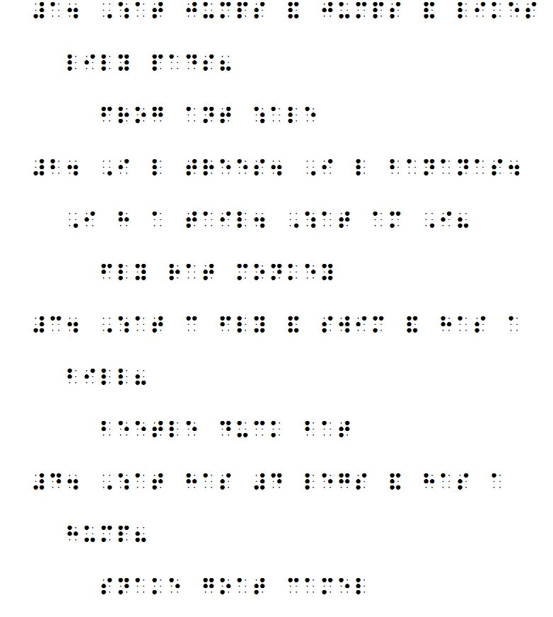

Sample 9
Unit 3: UEB Contractions (Sentence Tracking)
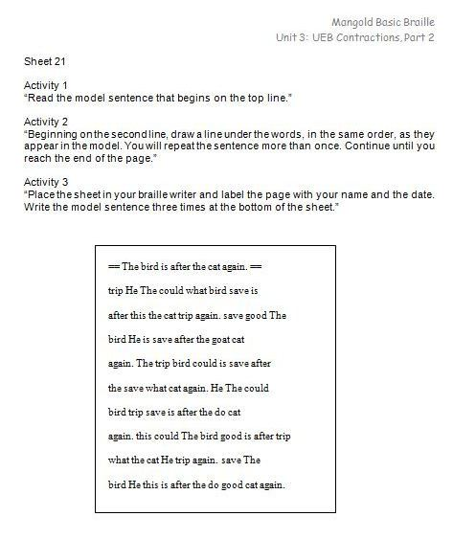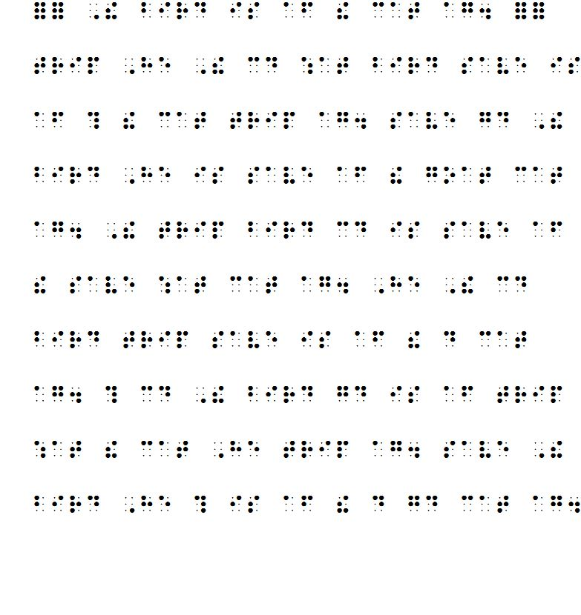

Sample 10
Unit 3: UEB Contractions (Comprehension Questions)
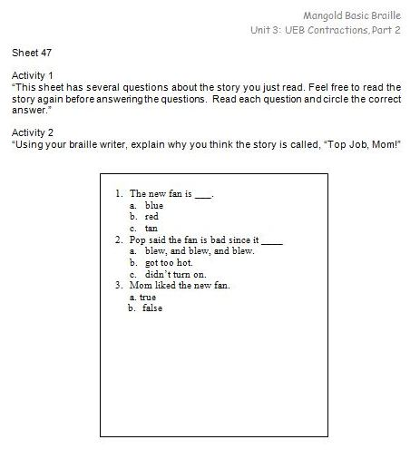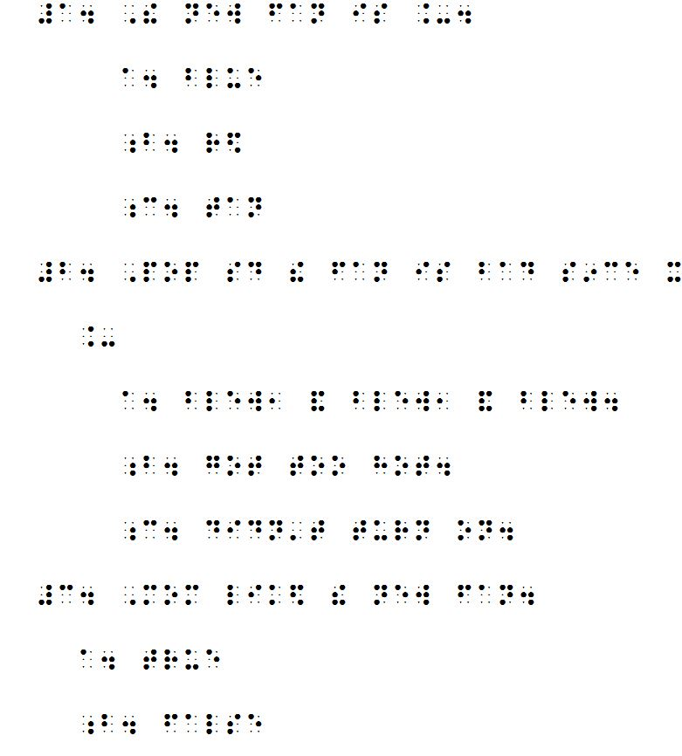

Sample 11
Unit 3: UEB Contractions (Review Page)
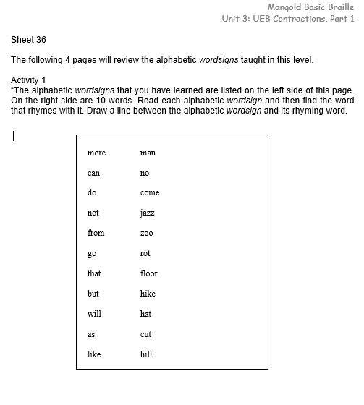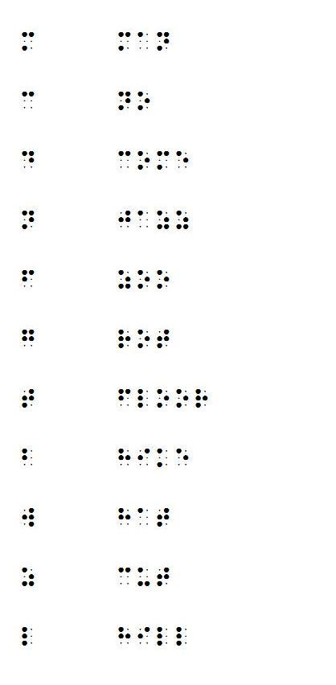

Sample 12
Unit 3: UEB Contractions (Assessment Page)

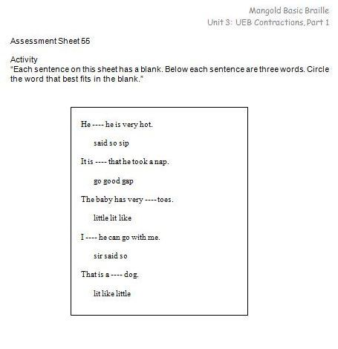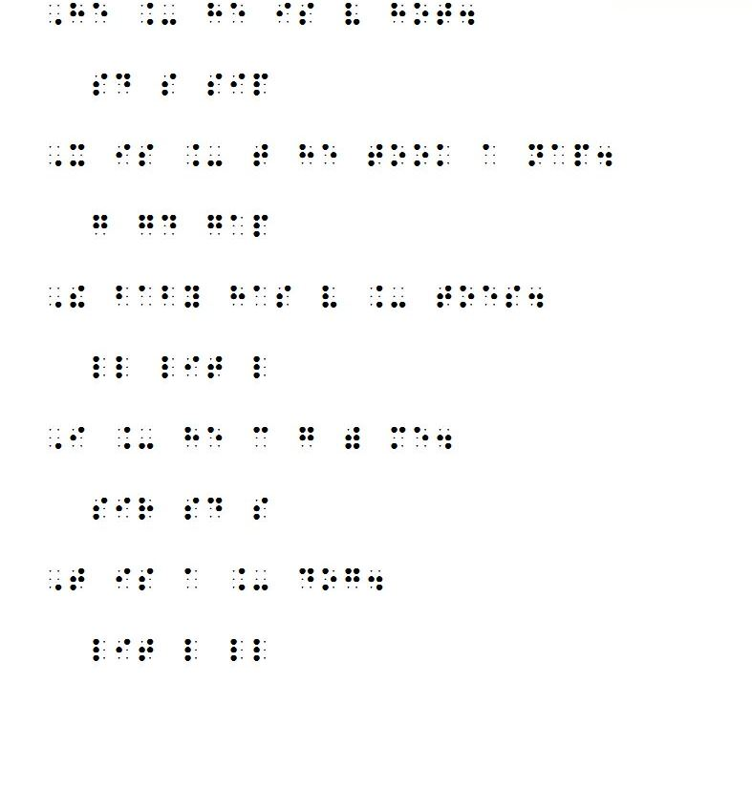

Conclusion
It is a testament to the brilliance of Dr. Mangold’s original Basic Braille Program that it continues to be one of the pre-eminent programs of braille instruction today. Much of the research that defines good literacy curricula is evident throughout Mangold Basic Braille. Research continues to show that braille learners must have consistent and structured reading instruction. (Wall Emerson, Sitar, Erin, Wormsley & Herlich, 2009).
Mangold Basic Braille provides a continuum of instruction for beginning braille readers from tactual perception, to letter recognition, and through the learning of UEB contractions. Using Mangold Basic Braille with a full spectrum reading curricula will enable students to become fluent and efficient braille readers.

References
American Educational Research Association (2002). What is Education Research? Retrieved February 12, 2016, from http://www.aera.net/EducationResearch/WhatisEducationResearch/tabid/13453/Default.aspx
Cunningham, P. M. & Allington, R.L. (2007). Classrooms that work: They can all read and write. Boston, MA: Pearson/Allyn and Bacon.
Herlich, S. A. (2015). Mangold Basic Braille Program Unit 3: UEB Contractions. Livermore, CA: Exceptional Teaching, Inc.
Lindsley, O. R. (1991). Precision teaching's unique legacy from B. F. Skinner. Journal of Behavioral Education, 1(2), 253-266. Retrieved from http://www.fluency.org/lindsley1991.pdf
Mangold, S. S. (1994). Mangold Basic Braille Program Unit 1: Tracking & Unit 2: Alphabet. Livermore, CA: Exceptional Teaching, Inc.
National Reading Panel (2000). Report of the National Reading Panel: Teaching children to read: An evidence-based assessment of the scientific research literature on reading and its implications for reading instruction. Retrieved February 12, 2016, from https://www.nichd.nih.gov/publications/pubs/nrp/Pages/findings.aspx
PACER Center. (2011). Evidence-Based Practices at School: A Guide for Parents. Retrieved February 28, 2016, from Evidence-Based Practices at School: A Guide for Parents.

Author? Precision Teaching: Concept Definition and Guiding Principles. (n.d.). Retrieved February 12, 2016, from https://psych.athabascau.ca/html/387/OpenModules/Lindsley/introa1.shtml

Author? Precision teaching; What is it? (2013, September). Retrieved February 13, 2016,fromhttp://www.moray.gov.uk/downloads/file88660.pdf.
Tellefson, M. (1999). Compare these reading rates: What do you think? WAER Newsletter.
Thorndike, E.L. & Lorge, I. (1944). The Teacher's Word Book of 30,000 Words. Teachers College, Columbia University.
Tuttle, D. & Tuttle, N. (2008). Sally Mangold Inducted 2008. Retrieved February 13, 2016, from http://www.aph.org/hall/inductees/mangold/

Wall Emerson, R., Holbrook, M. C., & D’Andrea, F. M. (2000). Acquisition of literacy skills by
young children who are blind: Results from the ABC Braille Study. Journal of Visual Impairment & Blindness, 103, 610-634.

Wall Emerson, R, Sitar, D., Erin, J. N., Wormsley, D. P., & Herlich, S. L. (2009). The effect of
consistent structured reading instruction on high and low literacy achievement in young children who are blind. Journal of Visual Impairment & Blindness, 103, 595-609.
White, O. R. (1986). Precision teaching—Precision learning. Exceptional Children, 52, 522-
534.

