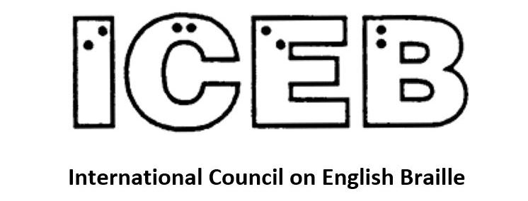

ICEB Newsletter
Issue 14
July 2022

In This Issue
From the President's Desk 3
A Note from the ICEB Mid-Term Hosts 4
Committee Reports 6
Braille Bombing hits Melbourne 10
Setting my sights on 1 million names in braille 12
People 13
Calendar of Upcoming Events 15
UEB Q&A Answer 17
ICEB Contact Details 18

From the President's Desk
Judy Dixon writes:
It’s been a busy first half of 2022 for those involved in ICEB. In June, we held the Mid-Term Executive Committee meeting. This meeting takes place halfway between each of the General Assemblies which occur every four years. It is a much-expanded version of our monthly Executive Committee meetings.
Again held virtually, the five-day meeting was hosted by Braille Literacy Canada. Many thanks to Natalie Martiniello, BLC’s then president, Jen Goulden, Canada’s rep on the ICEB Executive, and many others who worked very hard to bring together a terrific conference.
Major highlights of the conference were our three invited speakers. The keynote speaker, Debbie Gillespie, who made an impassioned presentation about braille and what it has meant to her as a life-long braille reader; Philippa Campsie, a professor in the Department of Geography and Planning at the University of Toronto. She presented some primary research on Charles Barbier, the creator of a tactile code from which Louis Braille most likely got his primary ideas for braille. But much about the history of Charles Barbier is not what we have all heard so many times over the years. Katie Rodda from the Music Section of the National Library Service for the Blind and Print Disabled in Washington made a very interesting presentation on the nuts and bolts of how NLS scans braille music.
Each of the ICEB committees gave interesting and informative reports covering the last two years of their activities. These included Music, Braille Technology, Research, Promotion, Code Maintenance, and UEB Technical Materials. Audio recordings of all the sessions are available as podcasts by searching for “ICEB General Assemblies and Mid-Terms” wherever you listen to podcasts.
It was a terrific conference and I hope the information and inspiration we gleaned from those five days will fuel everyone’s creative spirit for the next two years.

A Note from the ICEB Mid-Term Hosts
By Jen Goulden
Speaking on behalf of Braille Literacy Canada, it was our pleasure to host the 2022 ICEB Mid-Term Executive Committee meetings. We had nearly 150 registrants in total, not including members of the Executive or the mid-term planning committee. Although we couldn’t have you all here in person we tried to give you an idea of some of the things you might experience if and when you are able to come and visit us.
Over the course of the meetings we discussed everything from code maintenance to “night writing”, to the merits of hard copy versus electronic braille. Other sections of this newsletter will cover the work of the various ICEB committees, so I’d like to take this opportunity to highlight the ways you can still access the mid-term meetings if you weren’t able to join us on Zoom or via the livestream.
As with the General Assembly in 2020, the meeting documentation will be available on the ICEB website at https://iceb.org. In addition, we’ve created a podcast of the meetings that includes commentary before and after each day’s sessions. Go to live.braillecast.com or search for ICEB General Assemblies and Mid-Terms wherever you get your podcasts.
I’d like to thank Matthew Horspool for all of his technical support and for facilitating the lively podcast commentary. I’d also like to thank Ashley Shaw, Kim Kilpatrick and Natalie Martiniello, my fellow co-hosts on the podcast.
Whether you listened live or subscribed to the podcast you’ll have been treated to snippets of Canadian history, geography and culture referred to as Can Con. This is short for Canadian Content, and its origin is a story for another day. That said, here is a selection of the Can Con moments included in the mid-term meetings:
- The Canadian flag is red and is twice as long as it is wide. In the centre is a white square the width of the flag, and it contains a single red maple leaf.
- The red maple leaf and the fleur-de-lys have been recognizable and important symbols of our land for over 300 years.
- Braille first came to North America in the 1860s, by way of the Institut Nazareth et Louis Braille in Montreal.
- Here’s a link to the clip about Quebec City that we played at the beginning of the opening session: https://www.youtube.com/watch?v=mTTfnFLCSHs.
- The highest tides in the world occur in the Bay of Fundy, between Nova Scotia and New Brunswick. This body of water moves 100 billion tons of water through its tides twice daily.
- Canada has 20% of the world’s fresh water and 10% of the world’s forests, and lots and lots of rocks!!
- Last, but definitely not least, the Can Con moments featured Nanaimo bars, butter tarts, croissants, poutine, tortière, tarte au sucre (sugar pie), maple bacon doughnuts and of course, vast quantities of maple syrup.
To conclude, I’d like to thank everyone who helped to make this event such a great success, and I hope to see you all in person in 2024!

Committee Reports

Code Maintenance Committee Updates
Kathy Riessen writes:
I am pleased to announce that the Code Maintenance Committee and the ICEB Executive have approved some changes to the Rules of Unified English Braille, (Rulebook).
Firstly, we have approved a new symbol, the German sharp s or eszett when used in a UEB context. This will be introduced in a new section of the Rulebook, Section 4.6.
⠨⠮ (dots 46, dots 2346) ß (Unicode 00DF) German letter sharp s (eszett)
⠠⠨⠮ (dot 6, dots 46, dots 2346) ẞ (Unicode 1E9E) capital German letter sharp s (eszett)
Follow the rules of capitalisation when using these symbols including the use of the capitals word or passage indicators.
Secondly, following the addition of the word DeafBlind (capital Deaf, capital Blind) to the Shortforms List, there was a need to clarify the “standing alone” rules regarding interior indicators in longer words containing shortforms. This led to careful consideration of three sections of the Rulebook: Section 2.6, Standing Alone; Section 10.9, Shortforms; and Appendix 1, Shortforms List. The resulting changes give the required clarification as well as tidying other issues which became apparent as discussion evolved.
As a result, the above three sections have been rewritten. A list of the changes is too large to be included in this newsletter, but will be posted on the ICEB Announce Email list and the ICEB website.
The major resulting change is to allow the use of a shortform in longer words with an interior capitals indicator or terminator not within the shortform itself as long as the word meets the criteria of 10.9.3 (the 10 special shortforms) or the word with the interior indicator or terminator specifically appears on the Shortforms List (Appendix 1).
A more detailed explanation will be posted on the ICEB announce email list and the relevant changes will be posted on the ICEB website for download.
I would like to thank the hard work of the Code Maintenance Committee and all the email list observers over the past two years as we have worked towards these changes. The attention to detail given by all those who have contributed is invaluable.
Following the completion of this work, we now have a new set of charges to work on as we move towards the next edition of the Rulebook, due for completion mid 2024.
Watch this space for further discussions!!!

UEB Q&A
Why the difference?
Why is the “ed” groupsign used in “stoned” but not in “named”?

Technical Materials Committee
Clive Lansink writes:
The Technical Materials Committee looks after the Guidelines for Technical Materials (GTM). This covers braille that appears in STEM subjects (science, technology, engineering and maths).
During the Mid-Term Executive Committee meeting the delegates and observers held a very fruitful conversation about the work to be done to update the GTM. Most of the necessary symbols that we need have already been agreed on. But we need to better explain these symbols and give good examples to support transcribers, teachers and readers.
There was considerable agreement about the priorities for our work. That means we can get on with it and we look forward to completing much of the work prior to the General Assembly in 2024.

Braille Research Committee
Natalie Martiniello, Ph.D, CVRT, Past President of Braille Literacy Canada, Chair of the ICEB Research Committee writes:
The ICEB Research committee session during the ICEB Mid-term meeting brought together both research committee representatives and observers to discuss current and future priorities related to braille research. The committee report was presented by committee Chair, Dr. Natalie Martiniello, which was also circulated in advance to all meeting participants. One theme highlighted in the report is the importance of bringing people together from across the ICEB community to share information and discuss the implications of ongoing research initiatives. We can learn a great deal from evidence-based research to apply to professional practice; however, researchers can also gain much from interacting with practitioners and braille readers themselves about important issues and where gaps exist that may benefit from a research focus.
In addition, a lively discussion on the benefits of hard copy braille took place, in response to research highlighted during the report about advancements in braille technologies and the role of refreshable braille displays in adult braille learning contexts. Participants highlighted the value of accessing paper-based braille for easy and quick reference and for vital formatting information (such as when giving presentations) and that the decision to use paper or electronic braille depends significantly on the context.
Following our discussion on the need to understand braille literacy statistics in context (there are no reliable statistics of this nature at this time), this discussion also reinforced the need to ensure that braille readers remain central to discussions on future research priorities. There is much to gain from speaking directly to braille readers (about the feelings we attach to reading and factors that go beyond objective measures, such as speed and accuracy) that may otherwise not be considered from those who are otherwise unaware of braille when designing research questions or interpreting results. Without a doubt, this lively discussion was thought provoking but also highlighted a variety of fascinating topics to pursue in future research.
Separate from this, Braille Literacy Canada hosted their second annual braille symposium on June 17th. The list of speakers can be found here: www.brailleliteracycanada.ca
Of note is that this included a fascinating presentation on the science of reading by Dr. Robert Englebretson which raises a number of important questions that will be of interest to those involved in braille code matters. The recordings and transcripts from these sessions will be posted later in the summer.
In July, the Vision 2022 conference on low vision and blindness rehabilitation research was held in Dublin, Ireland. We look forward to sharing any braille related knowledge gained from this conference in a future newsletter issue.

Braille Technology Committee
In the Braille Technology session at the Mid-Term Executive Committee meeting, James Bowden gave a summary of the work undertaken in the last two years by the Braille Technology committee. This included continued work on the popular open source Liblouis braille translation system and an introduction to the EBRF file format, which promises further features for navigating through braille.
Many insightful questions followed and James had a few of his own to put to the meeting.

Braille Bombing hits Melbourne
By Leona Holloway, Monash University, Australia
In a world-first Braille Bombing event, members of the public took to the streets of Melbourne to add sticky braille labels to public signage. As part of the annual Melbourne Knowledge Week, the event was led by Monash University in partnership with the Australian Braille Authority. Around forty eager bombers, most with no prior exposure to braille, were given a quick introduction to braille and its importance before being provided with braille alphabet sheets and the tools they required to make their own sticky braille labels. They began by brailling their own names – a quick and easy icebreaker activity to make sure they understood how to write braille – then set about finding print signage on which to add braille labels.
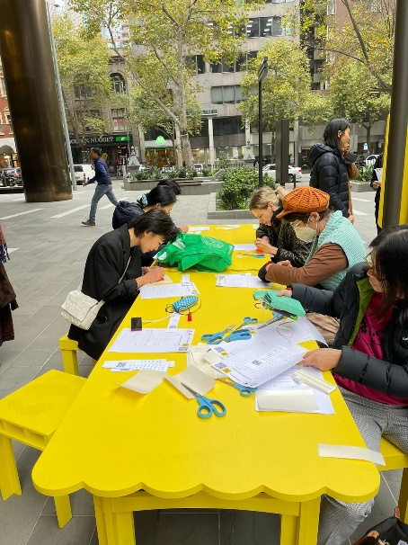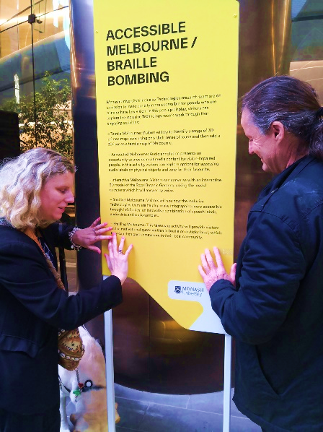
The Braille Bombing event was inspired by yarn bombing, a worldwide phenomenon whereby knitters and hookers (crochet aficionados) create public artworks displayed on the streets. While Braille Bombing is really just an extension of the braille labelling that you would do any time a touch reader starts using a new school, workplace or home, it serves the dual purpose of both providing accessibility and also raising public awareness of the importance of braille. With its catchy title, the braille bombing event easily garnered print and radio media attention, helping to bolster braille awareness in the community. As ABA executive member Tristan Clare explained, “Braille labelling is important just as print signs are. It offers information about floors in an elevator, provides essential fire safety information and prevents the embarrassment of walking into the wrong toilet. Also, if a braille learner is exposed to braille labelling around their home, school or place of work they are getting some of the incidental reading that sighted people have access to.”
While we believe that Melbourne’s event was the world’s first Braille Bombing, we very much hope that it is not the last. Similar events are already planned in a rural New South Wales town to make the school and main street shops more accessible for a young braille learner, as a fun activity for the Queensland Braille Club of school-age braille users, and as active learning for trainee vision specialist teachers in the USA. Please do contact leona.holloway@monash.edu if you would like to host a similar event in your home town and would like some insider tips.
It should be noted that Australian signage standards require grade 1 uncontracted braille so that it can used by beginner touch readers. Standards may differ in your country.
The braille bombers were instructed to install the braille at an appropriate height for touch reading, i.e. between elbow and shoulder height, and permission was gained from the signage owners before the event.
We 3D printed our own slates and styluses for use at the event, meaning that those who wanted to could take the equipment home with them to add braille labels in their workplace, apartment building or neighbourhood. The 3D printing files and instructions are available for free download at https://www.thingiverse.com/thing:5398591.

Setting my sights on 1 million names in braille
“That blind woman” Julie Woods from New Zealand first told us about this project in the ICEB Newsletter Issue 6, March 2020.
I have a group of women volunteers, both sighted and blind, who are also helping write names in braille. We meet once a month by Zoom where we share stories and totals of names we have written for people in the communities around New Zealand and the world.
One visitor to New Zealand in 2019 was Shawn Wallace, the dark destroyer from the television programme The Chase, who can be seen with me in this photo wearing the 10,000 sash, representing my 10,000th name in braille.
Since then many more names in braille have been written, taking the total to 21,777.
Helen Keller wrote “We are never really happy until we try to brighten the lives of others.”
At 1 million names in braille, we are happy to have brightened the lives of 21,177 people, and counting...
If you would like your name written in braille, or the names of people in your community, then please contact me by email Julie@thatblindwoman.co.nz or join the Facebook group 1 million names in braille.
Viva Louis Braille!

People

Tricia D'apice Awarded OAM
The Australian Braille Authority would like to congratulate Tricia d'Apice, who received a medal in the Order of Australia Honours in January 2022 for her service to education for people with vision impairment. Tricia works at NextSense as the Lead Consultant—Vision Impairment. She is also the author of dAp Dots, a program to help young braille readers learn and understand UEB through books and resources. https://dapdots.ridbc.org.au/about/
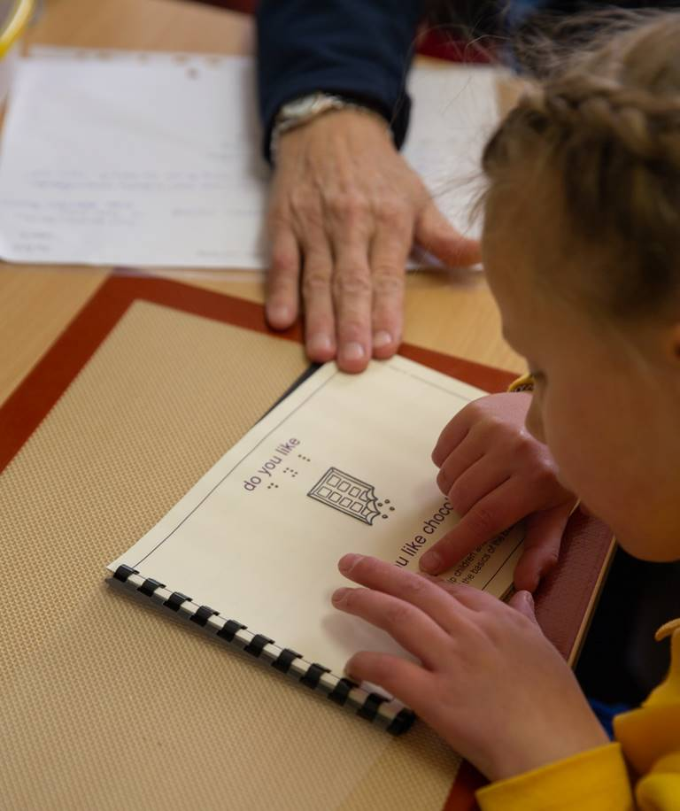
As well as teaching braille to children both in person and remotely through Teleschool, Tricia has undertaken research in the braille reading fluency rates of children.

Congratulations to Judy
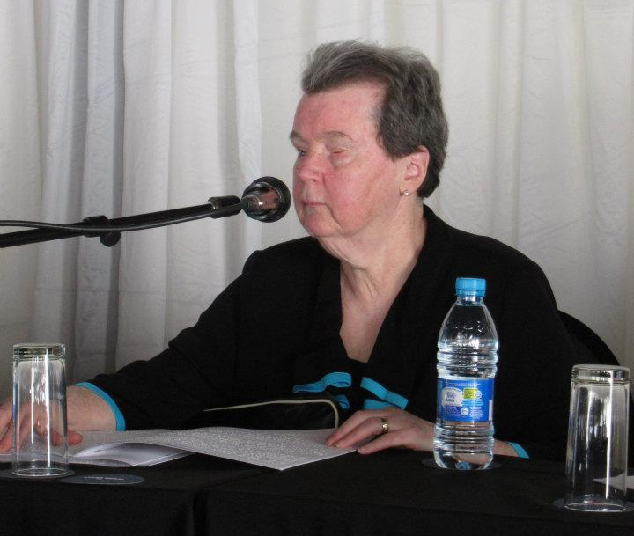
Congratulations are in order to Dr. Judy Dixon (ICEB President), recipient of the prestigious Migel Medal from the American Foundation for the Blind (AFB) this year! The Migel Medal was established in 1937 by M.C. Migel, the first chairperson of AFB, to honor those whose dedication and achievements have significantly improved the lives of people with vision loss. Judy's award was presented at the AFB Leadership Conference on 3 May.
Congratulations, Judy!!!
https://www.prnewswire.com/news-releases/american-foundation-for-the-blind-to-present-its-highest-honors-at-annual-conference-301532410.html

Ntshavheni Netshituni
Christo de Klerk writes: Ntshavheni Netshituni, president of Blind SA and also president of the SA Disability Alliance (SADA) has just completed and passed with distinction his LL.M (Master of Law) degree in International Human Rights. His graduation will be later this year, around October.
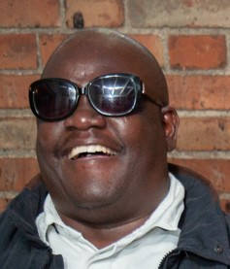
Ntshavheni, well done, congratulations! We are so proud of you and this great achievement. Blind SA is proud and honoured to have you as our president and I am proud to call you my friend.

Calendar of Upcoming Events

Raised Mathematics Project Presentations – September 2022, online
The Raised Mathematics Project is a consortium of researchers from the USA and Europe, working on the automated conversion of mathematical content into accessible formats. One goal is to provide an easy to use, fully automated workflow for the transcription of mathematical textbooks for electronic formats (in particular, PreTeXt and LaTeX) into tactile Braille.
A live online event will cover the topics of braille mathematics on 27 September and tactile graphics on 28 September. The presenters are Al Maneki, Rob Beezer, Michael Cantino, Alexei Kolesnikov and Volker Sorge. Registrations are free but limited to 490 seats for the live event. Additional registrations will be provided with the recording in the following week. Register at https://www.nextsense.org.au/professional-education/raised-maths-workshops-2.

National Braille Association Professional Development Conference – 2-4 November 2022, San Antonio, Texas, USA
At the National Braille Association’s professional development conference, leading industry experts will present three days of workshops in all subject areas of braille transcription. The event will take place at Embassy Suites hotel on the beautiful San Antonio Riverwalk. A virtual attendance option is also available. Registration and program available at https://web.cvent.com/event/3028d024-99aa-4930-a3ca-63fc347b0e0a/summary.

SPEVI Conference – 18-20 January 2023, New Zealand
The next Biennial Conference of the South Pacific Educators in Vision Impairment will be held over three days in January. It promises to be packed with informative and entertaining presentations for educators working with students with vision impairments. The call for papers is now open, closing 12 August 2022. More information at www.speviconference.org.au/program/.

Deafblind International Global Connections – 22-28 July 2023, Ottawa Canada
The 18th Deafblind International World Conference is coming to the beautiful national capital of Canada, Ottawa in July 2023. With the theme of Global Connections: The Future in Our Hands, the conference will be a hybrid event, which means you can attend in person, or virtually. More information available at deafblindnetworkontario.com/.

Getting In Touch with Literacy – November & December 2023, Florida, USA
Getting in Touch with Literacy brings together the most current thinking on all forms of literacy for people who are blind or visually impaired, including braille, tactile graphics comprehension and assistive technology. The Conference will include presentations plus more than 60 concurrent workshops and additional poster sessions.
While we wait to gather in person in 2023, you are invited to take part in a series of virtual conversations about literacy. Conversations on Literacy: Content and Conversations virtual sessions will take place between March 2022 and September 2023. Refer to https://www.gettingintouchwithliteracy.org/.

UEB Q&A Answer
The rules of precedence stated in 10.10.7 can be summarised:
Use strong groupsigns in preference to initial-letter contractions unless space is wasted.
The word “stoned” is 4 cells if either the “ed” groupsign or the “one” contraction is used. The “ed” groupsign has preference as so is used. ⠌⠕⠝⠫
The word “named” is 4 cells if the “ed” groupsign is used but only 3 cells if the “one” contraction is used. To save space the “name” contraction is used rather than the “ed” groupsign. ⠐⠝⠙

ICEB Contact Details
Website: https://iceb.org
Email: info@iceb.org
Twitter: @ICEBbraille
Facebook: www.facebook.com/ICEBbraille/
ICEB-announce list:
Send an email to iceb-announce+subscribe@groups.io to receive announcements from ICEB, including this newsletter and notifications regarding updates to Unified English Braille.

