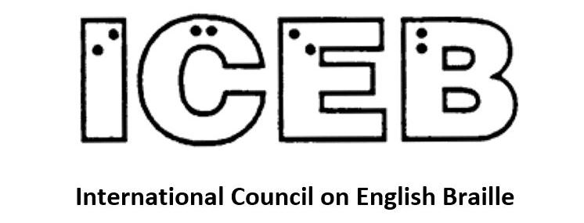

ICEB Newsletter
Issue 15
January 2023

In This Issue
From the President's Desk 3
ICEB Committee Updates 4
APH Partners with DAISY Consortium on New Digital Braille Standard 7
Braille Literacy Canada Endorses the Mi'kmaw Braille Code 9
ICEB Country Updates 10
Calendar of Upcoming Events 13
UEB Q&A Answer 14
ICEB Contact Details 15

From the President's Desk
Judy Dixon writes:
Happy New Year to all, and I wish you a wonderful and prosperous 2023.
As 2023 dawns, ICEB officers and committees are continuing to work hard on various braille-related activities. In this issue of the newsletter, there is a considerable amount of information and discussion on issues related to braille codes and encoding. I urge everyone to take a careful look at these articles. The future of braille and how it is used by braille readers is very much dependent on how braille is presented to readers. With the evolving electronic standards discussed in this issue, we are on the horizon of major changes.
ICEB is also beginning to plan for the Eighth General Assembly to be held in 2024. In the next issue of this newsletter, we will no doubt be able to announce the dates and location of this upcoming event. So, be sure to watch this space for this exciting announcement.
Many years ago, I learned that in New Zealand, people refer to the “proudness” of braille. This reference is to the height of the braille dots, not the fact that I am proud to be a braille reader. But I do enjoy the notion of braille being proud.
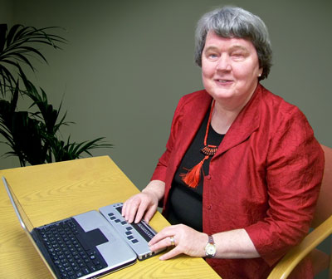
So, everyone, do have a wonderful new year and may all your dots be proud.

ICEB Committee Updates

UEB Q&A
Basic Arrows
How would you braille the arrow in the following genealogy?
Peter (right arrow) John, Susan.
See answer near the end of this newsletter.

Braille Technology Committee
A new document is almost ready that explains the various ways braille is encoded in computer files and the various associated braille terminology. It takes us through the mysteries of ASCII and Unicode characters and demystifies a lot of the language and terms for those of us who are not computer programmers.
Work continues on the popular open source Liblouis braille translation system with new releases on a regular basis. The latest release is 3.24.
In our last newsletter we talked about the development of the eBRF file format, initiated by the American Printing House for the Blind. An important development in this work is reported on later in this newsletter.

Braille Music Committee
BANA has appointed Bill McCann as its representative on the ICEB Music Committee. Bill is known to many of us as the founder of Dancing Dots and the Goodfeel suite of products for creating braille music.
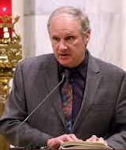
Bill McCann
Some members of the Music Committee continue to work with the DAISY Consortium and its braille music project.
If you are not already an observer on the Music Committee and you are interested in the production and reading of braille music, you can contact your own braille authority and ask if they can sponsor you as an observer. You will be the first to learn about any developments in braille music as the ICEB Music Committee is very well connected to the several projects in Europe, North America and elsewhere who are working on the music code and possible extensions of it.

Braille Research Committee
Natalie Martiniello, Ph.D, CVRT, Past President of Braille Literacy Canada, Chair of the ICEB Research Committee writes:
The ICEB research committee provides members with a platform to share information about braille related research across ICEB member countries and globally. To learn more about this committee or to share information about research that may be of interest to ICEB members, write to info@iceb.org.
In November 2022, country voting representatives of the Code Maintenance committee (CMC) were invited to join the ICEB Executive Committee for a discussion on the science of braille reading and the implications that this carries for the teaching, learning and development of braille. Invited guest speakers Dr. Robert Englebretson, Dr. Cay Holbrook and Dr. Simon Fischer Baum began by providing an overview of evidence-based research on reading, both as this relates to print and braille.
Reading (whether in print or braille) draws on a multitude of functions – all of which work cohesively in a matter of milliseconds. Understanding the science of reading – the processes that are at play during reading – is vital because it leads to evidence-based insights on how reading works, and by extension, how it can be taught and learned most effectively. In the braille research world, it is well known that congenitally blind children who learn braille early in life exhibit cortical plasticity, where the otherwise unused visual cortex (the region of the brain responsible for processing vision) is recruited during braille reading. Braille reading, like other skills, is also training dependent – meaning that as you practice, you improve. To learn more about braille and cortical plasticity, see this review: https://journals.sagepub.com/doi/10.1177/0145482X0610000704
The invited experts also highlighted that we bring both unconscious and conscious skills and knowledge with us to the reading and writing process. Fluent reading requires the fast recognition of letter-sound relationships (phonetics) and the meaningful patterns in words (morphemes). They highlighted findings from their research on braille reading and writing which demonstrates that morphology significantly matters during the reading of braille – just as it does in print. You can learn more about some of this research here:
https://www.sciencedirect.com/science/article/abs/pii/S0010027716300762
In other news, there is a call for articles on literacy across the lifespan in JVIB: https://afb.org/publications/jvib/jvib-authors/calls-papers/2023specialissueonliteracy

APH Partners with DAISY Consortium on New Digital Braille Standard
In a news release issued on 14 December 2022, The American Printing House for the Blind (APH) wrote:
We're pleased to announce our partnership with the DAISY Consortium to develop a brand-new, electronic braille standard!
This development is an important step as we continue to imagine, create, and produce more high-tech braille devices. It is essential that the eBRF be accessible on both braille displays and embossers. The eBRF is being created in collaboration with leaders from the field and will change the way braille users, teachers, and transcribers interact with braille and tactile graphics.
“This is a major milestone in our efforts to create the best digital braille format possible. DAISY's acceptance shows we are making the proper changes and enhancements with technology to create a braille standard that will be long-lasting,” said Craig Meador, APH President.
Changes were needed to the current braille standard because standard braille files are formatted entirely using blank lines and spaces. As a result, readers can't easily navigate large files. Also, braille content and embossed graphics are unable to be joined in the same electronic experience. The eBRF will solve these issues by providing braille text and tactile graphics in one file with enhanced navigation, including links for footnotes and endnotes.
“The amazing thing about the eBRF is that right now, the transcriber is giving us almost all the information we need to create it. But it gets thrown out when saved as a BRF,” said William Freeman, Tactile Technology Product Manager.
With the eBRF, users will have access to essential formatting tools, like headings, tables, and page numbers. The enhanced navigation will allow students to efficiently jump to sections, chapters, or pages and utilize links to access footnotes or other referenced material. The goal is that the eBRF will be easy to create and open. It will work on embossers, single-line braille displays, and multi-line braille displays, with each of these options benefiting from different features of the new file type. The eBRF, used with displays like our upcoming Dynamic Tactile Device (DTD), will display full pages of braille text and graphics, giving students access to texts and images used in the classroom at the same time as their sighted peers.
“A new modern electronic braille specification is going to positively impact many people around the world, and is sure to increase access to information,” said George Kerscher, DAISY Chief Innovation Officer.
The DAISY Consortium is a not-for-profit global organization focused on publishing and reading for people with blindness, low vision, and other print disabilities. The DAISY Consortium's expertise and global reach will help organize and lead the working group, which includes braille readers, braille producers, software companies, device manufacturers, educators, publishers, and libraries.
We are also working with representatives from international braille authorities and organizations, such as the National Library Service (NLS), Braille Authority of North America (BANA), International Council on English Braille (ICEB), the Royal National Institute of Blind People (RNIB), Austrian Association for the Blind, Duxbury Systems, National Network for Equitable Library Service (NNELS), and many more, on this effort to create a new braille file standard.
Together we will bring braille into the 21st century!
For more information, go to
https://daisy.org/activities/projects/ebraille/.

Braille Literacy Canada Endorses the Mi'kmaw Braille Code
Note: The following is taken from a press release issued by Braille Literacy Canada on 19 September 2022. The Braille Authority of North America (BANA) has also endorsed the Mi'kmaw Braille Code at the request of the Mi'kmaq community in the United States.
Braille Literacy Canada, the governing braille authority of Canada, is pleased to announce the endorsement of the Mi'kmaw Braille Code.
Atlantic Provinces Special Education Authority (APSEA) certified braille transcriber, Christine Muise worked in tandem with Dr. Bernie Francis, Membertou Linguist, native speaker of Mi'kmaw, and co-creator of the Francis-Smith print orthography currently used for the Mi'kmaw language to develop the Mi'kmaw Braille Code. This work was completed in consultation with Dr. Robert Englebretson, Carol Begay Green and Justin M.H. Salisbury.
The Mi'kmaw braille code in its current form has the support and approval from both Dr. Bernie Francis and Chief Terry Paul. Chief Terry Paul, OC, the elected chief and CEO Membertou declared, “Creating a braille code that represents our language plays an important role in communication and accessibility to Mi'kmaw cultural education for future generations of Indigenous students.” Membertou is an urban and progressive Mi'kmaw community located on Unama'ki – Cape Breton Island.
The code is meant to ensure that all blind readers of Mi'kmaw have a standardized, consistent braille code available to them and will be made available to transcribers across North America.
We commend Christine Muise on her contribution to the development of this braille code.
BLC celebrates this notable achievement and the important work towards the preservation of Indigenous language being accomplished.
For more information please visit the following page on the BLC web site:
https://www.brailleliteracycanada.ca/en/news/braille-literacy-canada-endorses-the-mi-kmaw-braille-code.

ICEB Country Updates

Canada
BLC is collaborating on a series of braille videos geared towards teachers of students with visual impairments and parents. You can learn more here: https://www.brailleliteracycanada.ca/en/news/prcvi-and-blc-team-up-to-produce-braille-bites-video-series.

New Zealand
Capital B for Braille! The Braille Authority of New Zealand Aotearoa Trust (BANZAT) is pleased to announce the results of a nationwide survey within the Braille user community regarding formatting of the word Braille in New Zealand English. A clear majority expressed a desire for the word Braille to be capitalised in all situations, regardless of whether it is being used as a proper noun or not. In respecting the wishes of those for whom Braille is their literacy medium, BANZAT recommends that this practice be adopted in all documents or situations where the word Braille occurs.
Examples:
- This book has been published in both print and Braille.
- I have a Braille recipe for Anzac biscuits.
- Jane will Braille the address labels for you.
- I am Brailling out my speech notes.
- The paper is stuck in my Brailler.
The word Braille, and its associated tactile reading code, came into our language thanks to its inventor, Louis Braille, who overcame sacrifices and resistance to enable today's blind population the right to fully independent literacy. Capitalising Braille gives the inventor the respect he is due.
Precedents in New Zealand include:
- The Deaf community have asked that Deaf be capitalised when talking about their culture.
- Many Māori words have entered New Zealand English and spellings corrected, thanks to the voices of Māoridom.
Note: Two other ICEB braille authorities also have policies on the capitalisation of braille. For the BANA policy see https://www.brailleauthority.org/capitalization-style-word-braille. For the UKAAF policy which opens a PDF see https://www.ukaaf.org/wp-content/uploads/2020/03/Capitalisation-Braille.pdf.
A Braille first in New Zealand Local Elections. For the first time in New Zealand, Wellington City Council provided information in Braille about candidates standing in their local government elections. Braille readers were able to learn about the candidates before casting their votes. This effort was praised by Braille reader Allan Jones who enjoyed the chance to sort out his votes before giving directions to the person who filled in the print ballot paper on his behalf.

South Africa
South Africa can join the Marrakesh Treaty after a decision by the South African Constitutional Court. In September 2022 the Court declared the 1978 Copyright Act to be unconstitutional as it discriminates against print disabled persons. The Court went on to tell Government to fix its unconstitutionality within 24 months. The Court also provided text for immediate inclusion in the 1978 Copyright Act that allows a print disabled person to buy or borrow a book and have it converted into accessible format without first having to get the permission from publishers. There is now the legal framework for government to accede to the Marrakesh Treaty. This will be our next advocacy drive to push government to do that as soon as possible. Print disabled individuals and blindness organisations in South Africa are delighted with this legal victory.

Calendar of Upcoming Events

CSUN 13 to 17 March
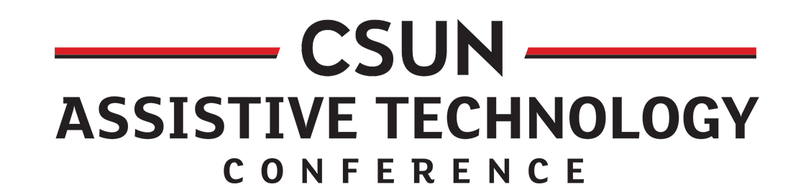
The California State University, Northridge is again running its conference that showcases just about everything in assistive technology. This year it will be held at the Anaheim Marriott. For the program see
https://www.csun.edu/cod/conference/sessions/index.php/public/website_pages/view/5.

Round Table Conference, 6-9 May, Sydney
The Round Table on Information Access for People with Print Disabilities is holding its first in-person conference since 2019. It's taking place in Sydney, Australia, from Saturday, 6 May to Tuesday, 9 May 2023. For more information go to https://printdisability.org/conference/

Deafblind International Global Connections – 22-28 July 2023, Ottawa Canada
The 18th Deafblind International World Conference is coming to the beautiful national capital of Canada, Ottawa in July 2023. With the theme of Global Connections: The Future in Our Hands, the conference will be a hybrid event, which means you can attend in person, or virtually. More information available at deafblindnetworkontario.com/.

Getting In Touch with Literacy – November & December 2023, Florida, USA
Getting in Touch with Literacy brings together the most current thinking on all forms of literacy for people who are blind or visually impaired, including braille, tactile graphics comprehension and assistive technology. The Conference will include presentations plus more than 60 concurrent workshops and additional poster sessions.
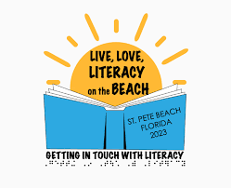
While we wait to gather in person in 2023, you are invited to take part in a series of virtual conversations about literacy. Conversations on Literacy: Content and Conversations virtual sessions will take place between March 2022 and September 2023. Refer to https://www.gettingintouchwithliteracy.org/.

UEB Q&A Answer
The symbol for the right arrow is
⠰⠳⠕
So the genealogy entry would be brailled:
⠠⠏⠑⠞⠻ ⠰⠳⠕ ⠠⠚⠕⠓⠝⠂ ⠠⠎⠥⠎⠁⠝⠲
Since this is in contracted (grade 2) braille, the grade 1 indicator is needed before the arrow indicator to prevent the OU contraction.
The arrow symbols are:
Left arrow: ⠰⠳⠪
Up arrow: ⠰⠳⠬
Down arrow: ⠰⠳⠩

ICEB Contact Details
Website: https://iceb.org
Email: info@iceb.org
Twitter: @ICEBbraille
Facebook: www.facebook.com/ICEBbraille/
ICEB-announce list:
Send an email to iceb-announce+subscribe@groups.io to receive announcements from ICEB, including future newsletters and notifications regarding updates to Unified English Braille.

