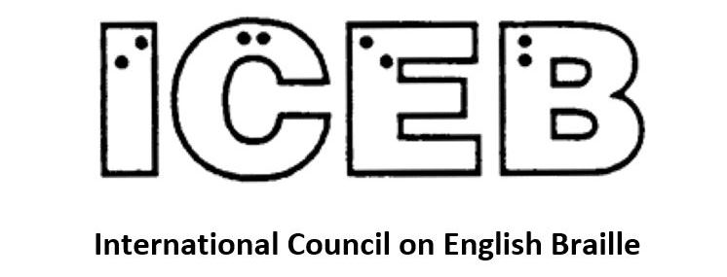

ICEB Newsletter
Issue 16
September 2023

In This Issue
From the President's Desk 3
ICEB 8th General Assembly is coming! 4
ICEB Committee Updates 5
Programs to translate music into braille 8
Accessible Equation Editor 10
Autoimmunity art: Making science accessible for blind and low-vision audiences 11
ICEB Country Updates 13
Calendar of Upcoming Events 13
UEB Q&A Answer 16
ICEB Contact Details 16

From the President's Desk
Judy Dixon writes:
Welcome to another exciting issue of the ICEB Newsletter. Our editor, Mary Schnackenberg, always does such a great job of updating everyone on the happenings within ICEB and finding relevant news stories of interest to the ICEB community. And she has done it once again!
In addition to updates on ICEB committees and interesting news stories, this issue contains details about ICEB’s upcoming 8th General Assembly to be held in Auckland, New Zealand. This will be our first in-person General Assembly in eight years. We are looking forward to hearing about the latest developments from leaders in the world of English braille as well as having lots of opportunity for that always-necessary networking among colleagues that we have so missed these last few years.
2024 will celebrate 200 years since Louis Braille published his initial work laying out the basics of his dot-reading and writing system, later to be known as braille. While in Paris in 2009 at a conference celebrating 200 years since Louis Braille’s birth, I asked the museum curator what Louis Braille’s tactile system was called before it was eponymously named Braille in 1871. The answer is “anaglyphography.” I am glad Louis had a short last name which is easy to say for five-year-old new braille learners.
Our 8th General Assembly will be an excellent venue to celebrate the past 200 years of braille and will give all of us an opportunity to take a critical look at where braille stands today, where we would like it to be going, and how to help it get there. As I write these words, using a refreshable braille display, I once again marvel on what a gift braille is, making it possible to write, edit, and proofread so effortlessly.
The Call for Papers for the 8th General Assembly has gone out on the ICEB Announcements List. Whether you are a researcher, practitioner, or consumer of braille, I urge you to consider writing a paper on a topic of interest to the braille community and come join us in Auckland in May of 2024.

ICEB 8th General Assembly is coming!
Mary Schnackenberg writes:
The International Council on English Braille (ICEB) will hold its 8th General Assembly from Saturday, 25 May 2024 to Thursday, 30 May 2024 at The Grand Millennium Hotel in Auckland New Zealand.
The Assembly theme is “Two Centuries of Braille”.
Each member country of ICEB will send up to four delegates to the Assembly. Observers are also warmly welcomed.
During the week we will hear from speakers delivering papers and posters as well as receive reports about work completed since the 2020 General Assembly. We will agree resolutions to guide ICEB over the next four years. And there will be time for recreation and all the usual face-to-face networking.
The outgoing Executive Committee will meet on Saturday 25 May and the incoming Executive Committee will gather on Thursday 30 May.
Your proud host for the General Assembly is The Braille Authority of New Zealand Aotearoa Trust (BANZAT). To help with planning, BANZAT needs the registration form up on its website by early October. The Assembly Programme will be on the BANZAT website and we will refine and update the programme as it develops. We will let you know through all our communications channels as soon as the Programme and Registration Form go live on https://www.banzat.org.nz/.
If you are thinking of any holiday time prior to or following the ICEB General Assembly, Monday 3 June 2024 is a public holiday in New Zealand.

ICEB Committee Updates

UEB Q&A
For which of the following examples would the general fraction indicator be needed?
a. Five eighths
b. Three-quarters (where a slash is used in print)
c. $3 over $9

Braille Technology Committee
James Bowden writes:
Work continues improving the UEB tables of the popular Liblouis translation system. The Braille Technology committee met in July to discuss a couple of questions relating to translation of some particular aspects of UEB. We hope these improvements will benefit Liblouis users in the coming months.
We also continue to watch with interest the development of the eBraille project, which promises better functionality when reading braille files, particularly with refreshable braille displays. As mentioned previously, some of the main advantages of eBraille will include the ability to automatically reflow text to the available line length, better international support, greater navigation possibilities when reading and the possibility to include tactile graphics.
The work is now well into the development stage.
To find out more about the eBraille project, go to:
https://daisy.org/activities/projects/ebraille/.

Braille Research Committee
Natalie Martiniello, Ph.D, CVRT, Past President of Braille Literacy Canada, Chair of the ICEB Research Committee writes:
The ICEB research committee provides members with a platform to share information about braille related research across ICEB member countries and globally. To learn more about this committee or to share information about research that may be of interest to ICEB members, write to info@iceb.org.
We begin by highlighting this important paper published in February 2023, written by Drs. Robert Englebretson, Cay Holbrook and Simon Fischer-Baum:
A position paper on researching braille in the cognitive sciences: decentering the sighted norm:
https://doi.org/10.1017/S0142716423000061
Abstract: This article positions braille as a writing system worthy of study in its own right and on its own terms. We begin with a discussion of the role of braille in the lives of those who read and write it and a call for more attention to braille in the reading sciences. We then give an overview of the history and development of braille, focusing on its formal characteristics as a writing system, in order to acquaint sighted print readers with the basics of braille and to spark further interest among reading researchers. We then explore how print-centric assumptions and sight-centric motivations have potentially negative consequences, not only for braille users but also for the types of questions researchers think to pursue. We conclude with recommendations for conducting responsible and informed research about braille. We affirm that blindness is most equitably understood as but one of the many diverse ways humans experience the world. Researching braille literacy from an equity and diversity perspective provides positive, fruitful insights into perception and cognition, contributes to the typologically oriented work on the world’s writing systems, and contributes to equity by centering the perspectives and literacy of the people who read and write braille.
Please see below for additional research updates that will be of interest.
Getting in Touch With Tactile Map Automated Production: Evaluating impact and areas for improvement:
https://pubmed.ncbi.nlm.nih.gov/37008596/
Abstract: This study evaluated the impact the Tactile Maps Automated Production (TMAP) system has had on its blind and visually impaired (BVI) and Orientation and Mobility (O&M) users and obtained suggestions for improvement. A semi-structured interview was performed with six BVI and seven O&M TMAP users who had printed or ordered two or more TMAPs in the last year. The number of maps downloaded from the online TMAP generation platform was also reviewed for each participant. The most significant finding is that having access to TMAPs increased map usage for BVIs from less than 1 map a year to getting at least two maps from the order system, with those who had easy access to an embosser generating on average 18.33 TMAPs from the online system and saying they embossed 42 maps on average at home or work. O&Ms appreciated the quick, high-quality, and scaled map they could create and send home with their students, and they frequently used TMAPs with their braille reading students. To improve TMAPs, users requested that the following features be added: interactivity, greater customizability of TMAPs, viewing of transit stops, lower cost of the ordered TMAP, and nonvisual viewing of the digital TMAP on the online platform.
Getting in Touch with Literacy 2023 – St. Pete Beach, Florida:
https://www.gettingintouchwithliteracy.org/
For the past thirty years, the Getting In Touch With Literacy conference has been a forum for discussion, explorations, and conversations about literacy for individuals who are blind or visually impaired. People have met colleagues and built connections through these in-person conferences since 1993. Dr. Cay Holbrook and Janie Blome, founders of the conference, recently shared the exciting announcement that CEC's Division on Visual Impairments and Deafblindess (DVIDB) and Allied Instructional Services (led by Karen Walker) will collaborate to continue the tradition of leading this conference into the future. Please join them in thanking Nicole Johnson-Mest and Karen Walker for making this happen. Visit the above link to receive updates on the conference. Frances Mary D'Andrea and Judy Dixon will be presenting a session on ICEB on Thursday afternoon November 30.

Programs to translate music into braille
James Bowden and Jordie Howell write:
Many of us are familiar with programs which can translate print text into braille, but what about music notation?
Over recent years, several new programs have been and continue to be developed to convert print music into good quality braille. These now include programs you can install on a Windows computer or use from a website.
The basic process generally starts with a good quality MusicXML file, produced in a music notation program such as Sibelius or MuseScore. The MusicXML is then given to the music translation program and this in turn generates the braille output. The braille can then be embossed onto paper or read on a refreshable braille display.
MusicXML is a file format used to represent all the elements of Western music notation. It is a format used to exchange digital sheet music and is often an option when you save or export from a music notation program.
If you only have an image of the print music, such as a PDF file, you'll first need to convert the image to MusicXML as an additional process.
As with most braille translation, there are all sorts of things to watch out for and various options which have to be checked, but the new suite of music translation programs add useful tools in the hands of both professional braille transcribers and personal users alike.
For more information about the DAISY Music Braille Project and latest developments, visit: https://daisy.org/activities/projects/music-braille/
Sao Mai Braille provides a free end-user tool to convert print to braille including music: https://saomaicenter.org/en/smsoft/smb
MakeBraille is an online automated music Braille conversion tool for professional transcribers, developed by dzb lesen: https://makebraille.dzblesen.de/MakeBraille
To find out about Musescore, the free music editor with music braille input, visit: https://musescore.org/en/accessibility

Accessible Equation Editor
Judy Dixon writes:
In August, Sam Dooley from Pearson made a Zoom presentation to the ICEB Executive Committee on the Accessible Equation Editor (AEE). Pearson specializes in textbooks, assessments, and more in the STEM subjects.
Here is a brief description of the AEE from the Pearson website:
“The Accessible Equation Editor is a program that allows a user to create math expressions within a web page. The equation editor is used in a number of Pearson products, most notably the TestNav assessment delivery system used for high-stakes testing.
“The equation editor is accessible to blind and visually-impaired users because it translates printed math notation into Nemeth braille, which can be displayed on a braille terminal, and it accepts Nemeth braille input, which it translates into printed math notation that it displays for a sighted user. A blind user can create math expressions that can be immediately read by a sighted user, and vice versa.”
You can learn more about the AEE at:
https://accessibility.pearson.com/resources/aee/aee-start.php.
ICEB is discussing the possibility of the Accessible Equation Editor being programmed to translate printed math notation into UEB.

Autoimmunity art: Making science accessible for blind and low-vision audiences
Leona Holloway, researcher in Inclusive Technologies at Monash University in Melbourne writes:
The Monash Sensory Science Exhibition – Autoimmunity offered an accessible and inclusive learning opportunity for Australians who are blind or have low vision to explore eight autoimmune diseases through multi-sensory, multi-modal artworks and tactile displays. From handcrafted immune cells made of clay, food, paper and fabrics, to technologies and interactive displays exploring autoimmune processes, visitors learned about the ways in which the body mistakenly attacks its own organs and tissues, resulting in health conditions such as type 1 diabetes, multiple sclerosis and celiac disease. And of course, braille was present throughout on handouts, posters and take-home activities.
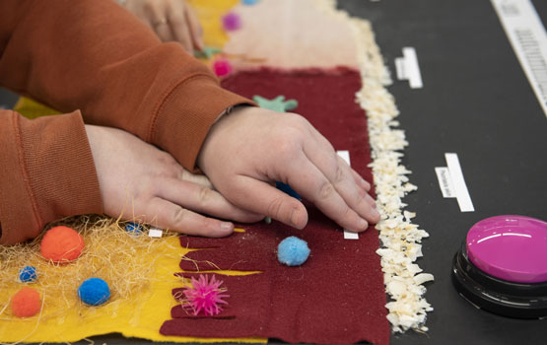
Image: Exploring a tactile poster with craft materials, braille labels and audio push buttons
Hosted by the Monash Biomedicine Discovery Institute, the main exhibition was a day-long event Monash University in Melbourne with over 100 visitors. The day began with a welcoming address from Professor Jamie Rossjohn, a Monash University T cell immunology expert, before visitors chose from a variety of small-group sessions exploring various diseases in depth. The Monash Assistive Technology and Society centre co-hosted the event and shared some of their research on technologies for non-visual accessibility such as 3D printing, tactile STEM kits and refreshable tactile displays.
For those unable to attend the main event, the sensory science exhibits went on the road, being shared as part of Australia’s National Science Week in Sydney and Melbourne. A further session will also be held at Able Australia for people who are Deafblind.
First held in 2018, the exhibition is an initiative of the Rossjohn Laboratory, a research group pursuing the advancement of knowledge of innate and adaptive immunity. Dr Erica Tandori, a legally blind artist, researcher and academic and the artist-in-residence in the Rossjohn Laboratory, led the development of the artworks and displays.
Dr Tandori said that the exhibition provided a unique opportunity for participants to explore science through the power of art. “Scientists already use art to make medical concepts tangible and tactile without even realising, such as when they create 3D models of organs or cells,” she said. “In our exhibition, we’re celebrating and highlighting the unique way in which art can make science accessible”.
Mary writes: Monash University is in Melbourne, Australia, and Leona Holloway works with a team of students in another of the Monash laboratories developing all sorts of tactile graphics and devices for blind people.

ICEB Country Updates

South Africa
On 27 June 2013, a treaty was concluded in Marrakesh, Morocco, called the Marrakesh Treaty to Facilitate Access to Published Works for Persons Who are Blind, Visually Impaired or Otherwise Print Disabled https://www.wipo.int/wipolex/en/text/301016. The Marrakesh Treaty promised to bring an end to what we call the "book famine".
Yet, ten years on, the Government of South Africa has still not acceded to the Treaty. South Africa is the one remaining ICEB country member that is not part of the Accessible Books Consortium family of the World Intellectual Property Organisation which is allowing eligible libraries and individuals to exchange accessible format titles all around the world without having to obtain permission from print publishers. Several South African organisations have written a joint letter to the President of South Africa, Cyril Ramaphosa, continuing their advocacy about joining the Marrakesh Treaty.

Calendar of Upcoming Events

Accessible Community, Culture and Technology Fair, New York, 20 October 2023
This is a free fair to learn about the many fabulous resources, groups, and offerings for community members who are blind, low vision, Deafblind, or physically disabled. The Fair will include tables from educational, employment, advocacy, arts, support, and recreation groups, technology demos, fun accessible activities; speakers on entrepreneurship, advice on starting your own business, and more.
Location: Stavros Niarchos Foundation Library (SNFL), New York, USA.
Date and time: Friday, October 20, 2023, 11AM - 4PM.
http://www.nypl.org/locations/snfl

VISCON 2023, 19-20 October 2023, Sydney, Australia

This two day event is always a great opportunity to come together to learn, network and engage with the vision and accessibility community. Dr Frances Gentle is confirmed as opening keynote speaker, and will be joined by Vision Queens Dr Cay Holbrook, Dr Frances Mary D'Andrea, Dr Karen Wolffe and Dr Penny Rosenblum.
Dates: 19-20 October 2023
Time: 9am-3pm
Cost: AUD$300
Location: NextSense, Australian Hearing Hub, Macquarie University, Sydney, New South Wales, Australia.
Website: www.nextsense.org.au/professional-education/viscon-2023

Getting In Touch with Literacy, 29 to 30 November 2023, Florida, USA
Getting in Touch with Literacy brings together the most current thinking on all forms of literacy for people who are blind or visually impaired, including braille, tactile graphics comprehension and assistive technology. Refer to https://www.gettingintouchwithliteracy.org/.

CSUN 18 to 22 March 2024
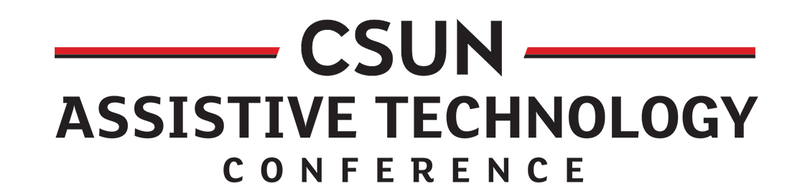
The California State University, Northridge is running its 39th conference that showcases just about everything in assistive technology. It will be held at the Anaheim Marriott. For the program see
https://www.csun.edu/cod/conference/sessions/index.php/public/website_pages/view/5.

Round Table Conference, 18 to 21 May, Perth
The Round Table on Information Access for People with Print Disabilities is holding its 2024 Conference from Saturday 18 May to Tuesday 21 May. The venue is Novotel Perth Langley, Western Australia. For more information go to https://printdisability.org/conference/.

ICEB General Assembly, 25 to 30 May
The International Council on English Braille is holding its 8th General Assembly in Auckland New Zealand from Saturday 25 May to Thursday 30 May. For updates go to https://www.banzat.org.nz/.

Tactile Reading Conference, 2 to 4 June 2025, Amsterdam
Tactile Reading's third edition brings together participants worldwide that contribute to making information accessible through tactile solutions. In addition to braille, this also involves tactile graphics, drawings and 3D. To learn more about the conference, visit https://tactilereading.yellenge.nl/

UEB Q&A Answer
The answer is Example c.
a. ⠼⠑⠌⠓
b. ⠼⠉⠸⠌⠼⠙
c. ⠰⠷⠈⠎⠼⠉⠨⠌⠈⠎⠼⠊⠾

ICEB Contact Details
Website: https://iceb.org
Email: info@iceb.org
Twitter: @ICEBbraille
Facebook: www.facebook.com/ICEBbraille/
ICEB-announce list:
Send an email to iceb-announce+subscribe@groups.io to receive announcements from ICEB, including future newsletters and notifications regarding updates to Unified English Braille.

