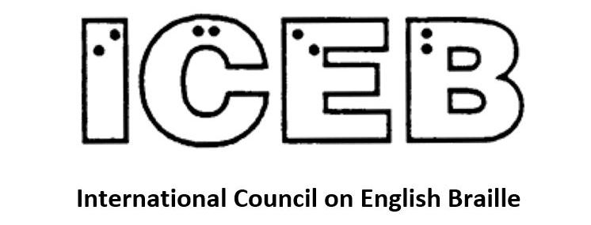

ICEB Newsletter
Issue 3, June 2019

Unified English Braille and Math

Signs of Operation and Comparison
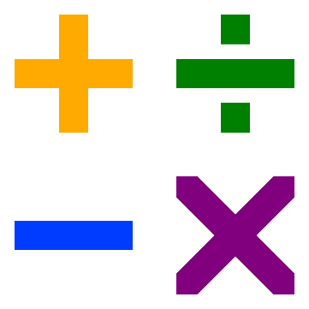
A subgroup of the UEB Code Maintenance Committee has been working hard on updating ICEB’s Guidelines for Technical Material (2014). This document was first produced in October 2008 by the Maths Focus Group, a subgroup of the former UEB Rules Committee during the UEB development phase. While it has served as a valuable document during implementation of UEB, there has been a call for many more examples and clearer rules covering all levels of mathematics.
We are pleased to announce that the first section of the updated Guidelines for Technical Material is now complete and available for use in print and braille. Section 3: Signs of Operation and Comparison gives a list of signs along with clear rules for their use and many more examples than the previous edition. The document is available from the ICEB website at http://iceb.org/ueb.html#GTM in print and braille formats. We encourage you to download, read and start using these guidelines.

Learning UEB mathematics online
In issue 2 of the ICEB Newsletter, Frances Gentle wrote about the creation of UEB Math Online for free online learning of UEB math. We are pleased to report the program is now live and available for use at https://uebonline.org.
And don’t forget, APH also offer an online UEB math tutorial at https://uebmath.aphtech.org/.

UEB Q&A

To “be” or not to “be”?
Work is underway to examine how the Rules of Unified English Braille should be applied to unusual words, scientific terms and words that are pronounced differently according to region.
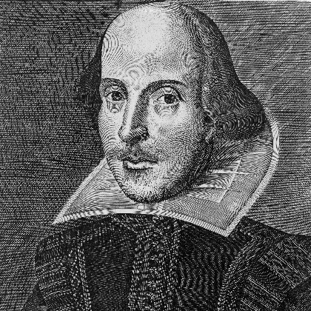
The first group of words all begin with the letters “be”:
- begum
- benefic
- Beowulf
- besom
- betel
- Bethesda
Should the “be” contraction be used?
According to the Rules of Unified English Braille 10.6.1, use the lower groupsign for “be” when the letters it represents form the first syllable of a word. It has been agreed that all of the words in question do in fact feature “be” as a syllable, so the contraction can be used:
- BEgum 2gum
- BEnefic 2nefic
- BE-OWulf ,2{ulf
- BEsom 2som
- BEtel 2tel
- BE-THEsda 2!sda

Test your UEB knowledge!


!Before"#$%&'()(*+(+(*((,
'---.
/
00(1"
#*$()(,
2
Question: What is the best position for the grade 1 terminator in the following example?
t-t-t-t-t-t-tonight
Check near the end of the newsletter for the answer.

LEGO Braille

RNIB partnership with the LEGO Foundation
RNIB is delighted to have worked with The LEGO Foundation and other organisations for blind people to review the concept of the LEGO Braille Bricks. The idea for the bricks came from the Dorina Nowill Foundation for the Blind in Brazil and this developed into a project with The LEGO Foundation.
Each brick is a standard 4×2 LEGO brick. The top part of the brick has up to 6 studs, some of which are removed, forming braille letters. The letter is also printed at the bottom of the brick so sighted and blind people can create words together and read and write messages to each other.
One of the main aims of the project is to introduce young children to braille through play. The project partners developed simple games such as finding a pair of bricks from a group of 5, which are fun to play and helps children to use their tactile sense to identify and differentiate combinations of dots. We also created games for older children who are learning braille.
RNIB tested the bricks in two schools and all the children involved really enjoyed playing with the bricks. Some older children wrote messages to each other and to the teachers and others tried writing their name or finding pairs of bricks.
The key take-away from our testing was how much fun the children had playing with the bricks and also their appreciation that braille was a fundamental part of the product. They talked about writing messages to sighted family members or helping parents or younger siblings learn braille and how pleased they were to have something made for them that they could use to teach other people.
We’re starting work now with The LEGO Foundation and partners in the UK, France, Germany, the US and Mexico to produce teaching material that will accompany the bricks when they are produced. We look forward to the bricks being available for use in education to complement existing teaching methods.
- Cathy Rundle, Senior Accessibility Specialist, RNIB

Access to braille on LEGO bricks
The LEGO Foundation plan to provide their braille bricks directly to major blindness organisations throughout the world, however they will not be available commercially. Meanwhile, other options are also available.
Brick-a-Braille is an independently developed teaching system using standard LEGO bricks. The not-for-profit project offers a method for teaching blind and vision impaired children spatiality, laterality and the braille alphabet. A PDF instruction manual is available by request.
As an alternative to LEGO, Tack-Tiles Braille Systems are a teaching tool for all ages with LEGO-style interlocking bricks. The dots on the bricks are domed for smoother reading more similar to that of standard braille, and the slates (base plates) are specially designed for correct spacing between letters and lines. Contractions and other symbols are available, as is a braille music set.
And finally, the 3D printing community has designed models for LEGO-compatible braille bricks that can be downloaded for free and 3D printed. For example, see the designs for braille Duplo and braille bricks on Thingiverse.
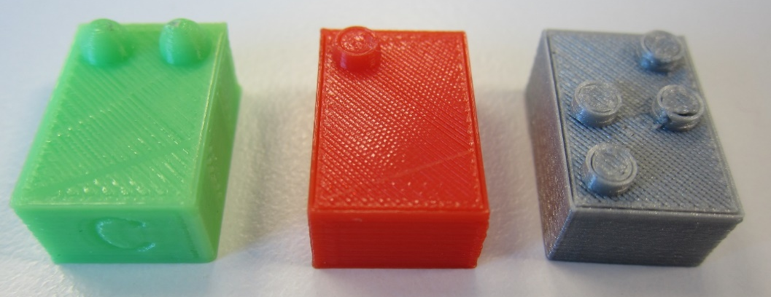
3D printed braille bricks

Braille technology – The Canute 360
Over the past eight years, Bristol Braille Technology has been developing the Canute 360 from our small workshop in Bedminster, Bristol. We are truly proud of how far we’ve come: We have produced the world’s first multi-line electronic Braille e-reader (Canute 360 features a nine line, 360 cell display), we were honoured to be awarded the National Braille Press Touch of Genius Award at CSUN 2019 back in March, and will be selling the first units to customers later this year.
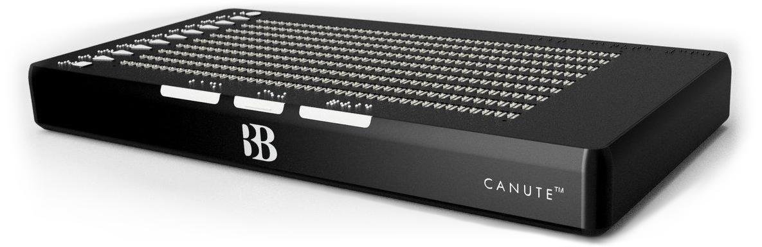
As a not for profit company, we have been sure to involve the wider community in our development process from the start. It would have been impossible to get to this stage without the active involvement and assistance of over 500 Braillists. Our philosophy has always been to share our progress (and our miss-steps) with the community, and to date, hundreds (if not thousands) of people have got their hands on our prototypes at shows and events.
We first introduced a very early Canute prototype to ICEB at the 2016 General Assembly in Baltimore, before showing off a more advanced pre-production prototype at the 2018 mid-term in Dublin. Since Dublin, we have been focussing on fine-tuning our technology and preparing for mass production. While it’s been slow going at times, and many of the changes we have made appear uninteresting (for example changing the manufacturing techniques employed for small internal components), the cumulative effect of our tinkering has been that we are preparing to send our first production units out to distributors (including APH and the CNIB) for pre-sale testing in early June.
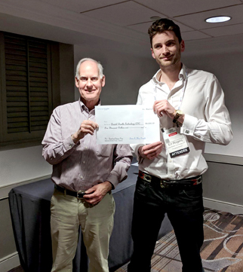
A particular source of pride for the team came in March 2019, when we were awarded the National Braille Press Louis Braille Touch of Genius Award (“an annual award for the project or projects that show the most innovative idea in the fields of Braille and tactile literacy”) jointly with BrailleSheets from Objective Education for our work on Canute 360. Brian Mac Donald, president of the National Braille Press, said: “This new braille display is like a Kindle for the blind and is undoubtedly an innovative game-changer and will only push forward braille literacy.”
Brian Mac Donald (National Braille Press) and Ed Rogers (Bristol Braille)
As we move forward into full production (we’re sending our first Canute units out to distributors imminently), we’re excited to continue to share our progress with the community. Later this year we’ll be at the NFB convention in Las Vegas, as well as the Sight Village shows around the UK. Of course, we particularly look forward to catching up with our friends in ICEB at the London General Assembly next year. APH will also be showing off Canute 360 around the United States. If you see us at a show, come and say hello, and have a feel of Canute 360 for yourself!
- Liam Smyth, Bristol Braille Technology

Recent events

Australian Braille Authority Annual Meeting and workshop
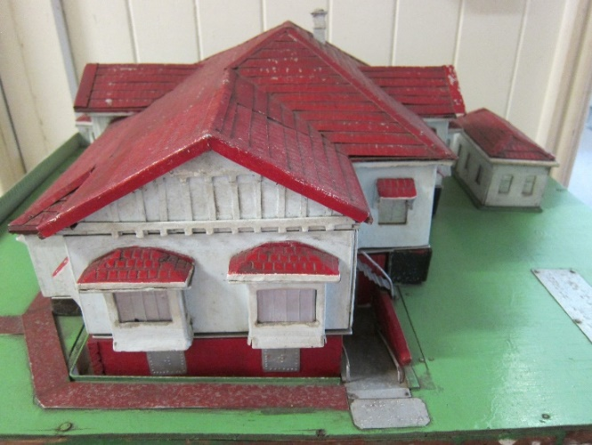
The Australian Braille Authority (ABA) is a subcommittee of the Round Table on Information Access for People with Print Disabilities, an umbrella organisation for accessible format users, producers, suppliers, teachers, technology suppliers, universities and public institutions throughout Australia and New Zealand. Each year, ABA holds its Annual Meeting on the first day of the Conference and hosts a workshop. This year, the meeting was held at historic Braille House in Brisbane, where we were treated to a tour of their facilities including Australia’s only collection of books in Moon type.
Tactile model of Braille House
made by R. F. Tunley
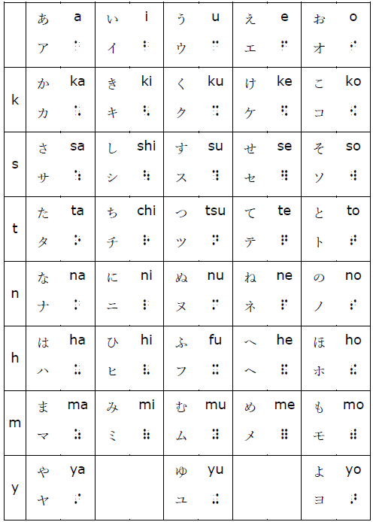
At the meeting and workshop we were pleased to launch the ABA Guidelines for Foreign Language Materials, explaining how to apply the UEB rules for treatment of foreign language text according to the type of text and intended audience. An appendix gives information on how the Duxbury Braille Translator may be used to implement each approach. A series of additional documents were also launched with advice on the treatment of specific languages in a UEB context: French, Italian, German, Spanish, Japanese and Latin. The documents can be downloaded in print or braille from the ABA website at http://brailleaustralia.org/unified-english-braille/languages/. Our thanks are extended to the many braille transcribers, proofreaders, teachers and readers who contributed to the guidelines, and in particular Kathy Riessen for leading the work.
Japanese braille chart
- Leona Holloway, Australian Braille Authority

Braille Literacy Canada Annual General Meeting
The 2019 AGM of Braille Literacy Canada (BLC) was held at the Novotel North York Hotel in Toronto on the afternoon of May 4th. Uniquely this year, the AGM took place in conjunction with the semi-annual meeting of the Braille Authority of North America (BANA). There was lots of braille enthusiasm in that building, and several BLC members enjoyed sitting in as observers. What an excellent reminder that all around us are people who are equally passionate and working hard on issues of importance to the ever-vibrant braille reading community!
For more information about BLC please visit www.brailleliteracycanada.ca or email us at info@blc-lbc.ca.
- Jen Goulden, President, Braille Literacy Canada

South African Braille Authority meeting
The South African Braille Authority (SABA) held its eleventh General Assembly on 16 and 17 May. Deviating from the three previous Assemblies where we had breakaway groups discussing various subjects, 2019 saw an all-engaging plenary programme for the duration of the Assembly. This was aimed at holistically discussing matters in the presence of everybody so that sufficient inputs can be solicited from everyone. Among other matters, the programme entailed:
Discussions on the proposed amendments of the constitution; report on the 2020 ICEB General Assembly; braille music; matters in relation to the public relations of ICEB; partnership training report; and World Read Aloud Day and the Braille Cup Competitions. As expected, resolutions were taken and those that need the attention of ICEB shall be forwarded for consideration to the relevant structures.
The Assembly also took note of the 2019 General elections, which saw the introduction of a longer Universal Ballot Template (UBT) [48 parties] participating on national elections. Depending on the province, between 21 and 36 parties participated. For the first time, the Independent Electoral Commission (IEC) contracted one of SABA’s members, Blind SA, to produce party lists in braille which, ideally, should have been made available in all voting districts. It was unfortunate that many of these lists could not make it to the stations, thus playing against the voters who wanted to use the template and, consequently, infringing on the right of privacy and independence of those voters.
We must also register great strides in starting the process of setting up a braille museum, which will be housed at the South African Council for the Blind (SANBC) in Brooklyn, under the title of one of South Africa’s stalwarts, Josie Woods. This will be a great step leading up to the realisation of preserving braille and its attributes. We must thank SANCB for affording us an opportunity to work together and to utilise the resources.
Finally, SABA extends its gratitude to Pioneer Printers for hosting the 2019 General Assembly.
- Ntshavheni Netshituni, President, South African Braille Authority

People
This issue, we pay tribute to a quartet of esteemed contributors to braille and ICEB who are retiring. All have played instrumental in the development of Unified English Braille and/or its implementation.

Darleen Bogart
Darleen Bogart was Chair of the Braille Authority of North America in 1991 when a letter was brought to the board from Drs Tim Cranmer and Abraham Nemeth explaining the problem of multiple braille codes across literary and technical material. The BANA board proposed that the newly formed International Council on English Braille take over the project to further unify the braille code across countries as well as content. Darleen was appointed as Chair of the UEB Project. “I thought it would take five years,” said Darleen, but the complexities involved meant that UEB’s development in fact took more than ten years, with Darleen as a key driver of progress throughout that time.
Darleen Bogart
Darleen was first “bitten by the braille bug” in 1961 when she volunteered for CNIB, where she began as a braille transcriber then went on to coordinate their many volunteer braille transcribers. Darleen taught correspondence courses across the country and taught a braille course every year at the CNIB for sighted people to learn to transcribe braille.
This May marked Darleen’s last BANA meeting as CNIB’s representative. Her commitment was rightly acknowledged with a presentation of testimonials from the many people she has touched on her braille journey.

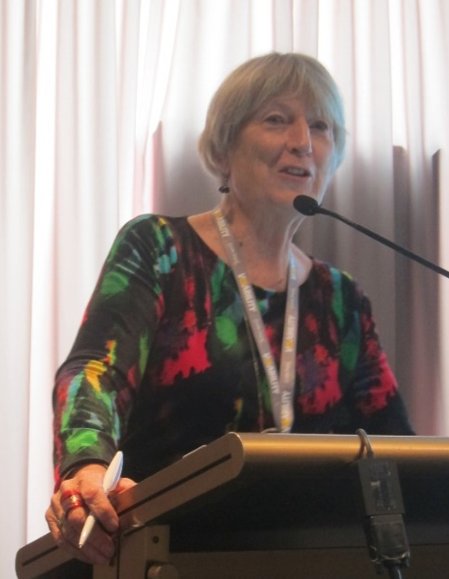
Josie Howse
Josie Howse has announced her retirement as Manager of State Braille and Large Print Services in New South Wales, Australia, after 40 years the field of education for children with vision impairment.
Josie has served on the executive of the Australian Braille Authority since 1986, including two separate terms as Chair. She was the editor of the Braille Primer: Australian Edition, going through several editions to the Unified English Braille: Australian Training Manual (2016). These documents have long served as the primary tool for sighted people to learn braille in Australia. More recently, Josie has been instrumental in the creation of the free UEB Online training program used worldwide and the new UEB Math Online.
Josie Howse
Josie has been an Australian delegate to all six General Assemblies. She was on the steering committee for the first edition of the Rules of UEB and a member of the working party which drafted and published the first edition of the Guidelines for Technical Material in 2008.
Qualified with a Masters in Special Education, Josie’s focus has always been on quality braille education. She has conducted countless workshop to improve the braille skills of vision specialist teachers throughout Australia. For decades, she has spent her evenings and weekends marking braille correspondence course materials. She has chaired the ABA Examinations board for the annual braille proficiency certificate. And throughout the development and implementation of UEB she has fought for a code that is easy to read and learn for young touch readers of all abilities to ensure its continued use in an integrated education setting.
We thank Josie for her leadership, passion and dedication.
- Leona Holloway, Australian Braille Authority

Stephen Phippen
Stephen Phippen retired at the beginning of June. We would like to express our sincere thanks to him for a lifetime of devotion to the dots.
Stephen started his career at RNIB back in 1981 and has seen many changes in both the national and international braille scene over the last 38 years. He was one of the original trustees of BAUK (the Braille Authority of the UK) when it was founded in 1990 and subsequently became its secretary. Upon the formation of ICEB in 1991, Stephen was appointed as Chair to two committees: Mathematics Braille and Print Symbols. He then became the UK’s representative to ICEB’s Unified Braille Code Committee, which was responsible for constructing the symbols of UEB and the rules for their use.
Stephen Phippen
In 2009 BAUK merged with two other organisations to form a cross format standards organisation (braille print and audio) known as UKAAF (UK Association for Accessible Formats). Stephen has been an active member of the braille coding group since then and his knowledge was key in producing a number of advisory documents after the implementation of UEB in the UK, particularly the foreign language, maths and Welsh guidelines.
We will miss his extensive knowledge, experience and intelligent observations on all our braille related discussions and we wish him well for a long and happy retirement.
- Mandy White, UK Association for Accessible Formats

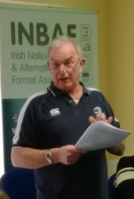
Pat Farrell
After having dedicated 42 years of his working life to high quality braille transcription in Ireland, Pat Farrell is retiring in June 2019.
Pat became interested in braille when working as a prison officer in Dublin’s Arbour Hill prison in the 1970s and was later manager of its braille unit until 2005, providing educational and commercial transcriptions. He then joined the National Braille Production Centre at St. Joseph’s Centre for the Visually Impaired (now Reading Services at ChildVision) and transcribed hundreds of textbooks for children in mainstream and special education in Ireland.
Pat Farrell
His braille expertise and tremendous transcription speed led Pat to become one of only two transcribers to work for the Irish State Examinations Commission for several weeks each year, transcribing all state examination papers into braille for the last 21 years.
To allow equal access to and strengthen the use of Irish braille, Pat researched the historical codes for Irish and devised the current Updated Irish Braille code (UIB). This work was supported by the Irish Braille Authority (INBAF) through its Irish Braille working group. UIB was adopted in 2013. This code works hand and hand with UEB, sharing punctuation and special signs, while, for the first time offering Irish word signs that users have described as “intuitive”.
Pat represented Ireland at ICEB’s 2016 GA and was one of the organisers of the 2018 Mid-term meeting in Dublin. We wish him a long and happy retirement and hope that INBAF and ICEB will continue to profit from his passion for braille.
- Irish National Braille and Alternative Formats Association (INBAF)

Calendar of Upcoming Events

Africa Forum – Addis Ababa, Ethiopia, October 2019
Africa Forum is Africa’s premiere conference for blindness activists, leaders and community. The 5-day program is open to any individual or organisation with an interest in blindness in Africa. It offers opportunities to learn, network and contribute to the future of disability advocacy in Africa.
The 7th Africa Forum will focus on achieving equality in education through innovation, access and lifelong learning. It is scheduled for 7-11 October 2019 in Addis Ababa, Ethiopia. Information and a link to registration are available at www.perkins.org/get-involved/events/africa-forum.
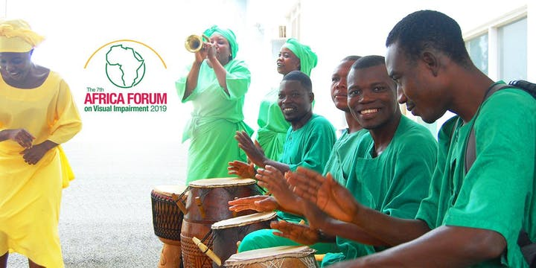

NBA Professional Development Conference – USA, October 2019
The National Braille Association holds an annual Professional Development Conference with workshops to learn more about braille code revisions, new techniques, software, hardware and production equipment. The next Conference will be held in Phoenix, Arizona from October 30 to November 1. Registration is now open at www.nationalbraille.org/professional-development-conference/.

Getting in Touch with Literacy – USA, November 2019
Getting in Touch with Literacy is a national conference on all forms of literacy, including print, braille, auditory, tactile graphics comprehension and the use of assistive technology. The proceedings include presentations, workshops and poster sessions.
The 2019 Conference will be held from 13-17 November in Seattle, Washington. Registration is now open at http://gettingintouchwithliteracy.org/ .

SPEVI Conference – Adelaide, Australia, January 2020
The South Pacific Educators in Vision Impairment (SPEVI) hold a Biennial Conference offering Australian, New Zealand, Pacific Island and international leaders, professionals and parents/carers the opportunity to share information and ideas about current and emerging services, programs, technologies and resources for children and adults who are blind, have low vision, deaf-blindness, or additional disabilities. The next SPEVI Conference will be held in Adelaide, South Australia, from 12-15 January 2020. The call for abstracts has been extended until 30 June and registrations are now open at https://synergyevents.eventsair.com/spevi-2020/.

ICEB General Assembly – London, England, May 2020
ICEB holds a General Assembly once every four years. The next General Assembly will be held in London from 11 to 15 May 2020.
More details on the General Assembly, along with a call for papers, will be distributed via the ICEB communication channels listed at the end of this newsletter.

WBU-ICEVI Joint Assembly – Madrid, Spain, June 2020
The World Blind Union (WBU) and International Council for Education of People with Vision Impairment (ICEVI) will hold their third joint General Assembly at the Hotel Marriott in Madrid, Spain, from 19 to 24 June 2020. The proceedings will include two days of paper presentations from 23 to 24 June, with abstract submissions due by 30 September. For more information and registration, see http://icevi.org/conferences/.

UEB Q&A
In answer to our earlier question, the grade 1 terminator should be placed before the final hyphen.
Braille: ;;t-t-t-t-t-t;'-tn
Explanation: The grade 1 terminator is inserted in order to use the shortform for "tonight". If the terminator follows the final hyphen, the shortform will not be standing alone (2.6.2) and cannot be used. See also the Rules of Unified English Braille 5.5.1 and 10.9.1.

ICEB Contact Details
Website: www.iceb.org
Email: info@iceb.org
Twitter: @ICEBbraille
Facebook: www.facebook.com/ICEBbraille/
ICEB-announce list:
Send an email to iceb-announce+subscribe@groups.io to receive announcements from ICEB, including this newsletter and notifications regarding updates to Unified English Braille.

