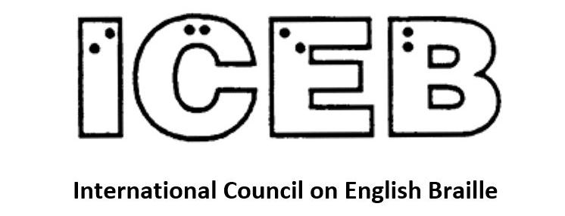

ICEB Newsletter
Issue 5, December 2019

Welcome
In this issue, we are pleased to present a special focus on braille research.

ICEB

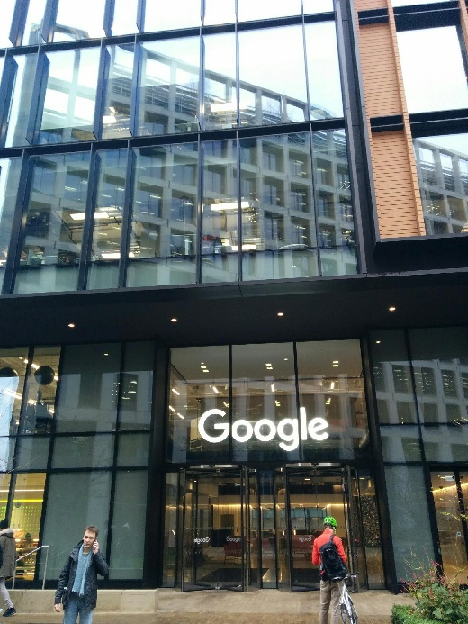
ICEB 7th General Assembly 2020
The International Council on English Braille (ICEB) will hold our 7th General Assembly from Monday 11 May to Friday 15 May 2020 at the Google Academy in central London. The focus for the week will be on braille as an exciting and relevant code for the future, particularly digital braille.
The call for papers has now closed. Presentations and poster presentations will be circulated prior to the General Assembly and then published on the ICEB website. Summaries will be presented at the Assembly and there will be a poster/demo session in an exhibition area as part of the General Assembly proceedings.
Each member country of ICEB is invited to nominate four delegates to the Assembly. Observers are also warmly welcomed. The recommended hotel for accommodation is the Premier Inn in London Victoria. Bookings to be made directly with the hotel.
The full program will be released at the end of January, at which time registrations will open via www.ukaaf.org. Further details will be posted to http://iceb.org as they become available. We hope that you can join us.

Unified English Braille

Revised rules for quotation marks and the apostrophe
ICEB is pleased to announce the release of revised rules for the use of quotation marks and the apostrophe, replacing section 7.6 of the Rules of Unified English Braille.
We have simplified old the rule, removing the concepts of “nonspecific” and “predominant” quotes. Instead, double quotation marks are represented by lower h 8 and lower j 0, while single quotation marks are represented by dot 6, lower h ,8 and dot 6, lower j ,0. We have emphasized the importance of the apostrophe in braille. There is an expanded section on avoiding ambiguity and a section has been added to give guidance for software developers. There are also several new examples.
The revised rule is the result of over five years of brainstorming, consultation and careful analysis by the UEB Code Maintenance Committee. The original problem arose from a desire to distinguish properly between the closing single quote and the apostrophe. Print often does not make a distinction and print readers have no problem interpreting the meaning from context. However, use of the wrong symbol can be quite disruptive for braille readers, who often see a two-cell closing single quote when a dot 3 for the apostrophe should be used. Transcribers were also frustrated with having to spend so much time editing material in order to ensure apostrophes appear in their proper place.
While we were unable to find a perfect solution that would meet the needs of all stakeholders, we believe that the revised rule is the best possible solution and will serve us well into the future. The revised rule can be downloaded in print and braille from the ICEB website at http://iceb.org. It took effect on 8 October 2019 for immediate use.
- Phyllis Landon, Chair of the UEB Code Maintenance Committee

Quotes and apostrophes in DBT – A transcriber’s perspective on implementation of the revised rule 7.6
The Duxbury Braille Translator (DBT) is commonly used for professional braille transcription.
In accordance with new rule 7.6.14, DBT already has an extensive dictionary allowing automatic recognition of the apostrophe at the beginning or end of abbreviated words such as ‘tis and nothin’. DBT also uses algorithms to determine the difference between single quotation marks and apostrophes as per 7.6.15.
It should be noted, however, that translation of quotation marks and apostrophes is most successful in DBT if text input has been performed using Word with Smart Quotes. This is because DBT will always translate the straight single quote or apostrophe (Unicode 0027 or ASCII 39) as the dot 3 apostrophe or non-directional single quote. In the rare instances when the non-directional double quote, (Unicode 0022 or ASCII 34) is required to be shown in braille as per 7.6.5, the code [ucl1~"] is needed before its use.
By default, DBT translates the first quote encountered as a single-cell double quote, regardless of whether it is a double or single quote. The opposite form will then be translated as a two-cell single quote. If the first quote encountered is single, and you don't want DBT to change the assignment of single and double quotes as per 7.6.4, insert the [uoq~"] code at the beginning of your document.
We await news from Duxbury Systems regarding updates to DBT to further support the revised rules.
- With thanks to Kathy Riessen, Coordinator Accessible Format Production, South Australian School for Vision Impaired (SASVI). She is happy to be contacted at Kathleen.Riessen@schools.sa.au if anyone wishes for more detailed instructions.

Liblouis implementation of the revised rule 7.6
LibLouis is Open Source braille translation software that is used within many other technologies such as Braille Blaster, JAWS, NVDA and refreshable braille displays.
The basic symbols for quotation marks and the apostrophe are already set correctly in LibLouis, however this relies on the correct Unicode symbols being entered in print.
There is currently no option to switch the symbols for the double quote and single quote, as allowed in revised rule 7.6.4. Furthermore, the symbols for angle quotation marks are not yet available in LibLouis. A dictionary with additional rules will be required to improve recognition of the apostrophe.
ICEB is working to assist in implementing the required changes to LibLouis. Considering the time lag between LibLouis version updates and implementation in screen readers, it is hoped that the revised UEB rules and improved translation will be available for use by mid-2020.
- James Bowden, Chair of ICEB Braille Technology Committee

Online UEB Study Group for International Braille Transcribing Students
With the adoption of Unified English Braille, students learning braille transcription worldwide can study together. The “Literary Braille Transcribing Study Group” study group on Facebook is a community of students working on becoming certified braille transcribers.
This study group offers free, instantly downloadable UEB study material in a Google Drive:
- Flashcards, quizzes and reference sheets
- Student user’s guide for Perky Duck software
- List of free online UEB courses
These study materials were created by students and professionals who are passionate about braille. Thank you very much to everyone who has shared files with this group! And if you have any documents to contribute, please upload them to the “Submissions Folder” in the Google Drive. We’re particularly looking for worksheets that cover the various wordsigns and groupsigns. Students worldwide will thank you!
After you’ve downloaded some free UEB study material, please say hello in the “Literary Braille Transcribing Study Group” on Facebook. Currently the majority of the group is made up of students going through the American UEB certification course, but we are all about helping each other learn the rules of UEB, regardless of where you live. The philosophy of this study group is that there’s no such thing as a stupid question. Everyone is welcome, whether you are on lesson one or working on your final project.
In this very active study group you’ll find students asking questions and encouraging each other to keep studying. There are also dynamic discussions about proofreading advice, technical support (like how to print in SimBraille in Perky Duck), as well as announcements for upcoming braille transcriber conferences and applicable scholarships.
The “Literary Braille Transcribing Study Group” is studious, but we also like to have fun!
Please join us for the January Braille Reading Challenge, which is where you read a fun book in braille for 10 minutes a day, 5 days a week. The idea is that the more fluently you read braille, the easier it will be to focus on learning how to transcribe.
In the spring we’re having a Facebook Live Braille Trivia Night, as well as a Bullet Journal Challenge as a fun way to practice using a slate and stylus.
Every September is the annual UEB Graduation Party. It’s important to celebrate the students who have worked so hard to earn the title of certified braille transcriber. If you can, try to finish your UEB certification before September 15 2020 so that you can be in the graduate slideshow and get your name on the cake! There will be games and prizes!
Please tell your friends about the “Literary Braille Transcribing Study Group” on Facebook and the Google Drive account that’s full of free study material. And if you have any files that you’d like to contribute, please upload them to the Google Drive account. Thank you in advance! Let the international study party begin!
- Elizabeth Symington, creator & admin of the Literary Braille Transcribing Study Group

UEB Math Online
UEB Online is a free online training course for print and touch readers to learn Unified English Braille. We are pleased to report that ten new lessons have been released this month covering Advanced Mathematics, the symbols and expressions encountered during the junior years of secondary schooling. This module is an extension of Introductory Mathematics, which must be completed first.
Extension Mathematics lessons covering mathematical symbols and expressions used in the senior years of secondary schooling are in development, with an expected release date in the first half of 2020.
Thanks are extended to the Royal Institute for Deaf and Blind Students, RIDBC Renwick Centre and Macquarie University for their support in producing and administering this course for braille learners worldwide.

UEB Q&A

Problem words – long prefixes bridging OF
Continuing ICEB’s work on determining the correct use of contractions in unusual or scientific words, this issue we look at use of the OF contraction in words with long prefixes:
griseofulvin griseo;lv9 FUL contraction
ichthyofauna i*?yofauna no OF
Islamofascist ,islamofasci/ no OF
mycroflora mycroflora no OF
myelofibrosis myelofibrosis no OF
neurofibril neurofibril no OF
neurofibroma neurofibroma no OF
neurofibromatosis neurofibromatosis no OF
nitrofuran nitrofuran no OF
profluent pr(lu5t OF is used
synchroflash syn*rofla% no OF
turbofan turbofan no OF

Test your UEB knowledge!
How would you braille the following example? In particular, should the second numeric indicator be placed before or after the numeric space?
12 345
[Twelve thousand three hundred and forty five with underline for the 12 and a space before the 3.]
Check near the end of the newsletter for the answer.

Braille research
ICEB’s newest committee is dedicated to monitoring and sharing braille research. The ICEB Braille Research Committee will present a summary of recent research at the ICEB General Assembly in London 2020. Here, we are pleased to share a glimpse at some of the work currently underway worldwide.

Braille reading hand movements
Researchers have studied the specific ways the eyes move when reading for more than 40 years. These studies have provided information on specific eye movement characteristics and the differences between highly fluent readers and readers with disabilities such as dyslexia. Similarly, the way tactile readers move their hands has been considered important to reading braille. Although far less research has been conducted on the topic of hand movements related to reading braille, the limited and sometimes contradictory research points to a correlation between hand movements and reading speed. Unlike eye movements in print reading, braille readers can be taught to move their hands in more efficient ways while reading braille which provides a unique avenue for intervention.
Two researchers, Tessa McCarthy from the University of Pittsburgh and Robert Wall Emerson, from Western Michigan University, are currently conducting a study in an attempt to learn more about the hand movements of adults who read braille using both visual analysis and an Optotrak. The data from this analysis has allowed us to collect dynamic data on the x, y, and z coordinates of each finger during braille reading at a rate of 20 frames per second. This highly detailed information will hopefully provide information on hand movement patterns as a whole as well as how each individual finger contributes to reading braille.
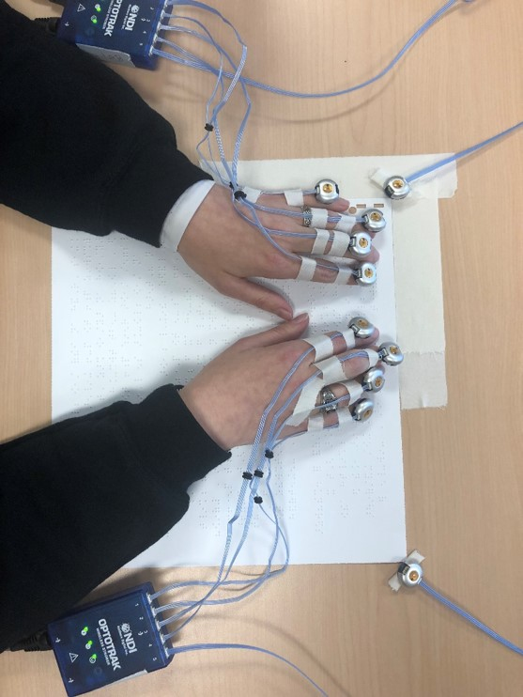
For more information related to this project, please contact Tessa McCarthy at tessam@pitt.edu.
- Tessa McCarthy, University of Pittsburgh

Braille reading rates of children in Australia and New Zealand
Research was carried out around Australia and New Zealand addressing the oral reading fluency rates of Braille and dual media school aged students. Seventy three students were assessed and results were compared to sighted students reading norms.
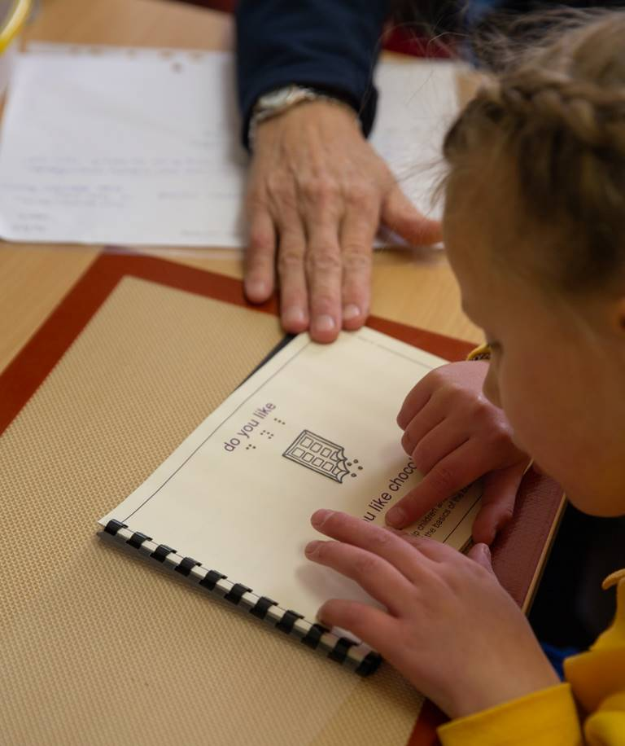
Findings were consistent with other studies carried out in the United States of America. Except for one student, all Braille and Dual Media students assessed were behind their sighted peers in Oral Reading Fluency (ORF).
As a result of this research, resource development is being carried out to develop braille knowledge for parents of young blind students so they can read and understand the UEB code while their child is very young.
Further information and free resources can be found at https://dapdots.ridbc.org.au/.
- Tricia d’Apice, Royal Institute for Deaf and Blind Children, Australia

BrailleBlocks: Smart Toys for Collaborative Braille Education
Researchers in the Superhuman Computing Lab at the University of Colorado, Boulder are creating smart toys to help blind or visually impaired children learn Braille both independently and collaboratively. BrailleBlocks, the most recent development in this project, is a system for visually impaired children and sighted parents to practice braille through blocks and a web application with associated learning games. Each block represents a single braille cell and children can place pegs in the holes to create braille letters and place blocks together to create words. The web application includes games such as Hangman, Word Scramble, and an animal sound-based game. The educational games encourage children to work on spelling, recognize letters through touch, and build vocabulary. The system uses an overhead webcam to track the blocks. The child’s answers are displayed on the interface for parents to track learning.
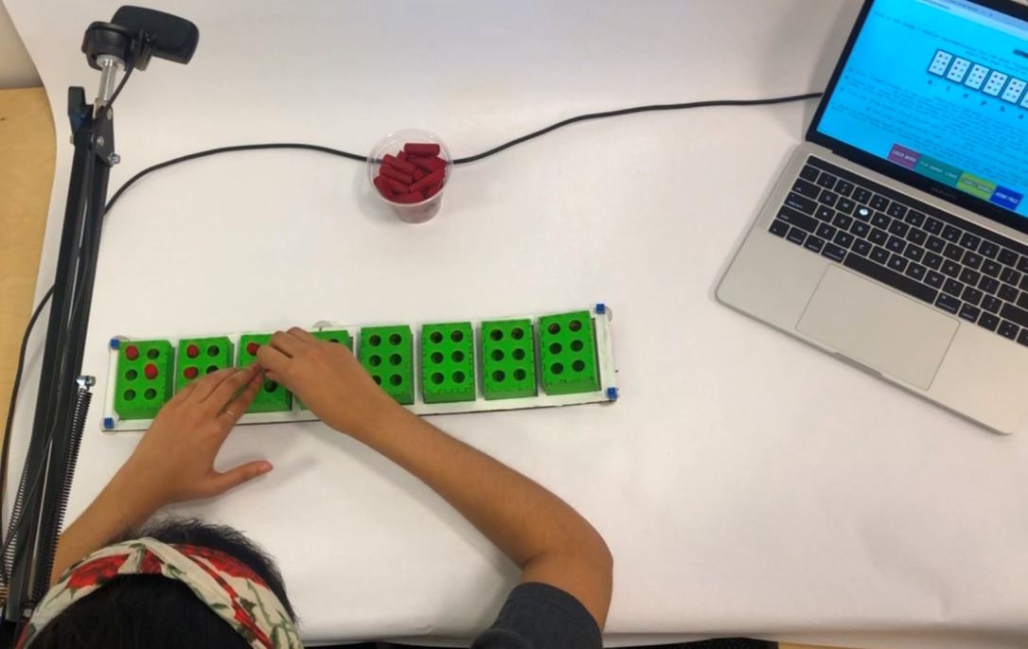
We conducted usability studies with sighted parents and visually impaired children to explore how they taught, learned, and collaborated using BrailleBlocks. Families used the system to practice spelling and to prompt critical thinking through guessing games. The interactive audio, like the animal noises and buzzer sounds in Hangman, made children laugh and want to continue playing with the system. Parents commended the visual feedback from block tracking as a way to check their child’s learning. Children also used the blocks to build structures during imaginative play and storytelling.
More information on the study and system can be found in BrailleBlocks: Braille Toys for Cross-Ability Collaboration. Please contact Vinitha Gadiraju at vinitha.gadiraju@colorado.edu for questions or information about this work.
- Vinitha Gadiraju, University of Colorado, Boulder

Tactile schematics
Schematics, or circuit diagrams, are a visual blueprint of electronic devices. They show the relationships between components and are used to understand and build circuits. Sighted learners use schematic images, while blind and low vision learners use circuit descriptions. Circuit descriptions are complex audio descriptions of how a circuit is configured. No tactile graphical representation had yet been able to compete with circuit descriptions—this pain point became the inspiration for our design research. We found that designing discernible tactile schematics was more difficult than expected since they possess small elements and complex relationships, while needing to follow industry standards.
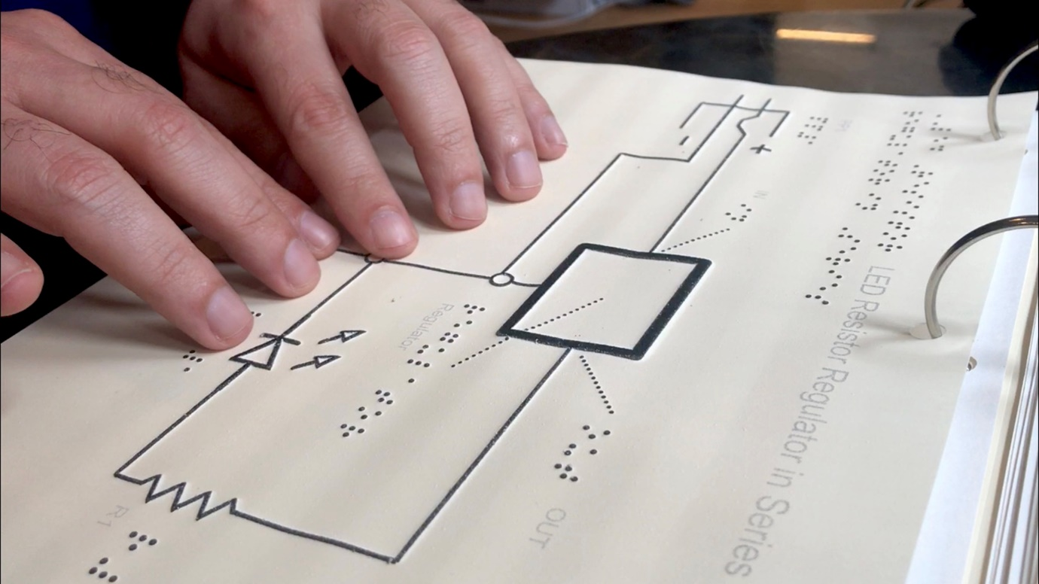
We conducted iterative design activities with non-visual designers, blind and low vision students, and physical computing instructors to create an improved set of tactile schematic symbols and nine guidelines for novices to create readable tactile schematics. A workflow and style guide with templates, for novices wanting to design their own tactile schematics, as well as all 50+ tactile schematics are available to the public, as a free download, at tactileschematics.com.
- Lauren Race, NYU Ability Project

Braille technology

Orbit Teacher
Orbit Research, the makers of the Orbit Reader 20 refreshable braille display, are pleased to share news of a new app to support braille use.
The Orbit Teacher platform enables teachers in mainstream classrooms to seamlessly interact with blind students through an app on a smartphone, computer or tablet. The app connects over Bluetooth to the student’s Orbit Reader 20 braille display and provides a real-time text translation of the braille being read or written by the student on the device.
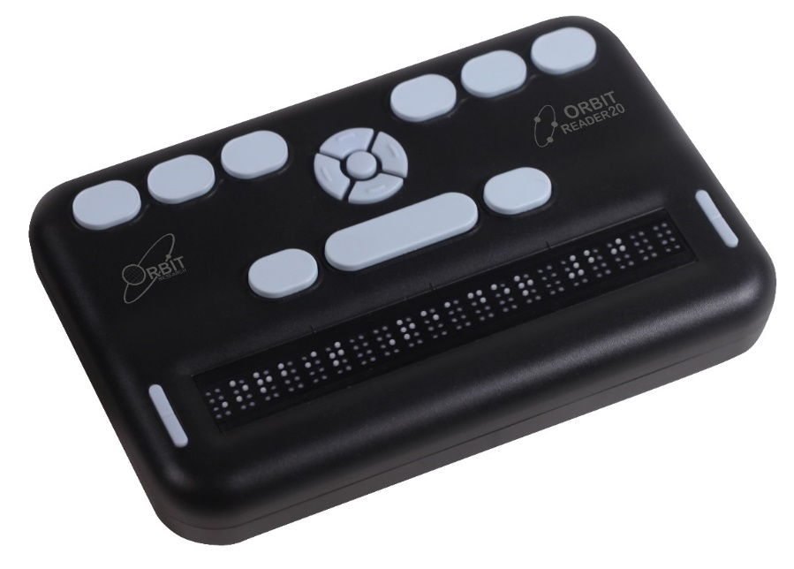
The platform also provides a student the ability to first learn braille (if they are not braille users) and then to learn other subjects using braille. Through specialized interfaces on Orbit’s braille and tactile graphics products, and software that runs on computers and smartphones or tablets, the platform provides the breakthrough ability to develop and deliver educational materials in the form of interactive lessons and tutorials that can be administered under a teacher’s (or parent’s) supervision, or by the students themselves, in a self-paced mode. The platform also provides remote operation capabilities allowing a teacher to easily provide instruction to students in remote locations.
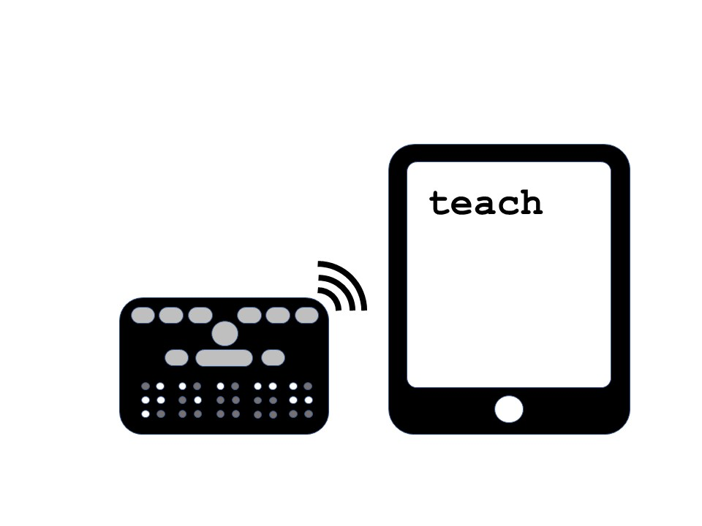
The platform includes content authoring tools that allow anyone to create interactive lessons and tutorials, with minimal training. Existing books and materials can be easily ported to the Orbit Teacher platform. While designed for both blind and deaf-blind users, the tutorials can also take advantage of audio and speech capabilities from the smartphone, PC or tablet to provide audio cues and feedback to the student when used in the interactive self-learning mode. The platform is capable of supporting over 40 languages and also offers the ability to translate to and from contracted braille, including UEB. The basic version of the app, which includes the real-time teacher interaction features, is available for free download at www.orbitresearch.com/product/orbit-teacher.
- Venkatesh Chari, Orbit Research

People

Congratulations, Dr Robert Englebretson
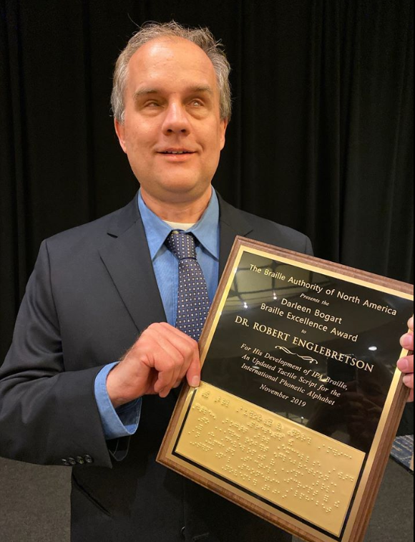
Congratulations are extended to Dr Robert Englebretson, who was awarded the Darleen Bogart Braille Excellence Award by the Braille Authority of North America (BANA) at the recent Getting In Touch with Literacy Conference. BANA created its Braille Excellence Award in honour of Louis Braille’s 200th Birthday. This year, the award was renamed the Darleen Bogart Braille Excellence Award in honour of the retirement of Darleen Bogart, who was one of BANA’s founding members and has also served as ICEB President and UEB Project Committee Chair.
The award recognises Dr Englebretson’s work with ICEB to develop IPA Braille. The International Phonetic Alphabet (IPA) is a notation system for representing speech sounds. Unfortunately, it was not international in braille, with two competing braille codes that did not cover all of the print symbols. From 2005 to 2010, Dr Englebretson served as the USA representative to ICEB’s UEB Committee for Foreign Languages and Linguistics, under the auspices of which he developed IPA Braille. This new code is up-to-date and complete, enabling standardised access to the IPA for blind students studying linguistics. The IPA is also commonly used in dictionaries and by singers. Dr Englebretson recently spoke about his work on IPA braille in an interview with Texas Public Radio, when he stated "We hope that it will empower more students to pursue their interests and the careers they wish to pursue". You can find the braille IPA at http://iceb.org/icebipa.htm.
Attendees at ICEB’s most recent General Assembly will recall that Dr Englebretson delivered a fascinating keynote address titles “Braille and the Brain: What we Know and Why it Matters”. Dr. Englebretson is Chair of the Linguistics Department at Rice University in Houston, Texas. He has developed and teaches a course that examines research on braille reading and writing from the perspective of the cognitive sciences. He is currently collaborating on a major research project designed to explore the knowledge, skills, and strategies teachers of students with visual impairments need in order to effectively teach braille reading and writing.

Recent events

Africa Forum
The 2019 Africa Forum Conference on Visual Impairment, themed: “Achieving the SDGs through Innovation, Access and Lifelong Learning” was held in Addis Ababa, Ethiopia, the “land of origin”, from 7 October to 11 October, 2019. The Conference started with a special gathering (grand opening) which was hosted by the African Union, at the AU Headquarters in Addis. The minister of Labour and Social Development graced the delegates with her presentation which, among other things, appreciated the organisers and the African Union of the Blind for choosing Ethiopia as their temporary home for the 2019 seventh Africa Forum.
The subsequent days (8 October to 11 October) were filled with various interesting presentations, including key note addresses on each day during plenary. Presenters pervaded their presentations along different subjects on visual impairment, including teaching and learning; technologies of the visual impaired; early childhood development; preservation of braille; and complementing braille with technology. Papers were presented on four languages, namely: English (predominant); Amharic (the native language); French and Portuguese. This was the largest conference of the blind ever held on the African soil, with 46 African countries having sent 450 souls to fill up the Intercontinental Hotel. Thanks to the Perkins School; African Union of the Blind; CNIB Foundation; Ethiopian National Association of the Blind (ENAB) and the Ethiopian government, amongst other sponsors, for having carried the load in the organization and bringing together all the delegates under the same roof with such success.
It is important to also note that from this conference are resolutions that speak to African countries. African countries were, as a manner of resolving, called on to “ratify the Marrakesh Treaty to facilitate access to published works for persons who are blind, visually impaired or otherwise print disabled”. We have seen several countries ratifying the Marrakesh Treaty in Africa, but more than those who had ratified are under the sword of this important resolution.
For more information about the Africa Forum, visit: https://www.perkins.org/get-involved/events/africa-forum/slides
- Ntshavheni Netshtituni, South Africa

CNIB’s Connecting the Dots Conference
I was excited to attend the “Connecting the Dots” conference in Toronto at the end of October. This used to be called “The Braille Conference” but CNIB has changed the name and is hoping to hold conferences in locations across Canada in 2020. Several members of Braille Literacy Canada presented at the conference and shared information about BLC with attendees. I especially enjoyed listening to the winners of the CNIB braille creative writing contest as they read their wonderful stories and poems at a lunchtime session for all participants. I love knowing that the next generation is passionate about braille!
I co-presented a workshop on the Canute 360. The session was well-attended and there is a lot of interest in this unique braille display. I also had the opportunity to attend interesting workshops on employment, as well as on blindness and mental health. There were three sessions focused specifically on the braille code. One of these looked at the “standing alone” rule and another dealt with formatting of technical material. Phyllis Landon, the CMC Chair, also did a session on the recent updates related to quotes and apostrophes.
I always love having my workshop numbers brailled on my name tag and having programs and presentation handouts available in braille. I wish all conferences offered these services!
- Kim Kilpatrick, Canadian Council of the Blind

National Braille Association Conference (USA)
Each fall, braille transcribers and teachers of the visually impaired gather for three days of training on Unified English Braille, Textbook formatting, Nemeth, and much more. The conference provides an opportunity for accessible media producers to learn face-to-face from leading experts in braille on an array of topics. This year’s conference was held in Phoenix, Arizona. I personally attended three fantastic workshops providing guidance on certain aspects of transcribing UEB braille that can be a little tricky, such as keying legends for tactiles and the integration of Nemeth within UEB contexts. This conference was a great opportunity to network with professionals in the industry. This event was also very informative and has helped my professional development.
- Jessica J. Blouin, T-Base Communications

Getting in Touch with Literacy
The 14th biennial Getting in Touch with Literacy conference was held in Seattle, Washington, USA, November 13-16, 2019. This beloved conference features presentations that are focused solely on literacy for children and adults with visual impairments. As the conference planners state, "We believe: It is important to focus on all areas of literacy including braille, print, combination of braille and print, use of assistive technology and other literacy tools, research, practice. The conference is not a 'braille literacy conference' though some have tried to define it as such--it is a conference that includes underlying respect for all forms of literacy. It is the belief of conference organizers that individuals with visual impairments have a right to respect for the use of all literacy tools.”
This year’s conference was well attended with almost 350 people from nine different countries participating. The agenda included 72 different concurrent sessions on topics as varied as early braille instruction, use of technology to support literacy, various approaches to literacy for students with complex support needs including CVI, and creating useful tactile graphics. Major Showcase Sessions featured topics such as dyslexia, problem-solving skills in reading, and being a thoughtful practitioner of literacy. In addition, 14 poster sessions and a full set of vendor exhibits allowed participants to mingle and talk about hot topics and new devices. Three special pre-conference in-depth sessions were also held: Gwyneth McCormack’s “Developing the Essential Early Life Experiences,” Karen Erickson’s “Literacy and Communication for Students with Complex Multiple Disabilities,” and APH’s “Using Code Jumper to Construct Narratives.
Mark your calendars for the next Getting in Touch with Literacy conference, December 1-4, 2021 in Tampa-St.Pete, Florida.
- Frances Mary d’Andrea, ICEB Research Committee Chair

Calendar of Upcoming Events

SPEVI Conference – Adelaide, Australia, January 2020
The South Pacific Educators in Vision Impairment (SPEVI) hold a Biennial Conference offering Australian, New Zealand, Pacific Island and international leaders, professionals and parents/carers the opportunity to share information and ideas about current and emerging services, programs, technologies and resources for children and adults who are blind, have low vision, deaf-blindness, or additional disabilities.
The next SPEVI Conference will be held in Adelaide, South Australia, from 12-15 January 2020. Registrations are open at https://synergyevents.eventsair.com/spevi-2020/.

ATiA 2020 – Orlando, Florida USA, January-February 2020
The Assistive Technology Industry Association holds an annual conference at the Caribe Royale Hotel and Convention Center in Orlando, Florida. The 2020 Conference will begin with pre-conference seminars from 28-29 January, to be followed by the Conference itself from 29 January to 1 February. Online registrations are open. See https://www.atia.org/ for more information.

West Asia Conference on Visual Impairment and Deafblindness – Lalitpur, Nepal, February 2020
Jointly organised by ICEVI West Asia and Sense International India, the West Asia Conference on Visual Impairment and Deafblindness has the theme “Inclusive Education: Leaving No One Behind”.
The conference will be held at the Nepal Administrative Staff College, Lalitpur from 16 to 18 February 2020. Please note that only 300 registration places are available.
More information is available at http://iceviwestasia.in/icevi-sense-india-national-conference/.

International Conference on Innovative Practices & Research for Education and Rehabilitation of Persons with Visual Impairment – Lucknow, India, February 2020
The goal of this International Conference is to deliver an outstanding program for exchange of ideas and authoritative views by leading eminent scholars which covers the entire spectrum of research in the field of visual impairment, their educational & rehabilitation and share the cross-cultural experiences of various intervention procedures. In addition to presentations and posters, an exhibition of assistive technology and a book fair will also be held during the conference days. The conference will be held from 26 to 28 February, 2020 in Lucknow, India. Online registration is available through the host organisation websites at dsmru.up.nic.in and www.nivh.gov.in.

CSUN Assistive Technology Conference – California, USA, March 2020
CSUN is the largest assistive technology conference worldwide, held annually. The 2020 conference will take place in Anaheim, California from 9 to 13 March. For more information, see csunconference.org or follow #CSUNATC20 on Twitter for the latest updates.

Round Table Conference – Melbourne, Australia, May 2020
The Round Table on Information Access for People with Print Disabilities is an umbrella organisation with 35 members from the print disability sector in Australia and New Zealand. Its next annual conference will be held in Melbourne, Australia from Saturday 2 May to Tuesday 5 May. Proceedings include the annual meeting of the Australian Braille Authority (ABA) and a braille workshop hosted by ABA.
More information is available at printdisability.org/conference/.

ICEB General Assembly – London, England, May 2020
The next General Assembly will be held from 11 to 15 May 2020 at the Google Academy in central London. Each member country of ICEB is invited to send up to four delegates and observers are warmly welcomed. One day of the Assembly will be devoted to paper presentations and an exhibition of braille innovations, technology and practice. For more details, refer to the start of this newsletter and iceb.org.

WBU-ICEVI Joint Assembly – Madrid, Spain, June 2020
The World Blind Union (WBU) and International Council for Education of People with Vision Impairment (ICEVI) will hold their third joint General Assembly at the Hotel Marriott in Madrid, Spain, from 19 to 24 June 2020. The proceedings will include two days of paper presentations from 23 to 24 June, with abstract submissions due by 30 September 2019. Registrations and a draft program are now available at http://icevi.org/wbu-icevi-general-assemblies-2020/.

AER Symposium Day – St Louis, USA, July 2020
The Association for the Education and Rehabilitation of the Blind and Visually Impaired (AER) has announced a Call for Proposals for the AER Symposium Day, to be held on July 23, 2020 as part of the AER International Conference. They are seeking workshops that are full day (7 hours) or half day (3.5 hours). Proposals for the Symposium are due January 15, 2020.
The Conference will bring together over 600 VRTs, Orientation and Mobility Specialists, TVIs, LVTs, advocates, scholars, policymakers, and other professionals. The Conference will take place July 22-26, 2020 at the St Louis Union Station Hotel, St Louis MO, USA. Further details can be found at https://aerbvi.org/professional-development/conferences/aeric2018/.

Vision 2020 – Dublin, Ireland, July 2020
Vision 2020 is the 13th International Low Vision Conference by the International Society for Low Vision Research and Rehabilitation. It will take place from Sunday 12 to Wednesday 15 July 2020 at The Convention Centre Dublin Ireland. Registrations and the call for papers are now open via vision2020dublin.com.

UEB Q&A
In answer to our earlier question, 12 345 should be brailled as:
_1#ab_'#"cde
Explanation: The terminator for underline also terminates numeric mode (6.3.1), so the numeric indicator is required to reset numeric mode. The numeric indicator precedes the numeric space because dot 5 only has the meaning of the numeric space in numeric mode. Also, the numeric space is always followed by a digit (6.2.1).

ICEB Contact Details
Website: www.iceb.org
Email: info@iceb.org
Twitter: @ICEBbraille
Facebook: www.facebook.com/ICEBbraille/
ICEB-announce list:
Send an email to iceb-announce+subscribe@groups.io to receive announcements from ICEB, including this newsletter and notifications regarding updates to Unified English Braille.

