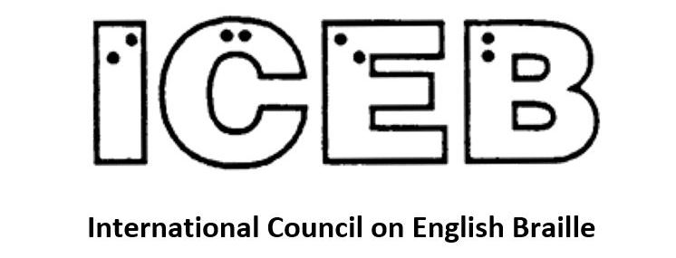

ICEB Newsletter
Issue 6, March 2020

ICEB General Assembly
Regretfully, the ICEB General Assembly will not be held in May as originally scheduled. This decision was made with regard to public health concerns and increasing restrictions on travel and mass gatherings.
Plans are now underway for a postponed event to be held from 19 to 23 October 2020 at the Academy London, Google’s dedicated learning space. The General Assembly serves as a time to get together and celebrate the importance of braille, as well as a formal setting for organisational operations. All business planned for the General Assembly will be delayed until October, including the appointment of a new Executive Committee for the next four year term. The Assembly will be live streamed for those unable to attend in person. In the event that continued travel restrictions prevent the General Assembly from being held face-to-face in London in October, a virtual conference will instead be held at the same time.
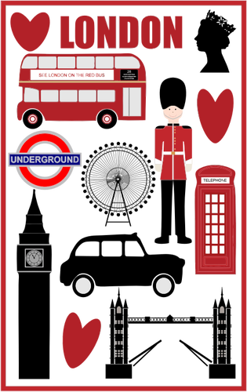
Please refer to the General Assembly web page at https://www.ukaaf.org/iceb-7th-general-assembly-2020/ for more detailed information. We will continue to keep you informed via the ICEB-announce listserv, Facebook and Twitter.
We thank you for your understanding and continued support. We very much hope that you can join us in October.
Our sincere gratitude is extended to the Assembly Organising Committee led by Mandy White and to UKAAF, RNIB and Google for their hard work and flexibility to support this event. They look forward to welcoming us to London in Autumn.

Unified English Braille

Improvements to UEB translation in LibLouis
LibLouis is an open source braille translator, used within many screenreaders, phones and braille translators.
LibLouis was updated to version 3.12 in December, implementing fixes to UEB translation of over 2,000 words. The words range all the way from abandonee to zonesthesia (do not use the ONE sign in either). One common fix was to prevent use of the ST contraction in words ending in –stown, such as Abbotstown, Howardstown or Jonestown. Another common fix was the prevent use of the THE contraction in words ending in –thead, such as flathead, flinthead or meathead.
Our thanks are extended to the ICEB Braille Technology Committee for their work on LibLouis, with special mention to their Chair, James Bowden of RNIB.

Test your UEB knowledge!
The theremin is a musical instrument. Can the contraction for “there” be used when brailling theremin?
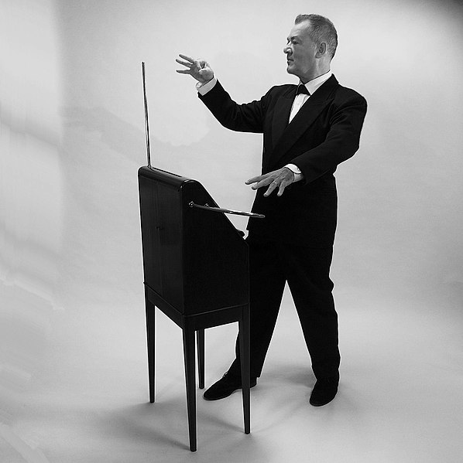
Check near the end of the newsletter for the answer.

Trouble in Wollongong
How do you make decisions about the use of contractions in unusual names? If in doubt, the answer is to consider the word’s construction and pronunciation, then refer to the Rules for Unified English Braille.
Recently, we were asked how to braille Wollongong, an Australian town that derived its name from the Aboriginal word woolyungah, meaning five islands. Wollongong is pronounced “wool-ong-gong”. Should the name be brailled with one or two “ong” contractions?
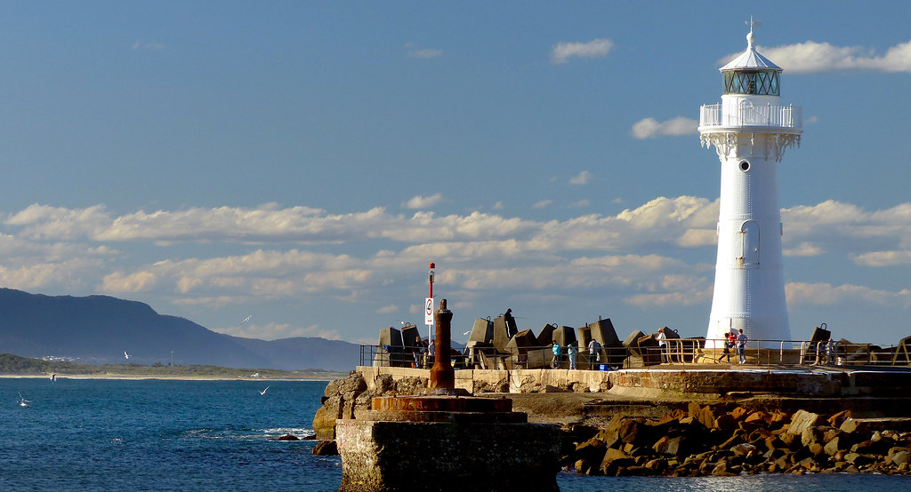
In Wollongong
According to the Rules for UEB 10.8.1, final-letter groupsigns including “ong” can be used whenever the letters they represent follow other letter(s) unless other rules apply. Rule 10.10.9 states that a groupsign should not be used if it would seriously distort the pronunciation or hinder the recognition of the word. However, examples throughout the Rulebook demonstrate that a hard “g” can occur following use of the “ong” contraction. For example, the “ong” contraction is used in the words incongruous and mongoose. Thus, Wollongong can be brailled as ,woll;g;g.

One blind Kiwi’s dream to write 1 million names in braille
On 27 March 2017, celebrating 20 years as a blind person, Julie Woods of Dunedin, New Zealand decided to write, on a little piece of paper “write 1 million names in braille” and place it in a jar in her office.
Why did she do this?
Because Julie had printed the braille alphabet on the front of her business card in 2012 and since then she had started writing people’s names in braille, using a one-line braille slate and stylus.
Julie really began doing this when her and her husband Ron started travelling overseas as it was a great gift to give their guides. One young woman in India cried when Julie gave her name to her, saying “Words cannot describe how I am feeling at this time.” That got Julie to thinking there was something in this small act of braille kindness.
As a life coach, Julie decided to set this goal because she knew when she set crazy goals and go after them, crazy things could happen! Who would have thought that saying why not to learning braille as a 35 year old adult would take her to Paris for Louis Braille’s 200th birthday bash. Or when her and her husband Ron had a dream to visit the Seven Wonders of the World that she would go on to visit 50 countries by the time she was 50! Even that walking one half marathon would lead on to ten ...
Already Julie has written 10,515 names in braille including the Prime Minister of New Zealand Jacinda Ardern, who wrote back to Julie in braille. She’s written the name of an All Black called Lima, a 110 year old New Zealander called Madeline, a prisoner called Caleb and a Minister of the Crown called Willy. When Julie was approaching 10,000 names in braille she presented a name and a sash with 10,000 on it to Shaun Wallace, one of the Chasers who was visiting her home town of Dunedin on a book promotion tour.
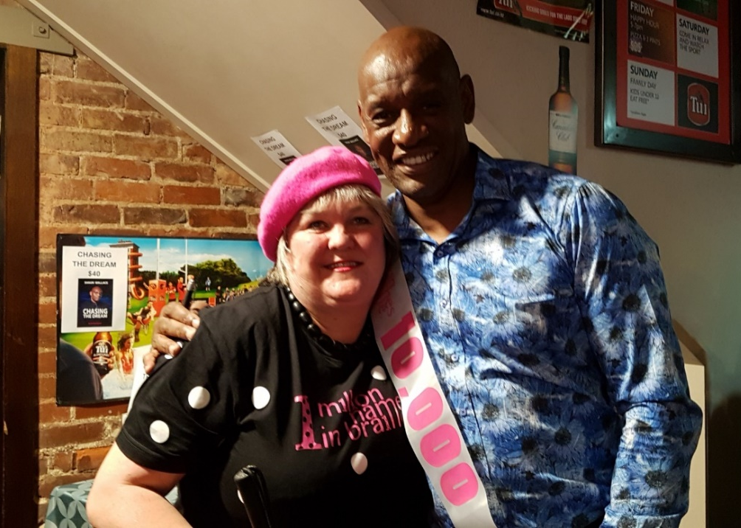
Julie with Shaun Wallace (the Dark Destroyer)
Names in braille have already gone to 33 countries around the world and Julie is keen to send them to all the rest. So far they have gone to China, USA, Vietnam, France, Kenya, Canada, Australia, Netherlands, Panama, Puerto Rico, Iceland, Brazil, Singapore, Costa Rica, India, Italy, Switzerland, Norway, Thailand, Poland, Spain, South Korea, Japan, Cambodia, Philippines, Germany, Hong Kong, Belgium, Taiwan, Vanuatu, Nepal, Bermuda and Croatia.
If you’d like to have your country included, please visit Julie at www.thatblindwoman.co.nz or email Julie@thatblindwoman.co.nz. Julie is keen to connect the world with dots and she’d love it if you would help her reach her dream of writing 1 million names in braille.
- Julie Woods, New Zealand

Braille technology

Braille Teach
Braille Teach is a new technology from Horizon Next, created by the Azerbaijani entrepreneur and inventor Rashid Aliyev. The product is equipped with an interactive handheld device designed for quick and engaging study of the braille font using audio feedback. The goal of the company is to make braille literacy accessible to all blind and visually impaired people.
Rashid Aliyev intended to begin learning braille using the Braille Pad - a tactile display tablet. However, he found that this system of writing was not easy, and other devices were too expensive. Therefore, he decided to work on a simple solution to this problem.
Braille Teach is intended for anyone who needs to study braille: For preschoolers who are blind or have vision impairment, for their family members, parents and supporting organizations.
Support has been provided by the Ministry of Education of Azerbaijan, RNIB (Royal National Institute of the Blind, Great Britain), School No 5 for children with vision impairment (Azerbaijan), Bank Baku (Azerbaijan), UAFA (Joint Assistance to Azerbaijan) and many other structures and benefactors.
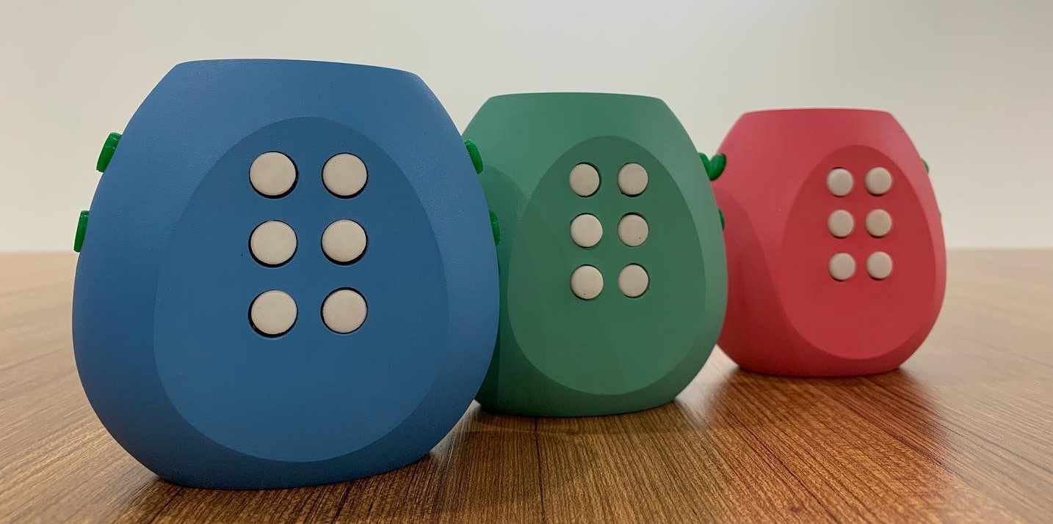
Braille Teach
Braille Teach improved its device in collaboration with organizations and inventors. Among the improvements, it is worth noting the change in the size of the buttons with large and small versions, an additional headphone jack and new languages.
Braille Teach plans to start mass production and is looking for grants and investments. To learn more about Braille Teach and support their product, visit their Facebook page at facebook.com/BrailleTeach.
- Rashid Aliyev, Azerbaijan

Braille Me in South Africa
Up until recently very few individuals in South Africa could afford to own refreshable braille devices. These devices were prohibitively expensive for most people in South Africa due to the fact that there is no government or other support to finance these devices and this problem was exacerbated by a very negative exchange rate.
Then low-cost refreshable braille devices like the BrailleMe and the Orbit hit the market! This changed everything.
About two years ago Blind SA, a prominent consumer organisation of blind persons, decided to become a distributer for the BrailleMe. The decision was met with great excitement. Soon after we started importing the devices, a number of us were trained via Skype by the manufacturers of the BrailleMe, Innovision in India, to do hardware repairs on the BrailleMe so that they would not necessarily have to be returned to India for repairs should something go wrong.
The BrailleMe implements a whole new technology which drives its display. Initially there were a lot of teething problems with dots either not showing, or stuck in the up position, but fortunately these issues have been sorted out now.
Many people have bought BrailleMe’s. One often hears people say: “I never thought I would ever own a refreshable braille notetaker – and now I have one and I love it”.
An extremely important use of the BrailleMe is to read and write documents in our local languages for which there are no acceptable speech synthesisers. This has opened doors for people who previously had not had access to such material.
Many use their BrailleMe’s to take notes in meetings, conferences or at their jobs. Being able to write in contracted UEB and then simply transferring the files to a computer without having to back translate them into a readable format for sighted people, makes the BrailleMe a really useful tool. It is quiet and non-intrusive and its cursor routing keys make editing a breeze.
Many use their BrailleMe’s to operate their smart phones. This is a very powerful combination which allows the user to use his/her phone without causing a disturbance to perform tasks like accessing the internet, e-mail, social media, a word processor and much more.
We are in the process of developing LibLouis translation tables for some of our local languages that we hope could be implemented on the BrailleMe soon. This would make it an even far more valuable device.
- Christo de Klerk, Braille Authority of South Africa (SABA)
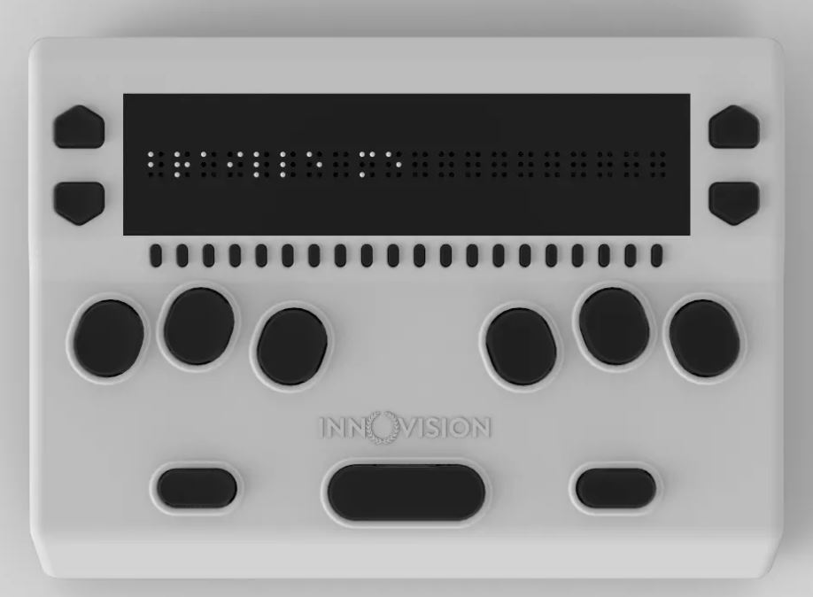

3D printing for touch readers
With affordable commodity 3D printers becoming more common in schools, libraries and businesses, enthusiasts around the world have been investigating this new technology and its potential as an additional format for touch readers.
In Europe, the UBIS Project (Universal information containers for Blind and Visual impaired Students) has just completed the first phase of their work identifying and developing 3D models suitable for touch readers. Results will be published at www.ubis-project.eu. In the USA, the DIAGRAM Center is hosting a similar 3D working group to develop guidelines on when and how to use 3D printing for accessible educational materials. Some of their work is shared at www.tactilemodels.com. Meanwhile, Australia is undertaking a Linkage Project on 3D printing with a focus on accessible materials for education and mapping.
As part of this work, a large number of free models have been identified or developed for use by touch readers. The BTactile online metalibrary has over 500 accessible models, ranging from tactile measuring tools to replicas of famous artworks.
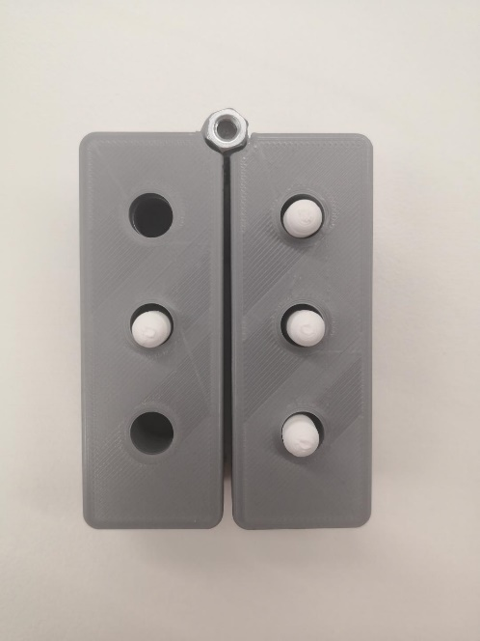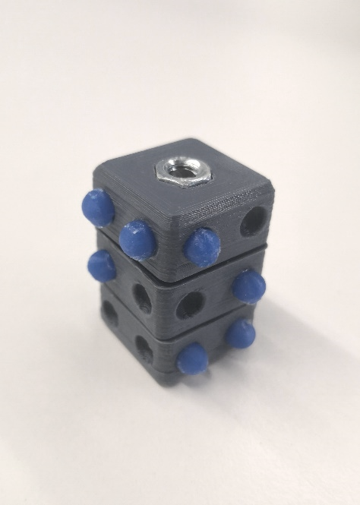
3D printed braille swing cell and braille fidget cube
There has been considerable debate regarding the inclusion of braille on 3D printed models. Rounded braille printed on the side of a model can be very good quality, however braille printed flat on the top of a model can be rough to touch and difficult to read. Inclusion of braille labels on a model also means that the scale cannot be changed and it cannot be shared across different languages. Often, it is easiest to simply attach braille labels after printing is complete. If you do wish to add braille labels as part of the model, the UEB braille generator for OpenSCAD allows contractions and gives good quality curved dots.
- Leona Holloway, Monash University, Australia

Recent events

World Braille Day Celebrations in Ireland
World Braille Day is held on 4 January every year in commemoration of the birth of Louis Braille. This year, the Irish National Braille and Alternative Formats Association (INBAF) marked the occasion with an exhibition of all things braille-related at the Ilac Centre Library in central Dublin.
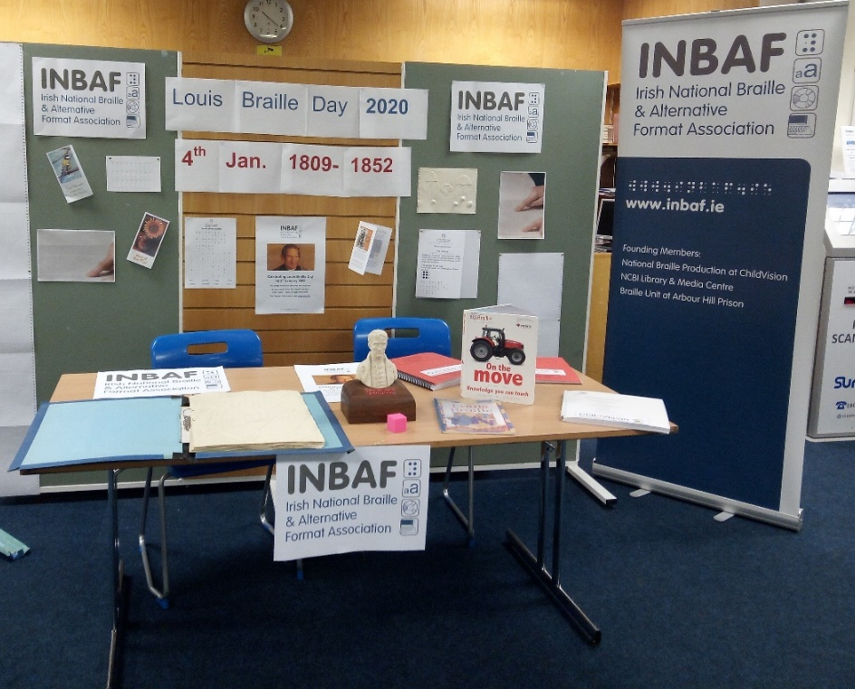
There was a range of braille access on show, from Braille books, tactile maps, Perkins Braillers, braille displays, a selection of braille coins, braille games and much more!
Members of the INBAF committee were on hand for the day to chat with members of the public about Braille and its importance in all aspects of life. Visitors had the chance to have their name brailled as part of the day’s activities, and a specially equipped children's corner meant that junior visitors were kept entertained as well!
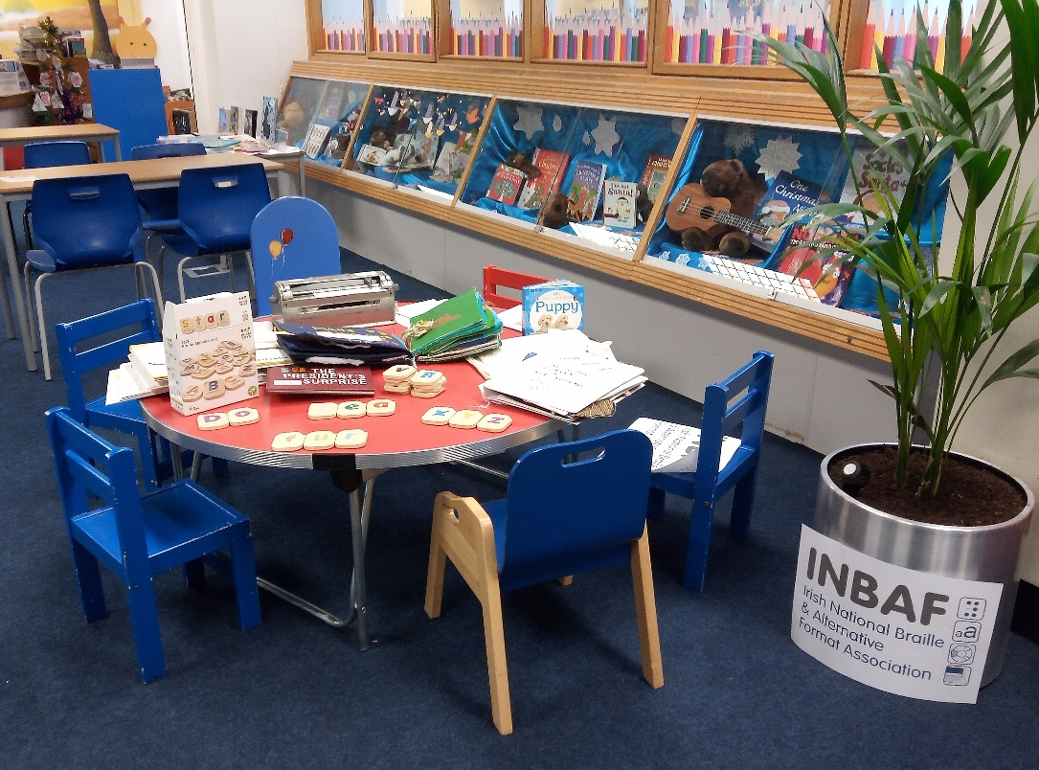
We were delighted with the level of interest in this event and hope to build on its success next year.
- Stuart Lawler, Irish National Braille and Alternative Formats Association (INBAF)

SPEVI Conference
The South Pacific Educators in Vision Impairment (SPEVI) held its most recent biennial Conference in Adelaide, Australia in January. Designed primarily for specialist vision teachers in Australia, New Zealand and the Pacific Islands, the conference also attracts international guests, professionals from related fields and parents.
ICEB was pleased to present a poster about our work and resources in collaboration with the Australian Braille Authority and the Braille Authority of New Zealand Aotearoa Trust (BANZAT).
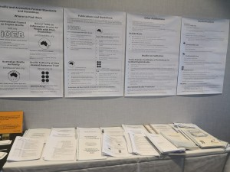
Posters and guidelines at SPEVI 2020
The program featured a big emphasis on braille, tactile literacy and touch access. Emily White of Melbourne University delivered an excellent keynote presentation and call for more research on the topic of braille literacy with involvement from expert practitioners. Strategies for encouraging early tactile literacy were presented by Lea Nagel (SVRC), Trish Bishop (BLENNZ), Meredith Pitcher (BLENNZ) and Sonali Marathe (RIDBC); and research on acquisition of braille skills was presented by Frances-Mary d’Andrea (University of Pittsburgh) and Tricia d’Apice (RIDBC). We were also treated to hands-on workshops making toys to encourage early tactile literacy, creating and appreciating art through tactile media with the Art Gallery of South Australia, and exploring 3D printed tactile education materials. We especially enjoyed finding braille on the labels of Fox Creek Wines at the Conference dinner!
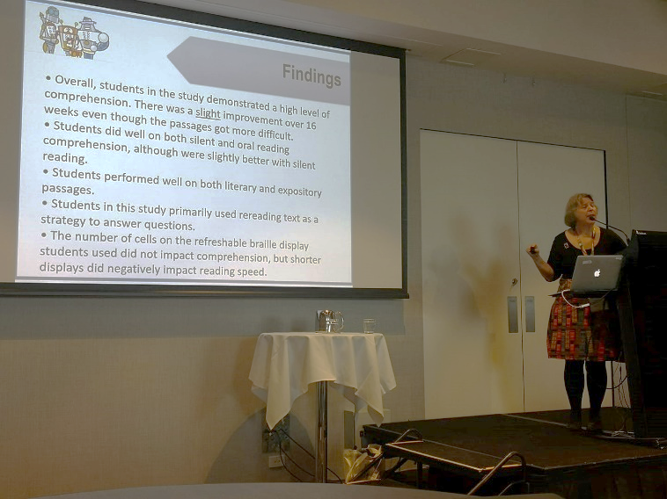
Frances-Mary d’Andrea presenting
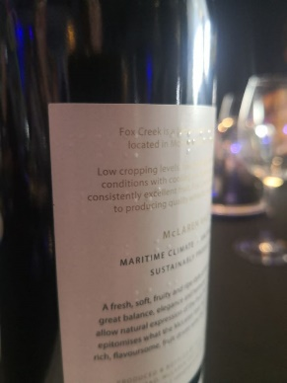
Congratulations are extended to Josie Howse, who was awarded an Honorary Lifetime Membership to SPEVI in recognition of her Australian and International contributions to braille education.
All papers from the conference will be published at www.spevi.net/conference/.
- Leona Holloway, Australian Braille Authority

2020 World Read Aloud Day in South Africa
For the third time, World Read Aloud Day was commemorated in South Africa with a successful braille reading event. Nali-Bali, Blind SA and SABA all met to put together the 2020 edition of the WRAD which took place on 21 February, the “mother tongue” day.
IT CAN NEVER BE BETTER!!!
With a vast growth from the 2019 event, 2020 WRAD registered more than 750 learners from 18 schools across six provinces. We had two stories in which learners participated. One story was written by a young learner, Stacey, and the other was authored by Nali-Bali in Zulu. Participation was awesome and learners enjoyed the reading!
SABA is proud to partner with these two organisations to encourage learners to love reading, especially reading braille, for their leisure.
- Ntshavheni, Netshituni
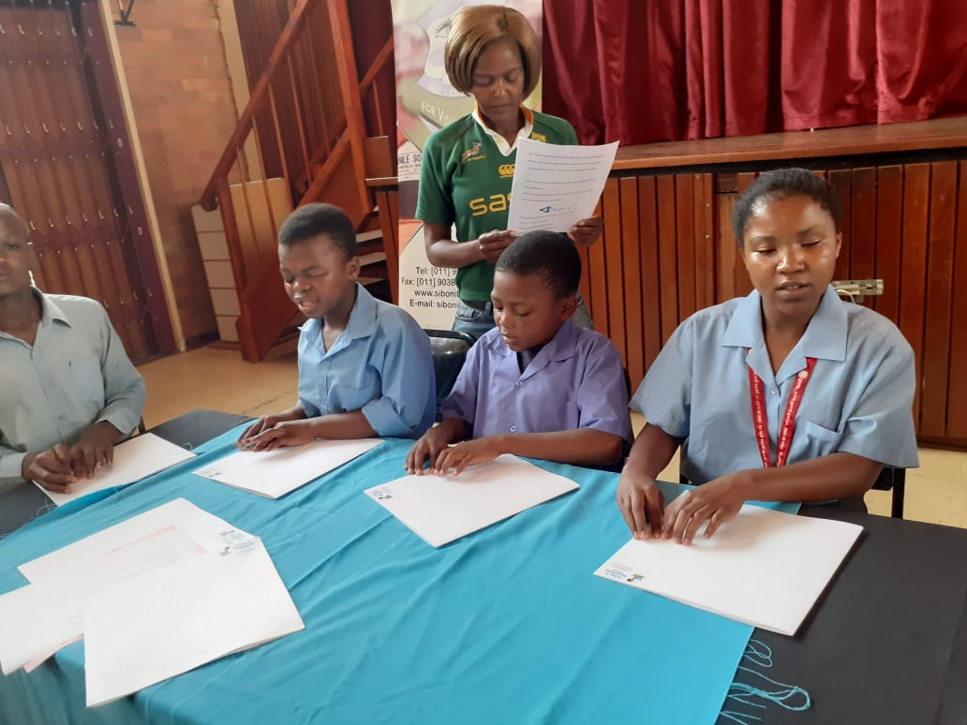

Calendar of upcoming events
A list of upcoming events relating to braille is now also available on the ICEB website at http://iceb.org/PRupdates.html.
This list was correct at the time of publication, however please check the relevant websites for updates.

Round Table Conference – Melbourne, Australia POSTPONED
The Round Table on Information Access for People with Print Disabilities is an umbrella organisation with 35 members from the print disability sector in Australia and New Zealand. Its next annual conference will be held in Melbourne, Australia. Proceedings include the annual meeting of the Australian Braille Authority (ABA) and a braille workshop hosted by ABA. The conference was originally scheduled for May 2020. It will now be postponed, with a future date to be advised. More information is available at http://printdisability.org/conference/.

CVTC 2020 – Toronto, Canada, May 2020
The Canadian Vision Teachers' Conference (CVTC) 2020 welcomes teachers of students with visual impairments, Orientation and Mobility Instructors, Deafblind intervenors, accessible formats specialists, students, parents, researchers, health care practitioners, early childhood educators, community partners and agencies across Canada and beyond interested in the education, empowerment and advocacy of people with visual impairments. The Conference is scheduled for 6 to 8 May 2020 at the Sheraton Toronto Airport Hotel and Conference Centre, 801 Dixon road Toronto, Canada. Information is available at http://bit.ly/cvtc2020.

WBU-ICEVI Joint Assembly – Madrid, Spain, TBA
The World Blind Union (WBU) and International Council for Education of People with Vision Impairment (ICEVI) had scheduled their third joint General Assembly at the Hotel Marriott in Madrid, Spain, from 19 to 24 June 2020. The proceedings will include two days of paper presentations. Given the spread of coronavirus (COVID-19), the local host, ONCE, is working to identify the best option going forward. More specific information will be announced by 25 March 2020. For more information, see http://icevi.org/wbu-icevi-general-assemblies-2020/.

Vision 2020 – Dublin, Ireland, July 2020
The 13th International Low Vision Conference by the International Society for Low Vision Research and Rehabilitation is scheduled for Sunday 12th to Wednesday 15th July 2020 at The Convention Centre Dublin, Ireland. See http://vision2020dublin.com for the program and registrations.

AER International Conference 2020 – St Louis, USA, July 2020
The AER International Conference 2020 aims to bring together over 600 VRTs, Orientation and Mobility Specialists, TVIs, LVTs, advocates, scholars, policymakers, and other professionals. The Conference is scheduled for July 22 to 26 at the Union Station Hotel, St Louis MO, USA. Information and registrations are available at aerbvi.org/professional-development/conferences/.

ICEB General Assembly – London, England, October 2020
ICEB holds a General Assembly once every four years. The next General Assembly has been postponed and is now scheduled for 19 to 23 October 2020 at Academy London, Google’s dedicated learning space in central London. Each member country of ICEB is invited to send up to four delegates, and observers are warmly welcomed. One day of the Assembly will be devoted to paper presentations and an exhibition of braille innovations, technology and practice.
Further details can be found at https://www.ukaaf.org/iceb-7th-general-assembly-2020/

Tactile Reading Conference – Oslo, Norway, May 2021
After a successful first conference in Sweden in 2017, the Tactile Reading Conference returns in 2021. The Conference will focus on braille and graphics, including digital aids for braille reading and the use of 3D-printed material. Topics will include early intervention and education for children, youth, and adults within the field of tactile reading. The Conference will be held on the 29th and 30th April 2021 in Oslo, Norway. A Pre-Conference on technology and aids for the blind and visually impaired will take place 28th of April 2021, organized by The Norwegian Library of Talking Books and Braille (NLB). Abstracts are due by 15 May 2020. See www.statped.no/tactilereading2021 for more information.

Test your UEB knowledge!
In answer to our earlier question, theremin should be brailled as !rem9
Explanation: The initial-letter contraction for "there" cannot be used because it does not retain its meaning as a whole word (RUEB 10.7.2). Use the strong contraction for "the" in preference to the groupsigns "th" and "er" (RUEB 10.10.3).

ICEB Contact Details
Website: www.iceb.org
Email: info@iceb.org
Twitter: @ICEBbraille
Facebook: www.facebook.com/ICEBbraille/
ICEB-announce list:
Send an email to iceb-announce+subscribe@groups.io to receive announcements from ICEB, including this newsletter and notifications regarding updates to Unified English Braille.

