ICEB Newsletter
Issue 7, June 2020

Special Edition:
Online connections

UEB Code Maintenance Committee leadership

Phyllis Landon
Phyllis Landon, Chair of ICEB’s Unified English Braille Code Maintenance Committee since its inception, retired from the position on 31 May 2020 after a ten year term in office.
The UEB Code Maintenance Committee is the most active of ICEB's subcommittees, being responsible for all decision-making and documentation regarding Unified English Braille. In addition to the Committee members, hundreds of observers contribute to discussions on the group’s two listservs.
ICEB extends its deepest gratitude for the thoughtful leadership, incredible dedication and depth of knowledge that Phyllis has so generously devoted to the CMC and the international braille community over the last decade. She oversaw the creation of the first and second editions of the Rules of Unified English Braille as the comprehensive reference for literary braille. She gracefully steered her Committee through technically difficult and contentious decisions such as the assignment of braille symbols for the apostrophe and quotation marks. And she has launched a major revision and expansion of the Guidelines for Technical Materials.

Phyllis has now been appointed by the President as an invited expert of the Code Maintenance Committee, allowing her to take part in discussions and vote on important matters.

Kathy Riessen
Kathy Riessen has been appointed by the ICEB President as the new Chair of the UEB Code Maintenance Committee. She is on the slate for election at the ICEB General Assembly in October. Observers on the UEB Code Maintenance Committee listserv will already be familiar with Kathy's well-considered and balanced approach to braille code problem solving. She has helped moved many issues forward through her contributions as an observer and has our full confidence and support as the new Chair.
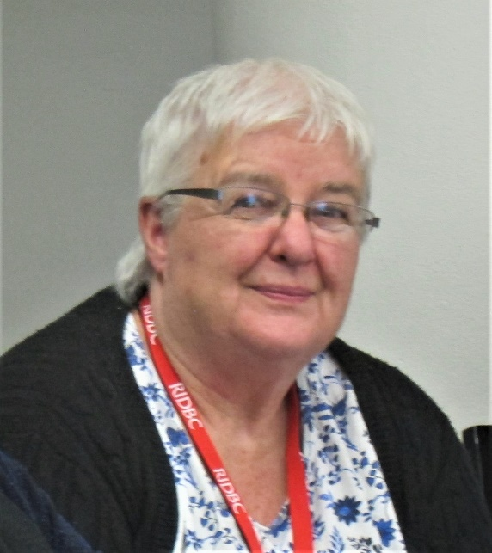
Kathy began work as a transcriber just over 30 years ago at Townsend School, now South Australian School for Vision Impaired (SASVI), and was thrown in at the deep end transcribing anything from mathematics, music and languages including Japanese. Kathy now manages the SASVI Production Services, which provides teaching support and resources to all vision impaired students across the state at all year levels from pre-school to Year 12.
Kathy is a member of the National Executive of the Australian Braille Authority (ABA). One of her passions, along with working on efficiencies of transcription, is ensuring availability of good, freely available documentation. She has co-authored or edited a number of documents for use in Australia, including the UEB Australian Training Manual that forms the basis of UEB Online literary materials. Kathy has also facilitated workshops on various aspects of transcription: formatting, mathematics, foreign language and use of the Duxbury Braille Translator to name a few.
More than anything else, Kathy loves to problem solve and is always seeking to improve the quality as well as quantity of materials that students can access. We look forward to the continued success of the UEB Code Maintenance Committee under Kathy’s able guidance.

Bill Jolley
We also extend our thanks to Bill Jolley, who has retired from his role as invited expert to the UEB Code Maintenance Committee. Bill was originally appointed for his expertise by the ICEB President in May 2016. He brought to the role a technical background and extensive experience in the braille world and ICEB. His contributions to discussions were always carefully thought out. Although he will no longer be a voting member, Bill has agreed to continue as an observer on our lists so we will continue to benefit from his knowledge and wisdom.

Business (but not) as usual
In this time of the COVID-19 pandemic, we are reminded more than ever that we are a global community who can and must work together. In fact, we are becoming more proficient in connecting online and bridging distances.

ICEB General Assembly update
ICEB holds a General Assembly once every four years. The 2020 General Assembly was originally scheduled to be held in May, however it has now been delayed until October 2020. As international borders slowly begin to open, ICEB will continue to monitor the situation and make a decision in July as to whether the General Assembly can be held in person or needs to be conducted entirely online. Please subscribe to the ICEB-announce list or follow us on Facebook or Twitter (@ICEBbraille ) for updates.
Regardless of the meeting mode, all major components of the General Assembly will go ahead in October, including presentation of papers. If the Assembly is held entirely online, consideration will be made to best accommodate participation across time zones.

Dot Power
In Victoria, Australia, the Statewide Vision Resource Centre has adjusted its Dot Power braille education days for beginner touch readers, now being held remotely from home. Families are provided with the braille activities and instructions of how these should be implemented with new readers of braille. Braille will be provided with print "over-writing" so that those without braille skills can assist their children in the activities.
The families are also provided with age-appropriate books from SVRC’s “Ozzie Dots” braille reading series. These books are also provided with a print out of what is on each page, explaining where there are contractions in the words. For example,
After dark, I like to sleep in my warm bed.
The print out also explains any punctuation or braille “indicators” such as capital letter sign or number sign.
- Marion Blaze, Manager, Statewide Vision Resource Centre, Australia
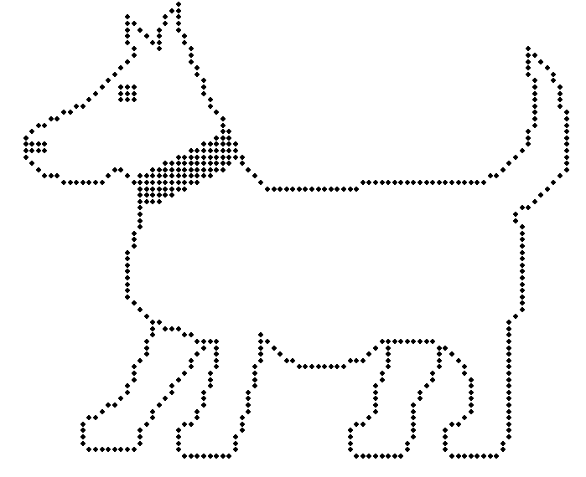
Slob the dog, a popular character from the Ozzie Dots series

The Braillists Podcast – When Two Formats Collide
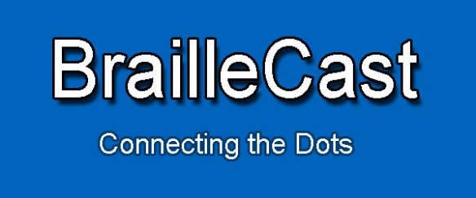
We all know about the importance of braille, but audio is also a very natural way in which blind people share information, and podcasting is a well-established, convenient way of delivering audio at scale. So, how about a podcast about braille?
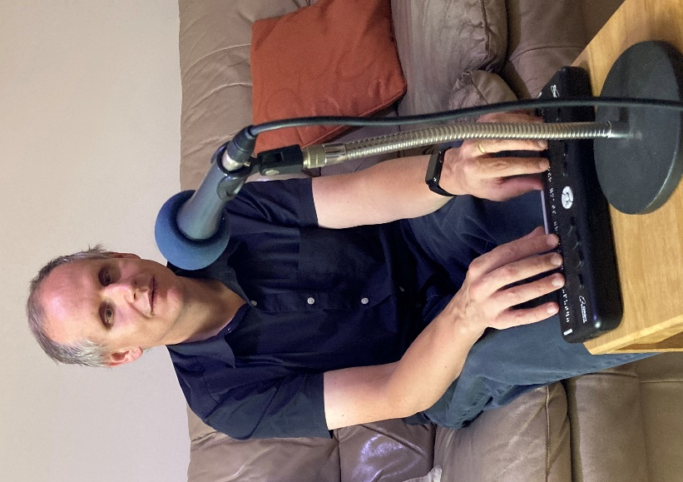
"Lots of people listen to podcasts about all manner of weird and wonderful subjects," said host Dave Williams when he initially proposed the idea. "A braille podcast could help introduce new people to Braille; support those getting started with Braille; re-energize anyone who has lost their confidence with Braille; provide Braillists with resources to help spread the word about Braille, seek to showcase the many ways Braille touches our lives, share ways of broadening Braille's appeal, explore innovations in Braille technology, and be a vehicle for sharing Braille news and Braille reviews, not just of gadgets, but Braille publications, Braille policy and all manner of other things braille."
Dave Williams
Almost 20 episodes on, BrailleCast has covered topics as diverse as braille competitions, the importance of braille in the deafblind community, unusual braille products, braille conferences, remote braille tuition and, most recently, the impact of COVID-19 on braille production. It's available in most places where you can find podcasts including iTunes, TuneIn and specialist blindness products, and the audience now also includes braille instructors, rehabilitation officers and Teachers of the Visually Impaired.
The podcast is produced, presented and managed by a team comprised entirely of braille users. Episodes are published monthly and typically last anywhere from 20 to 40 minutes. Feedback so far has been overwhelmingly positive, with at least one listener planning to re-engage with braille as a direct result of BrailleCast.
- Matthew Horspool, The Braillists, UK
Braille Zoomers: Virtual Get-Togethers for Adult Braille Learners
In April 2020 Braille Literacy Canada (BLC) launched the Braille Zoomers group, a monthly virtual get-together for adult and older adult braille learners.
Each virtual get-together is an informal opportunity to share resources, support and ideas for adult braille learners. While there is a general theme each month, the intent is that participants will determine the direction of the discussion so that BLC can best support their braille learning journey.
As the name suggests, these meetings take place on the Zoom platform and are held the first Saturday of each month. We generally have different moderators each time so that attendees can benefit from the varied experiences and perspectives of long-time readers, as well as educators in the blindness field.
In the first session participants had a chance to encourage one another by sharing tips and resources that they find most helpful as they learn and practise braille. The following month we had a discussion led by one of our board members who uses both large print and braille. This month we gave members an opportunity to ask their braille-related questions in an informal “ask the experts” panel. Although each get-together is centered around a different topic the focus is always the same: supporting and encouraging adult braille learners.
Many of the Braille Zoomers have shared that they were discouraged from learning braille. Some were told that it would be too difficult and others were told that they had too much vision and should wait until they had lost more sight before even considering braille as an option. We’re glad they didn’t give up, and we believe that this program will provide much-needed support to adult braille learners across Canada. It is never too late – or too soon, for that matter – to learn braille!
- Jen Goulden, Past President of Braille Literacy Canada

COVID-19 updates braille in New Zealand
Even with one of the world’s strictest lockdown responses to the COVID-19, the Blind Low Vision NZ Accessible Formats and recording studios were able to continue their work. This was the result of hard work and lobbying by Blind Citizens New Zealand and Blind Low Vision NZ.
All COVID-19 materials released from the New Zealand Government were produced as audio and braille and through the telephone information service for those folk who do not have internet access. This included information on restrictions at each alert level, the availability of disability support services, how to get food during the lockdown and advice on looking after your mental wellbeing.
Before the braille copies were sent to requesters they were packaged and left in quarantine for 72 hours. A local courier company then collected and delivered the materials. To date, 18 such documents have been produced on a weekly basis, providing New Zealanders who are blind and or have low vision with equitable access to information.
- Maria Stevens, Accessible Formats Production Manager, Blind Low Vision NZ

Advocating for socially distanced education for blind students in South Africa
Schools for the Blind are not ready to reopen in South Africa, however sufficient support has not been provided for blind and vision impaired students to learn from home. Blind SA is leading advocacy efforts.
Blind SA established a Task Team to review the draft Guidelines for the reopening of the Schools for the Blind developed by the Department of Basic Education. The Task Team included Principals from Schools for the Blind, representatives from ICEVI, OMASA and Blind SA. The Task Team submitted comment to the draft Guidelines produced by the Department of Basic Education.
It was pointed out that the special needs and reasonable accommodation of blind and partially sighted learners cannot be grouped with the same requirements of other schools as social distancing is more difficult due to the reliance on touch for blind and partially sighted learners. The learners move about the school and at hostel with close-contact assistance from other learners and staff. These learners also use their fingers for reading braille and using braille writing machines or to feel an object. Therefore, there is a greater need to sanitise equipment and surfaces more regularly. Another major concern is the poor infrastructure. The hostels are full to capacity and in many instances there is overcrowding, making social distancing more difficult.
Blind SA is urging the Department of Basic Education and the Provincial Departments of Education to provide mobile classrooms, emergency hostel facilities and additional human resources for Schools for the Blind. In addition, the Department needs to provide alternative learning, accessible textbooks, readers and assistive devices for reading and writing to learners whilst they are still at home. In their statement, they say “We urge the DBE to engage in meaningful consultation with learners, school staff and caregivers, and to move expeditiously in ensuring that all deliveries occur at all schools. It is critical that the uncertainty surrounding the re-opening of schools is resolved in the interest of the right to basic education for all learners in South Africa.”

Unified English Braille

DeafBlind
The word DeafBlind (with a capital "D" and capital "B") has been added to the Shortforms List in Appendix 1 of the Rules of Unified English Braille. This means that DeafBlind should now be brailled using the bl shortform, i.e. ,d1f,bl. This decision has been made as a special exception to the "Standing Alone" rule, with respect for the importance of the word to the DeafBlind community. Other words with medial capitals cannot use shortforms. This change and any others made since the second edition of the Rules of UEB in 2013 are documented on the ICEB website at http://iceb.org/ueb.html.
Thanks are extended to the UEB Code Maintenance Committee for considering and permitting this update, which was made in response to user requests.

Test your UEB knowledge!
Question: Does this expression using the prime sign need a grade 1 indicator?
Print: E'F'G'H'
Check near the end of the newsletter for the answer.

Braille Technology

Orbit Chat – Face-to-face communication for people who are deafblind
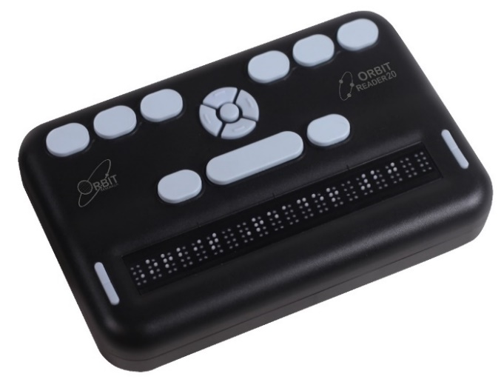
People who are deaf and blind typically communicate with others through various means including tactile sign language and often require a trained interpreter since most people are not familiar with such methods. The Orbit Chat system changes this forever by offering a free solution that enables a deafblind person to use their Orbit Reader 20 braille display and an app running on a smartphone or tablet to communicate with a sighted, blind or deaf person. The system can be used in any situation – in public settings such as markets, restaurants and classrooms or in private conversations.
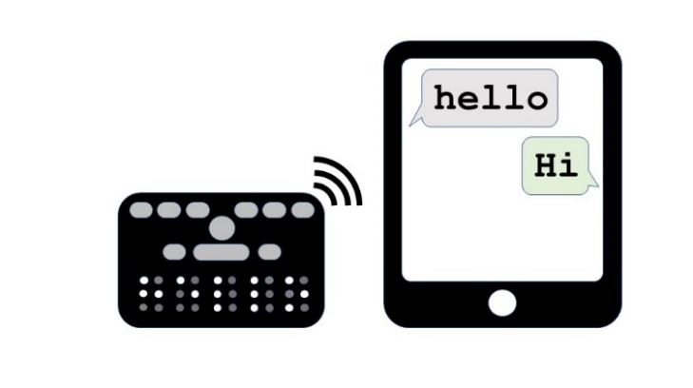
The system allows a blind, deaf or sighted person to use a familiar chat or messaging user-interface to type messages using the phone or tablet’s on-screen keyboard, which are immediately translated and displayed on the deafblind user’s Orbit Reader 20 device in braille. The deafblind user types her messages in braille using the braille keypad on the Orbit Reader 20 and these are translated to plain text and instantly displayed on the phone or tablet. The app is self-voicing, which allows a blind person to use it to communicate with a deafblind person without needing any special screen-reading software.

The system also includes other innovative features such as a broadcast mode which allows the deafblind user to send messages to multiple people who have the app installed, the ability to save conversations on the Orbit Reader 20 as well as on the app for later review, a file transfer feature to exchange files between the Orbit Reader 20 and the phone or tablet. It allows the use of contracted and uncontracted braille in English and offers support for other languages through localization. The app is available now for free download at www.orbitresearch.com/product/orbit-chat.
- Venkatesh Chari, Orbit Research

People
Sadly, we say goodbye to three colleagues from the US and Canada who made significant contributions to braille.

In memoriam – Constance Craig 1956-2020
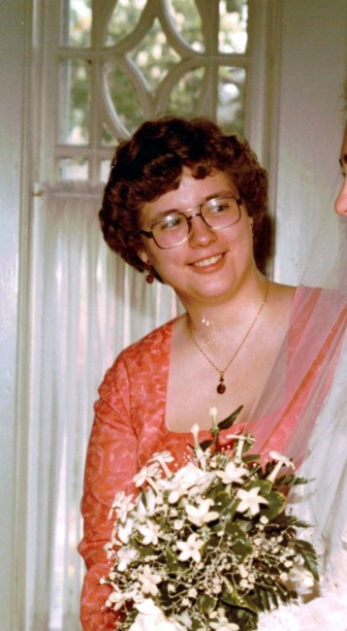
We are heartbroken to announce the passing of Constance Justine Craig in Toronto at the age of 64. She died during the COVID-19 pandemic but not as a result of it - but there has not been a chance to mourn her. Constance’s many years of work (creative and research) served as the base for the BANA Guidelines and Standards for Tactile Graphics. She was a pioneer in tactile graphics and developed a very successful course and certification in tactile graphics in Canada.
Constance was generous with her friendship, devoted to her family and her cats and passionate about her work. She was a remarkable person with an intensive mind. She had so many good ideas, and she was always figuring out ways to do things. Her great sense of humour took her through many challenges and made her excellent company.
Constance attended high school at Jarvis Collegiate where she sang classical music as an alto in the choir for five years. She graduated in Geography from the University of Guelph and in Cartography from Seneca College in Toronto. She started her career in mapping and then transferred her skill set to a position created for her as Tactile Coordinator at the Canadian National Institute for the Blind (CNIB). There she formed the Tactile Department and created an incredible collection of 3,000 titles. During her 25 years at CNIB, Constance attended domestic and international conferences and was known internationally for her work.
- With thanks to Darleen Bogart, Canada

In memoriam – Phyllis Campana
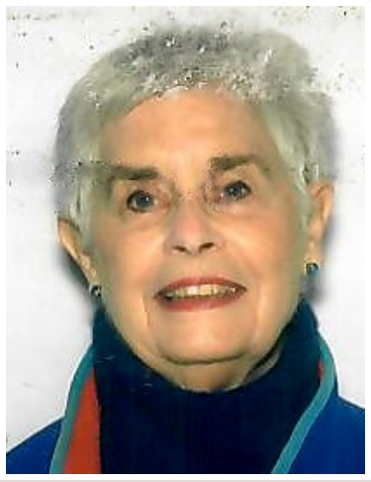
Phyllis Campana, a leader in braille production in the USA, died on 31 March 2020 aged 81.
Phyllis became certified in Literary Braille Transcription in September 1980 and spent the remainder of her career as a braillist. She was Director of Operations at the National Braille Press from 1987 to 1991. In July 1991, Phyllis assumed the role of Braille Division Manager at the American Printing House for the Blind in Louisville, Kentucky. She later took on the role of Braille Sales at APH.
While at APH, Phyllis served as their representative to the Braille Authority of North America (BANA). She served as secretary of BANA in 1998 and then as Chair Person in 1999 and 2000.
From 2000 to 2005, Phyllis was the Vice-President of Operations, Braille International Inc. in Florida, managing production of braille.
Phyllis’ dedication to braille did not end in 2005. She continued transcribing braille right up to 2019 through agencies including the American Printing House for the Blind, Braille International, National Braille Press, and some school districts. Phyllis loved producing braille and always loved a challenge.
- With thanks to Eileen Curran, USA

In memoriam – Jean Stauble 1929-2019
Jean Stauble was a long-time volunteer braille transcriber for CNIB. Jean was one their many volunteer braillists who accurately brailled what they were asked within the deadlines required with the realization that what they were doing was filling someone's need. Jean did this as part of the group in Toronto and then on her own in a small community outside Toronto for over twenty years. Jean exemplified the qualities of service of volunteer braillists.
Jean was also a volunteer driver with Red Cross Corps. Jean loved language, music and art, tennis, bridge and Scrabble.
Jean died peacefully on November 24, 2019, in Toronto, aged 90, following a stroke. In lieu of flowers, friends and family were asked to make a donation to CNIB in her name.
- With thanks to Darleen Bogart, Canada

Calendar of Upcoming Events

Deafblind International Webinar Series – online, June 2020
The first Deafblind International webinar series will be held on Zoom from 22-26 June 2020 with the theme “Living with Deafblindness in a New Reality”. Each webinar will consist of a 1 hour presentation and they will be held around the clock to accommodate global time zones. See https://www.deafblindinternational.org/conferences/dbi-webinars/ for more information.

NFB National Convention – virtual meeting, July 2020
The National Federation of the Blind National Convention is the largest gathering of blind people in the world. The 2020 National Convention will be held virtually for the first time, from Tuesday 14 July to Sunday 19 July 2020. It is expected to be the largest gathering of blind people in history. Registration is available at no cost, however donations to support the work of the NFB are welcome. More information and registration is available at www.nfb.org/get-involved/national-convention.

ICEB 7th General Assembly
ICEB holds a General Assembly once every four years. This year’s Assembly has been postponed and will now be held from 19 to 23 October. An announcement will be made in July as to whether the Assembly will be held in person at Academy London or online. Up-to-date information is available at www.ukaaf.org/iceb-7th-general-assembly-2020

SPEVI Virtual Conference – South Pacific, January 2021
The South Pacific Educators in Vision Impairment (SPEVI) have announced the first ever virtual SPEVI Conference, to be held from 18-19 January 2021. The conference theme is "Insights of leaders and researchers in vision education". They are planning to invite leaders in vision services in Australia, New Zealand and overseas to share current or emerging education sector initiatives, services and research in the field of vision impairment. Speakers and participants will have the opportunity to share ideas in real time via the virtual conference platform.

Tactile Reading Conference – Oslo, Norway, April 2021
After a very successful first conference in Sweden in 2017, the Tactile Reading Conference returns in 2021. The conference will focus on braille and graphics, including digital aids for braille reading and the use of 3D-printed material. Topics will include early intervention and education for children, youth, and adults within the field of tactile reading. The Conference will be held on the 29th and 30th April 2021 in Oslo, Norway. A Pre-Conference on technology and aids for the blind and visually impaired will take place 28th of April 2021, organized by The Norwegian Library of Talking Books and Braille (NLB). The call for abstracts has now closed. See www.statped.no/tactilereading2021 for more information.

Round Table Conference – Melbourne, Australia, May 2021
The Round Table on Information Access for People with Print Disabilities is an umbrella organisation with 35 members from the print disability sector across Australia and New Zealand. The next Annual Round Table Conference will be held in Melbourne, Australia from Saturday 15 May to Tuesday 18 May 2021. Proceedings will include the Annual Meeting of the Australian Braille Authority (ABA) and a braille workshop hosted by ABA. Further information is available at printdisability.org/conference/.

WBU-ICEVI joint General Assembly – Madrid, Spain, May 2021
The World Blind Union (WBU) and International Council for Education of People with Vision Impairment (ICEVI) third joint General Assembly has been postponed and will now be held in from 21 to 26 May 2021. More information is available at the WBU and ICEVI Assembly pages.

Vision 2020+1 – Dublin, Ireland, July 2021
The 13th International Low Vision Conference by the International Society for Low Vision Research and Rehabilitation has been postponed and will now be held from 11 to 15 July 2021 at The Convention Centre Dublin, Ireland.
http://vision2020dublin.com/

UEB Q&A
In answer to our earlier question, a grade 1 indicator is not required for the following expression.
Print: E'F'G'H'
Braille: ,e7,f7,g7,h7
Explanation: The prime sign will not be read as "gg" because the lower groupsign cannot be used when it is followed by a capital indicator (Rules of Unified English Braille section 10.6.6).

ICEB Contact Details
Website: www.iceb.org
Email: info@iceb.org
Twitter: @ICEBbraille
Facebook: www.facebook.com/ICEBbraille/
ICEB-announce list:
Send an email to iceb-announce+subscribe@groups.io to receive announcements from ICEB, including this newsletter and notifications regarding updates to Unified English Braille.

