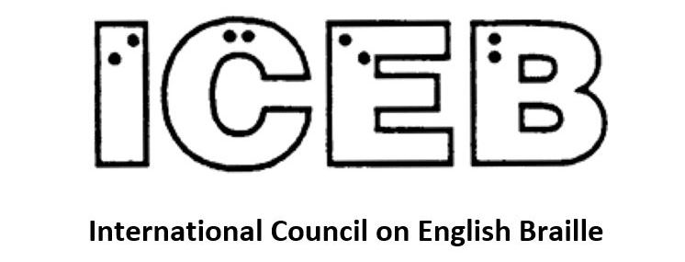

ICEB Newsletter
Issue 8
September 2020

ICEB General Assembly
The ICEB General Assembly is nearly here!
UKAAF and RNIB are delighted to be working with ICEB to host the 2020 ICEB General Assembly.
It doesn’t look very much like the event we were planning this time last year but we have embraced the challenges. We are happy to report that we have managed to put together, for the first time, a new look Virtual ICEB General Assembly. It will take place from Sunday the 18th October to Thursday 22nd October (19th to the 23rd for our antipodean attendees) for three hours each day. The time zones have given us our biggest headache, there will be some early mornings and late nights for some countries attending the live sessions but we hope we have managed to accommodate most people at a vaguely civil hour!
There will be the usual procedural business along with question and answer sessions focussed on different aspects of braille. Day 2 will feature music, Day 3 will feature technology and Day 4 will feature education and the braille code. Our presenters have recorded short videos on the highlights of their papers to give you a flavour of their contents. The papers themselves will be sent to everyone registering for the event, so if you want to know more you can delve into the detail. The presenters of the papers will be available for live question and answer sessions and discussions on the day that covers their topic.
We hope you will be able to join us for all or some of the live sessions. If the times don’t work for you then you are welcome to download the recordings of the daily proceedings. All the information you need, including the event programme, is available on the assembly website (which is updated regularly) at www.ukaaf.org/iceb2020/.
The most important thing to do is to register. It is absolutely free and it means that we can keep you updated with refinements to the programme and send you the link to listen into the conference. To register, please send your name, country and email address and the days you would like to attend to ICEBconference@rnib.org.uk . Note that if you are one of your country’s four official delegates or a presenter then you will be registered automatically. Any other queries can also be sent to the same email address.
We look forward to welcoming you to our Virtual Event!
- Mandy White and the organising committees

Unified English Braille

The obeah debate
Recently on the UEB-ED listserv, there was discussion of the word "obeah" and whether the "ea" should be contracted.
It was agreed that the “ea” should indeed be contracted, based on the following considerations:
- The word "obeah" originated in the Caribbean but has been adopted into English. It is not considered a foreign word used solely in another language.
- The “e” and the “a” are pronounced separately, however the “ea” contraction can still be used, just as it is in words such as acreage, borealis and Carribbean [UEB Rulebook 10.6.5].
- Other rules do not apply.
UEB-ED is a discussion list for questions and answers about Unified English Braille. It is hosted by UKAAF but has become an international community. To join, send a blank email with the subject "subscribe" to ueb-ed-request@freelists.org.

UEB Q&A: Test your UEB knowledge!
Example: The play was—in my opinion—poorly done.
Question: Can the lower wordsigns be contracted in contact with
the dash?
Braille: was,-9
Explanation: The lower wordsign for "was" is not used when in
contact with punctuation that has only lower dots. [RUEB 10.5.1]
The lower wordsign for "in" is used provided the sequence
includes a sign with an upper dot. [10.5.3] The provisions of the
lower sign rule in 10.10.10 do not need to be applied in this case
Example: The play was—in my opinion—poorly done.
Question: Can the lower wordsigns be contracted when in contact with the dash?
Check near the end of the newsletter for the answer.

Braille Fails: Common errors in braille signage (and how to avoid them)
Braille provides a means of immediate and independent access to information for people who are blind or have low vision. As such, ICEB advocates for mandatory provision of braille for important signage and product labelling. At present, provision of braille signage differs from one country and even when braille signage is provided, errors can be common. As demonstrated in some of the examples below, these errors can be the cause for amusement. But what can we do to make sure that braille signage is correct and provides the access intended?
Lift buttons – It is quite common to find lift buttons with upside-down braille, such as the two images below of a lift with two “up buttons” and another lift with two “down buttons”. In each, one of the buttons has been turned upside down so that the arrow is pointing the correct direction.
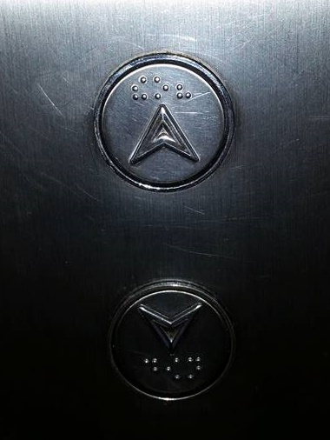
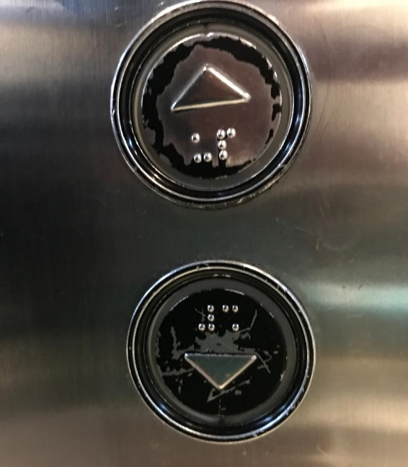

No raised dots – Sometimes you may come across signs with images of braille that are not raised. Usually, this is not actually a braille fail. Rather, it is temporary signage put in place while the braille and tactile signage is being manufactured. But it is always worth checking and enquiring about when the braille will be installed.
Incorrect translation or positioning – In the example below, the dots in each braille cell appear to be centred. For example, the letter “a” is shown as a single dot in the middle of the cell. This is actually a nice demonstration of the fact that the dots in braille are all identical and have no meaning by themselves; only by their position in relation to the other dots!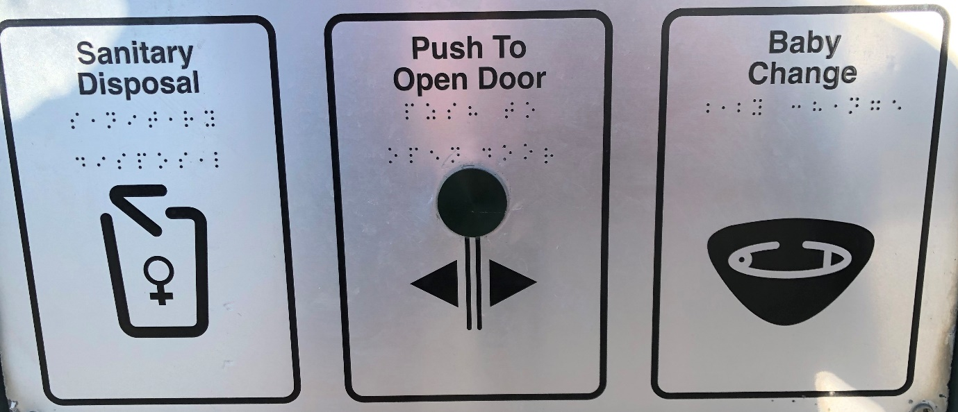
Braille in stupid places – We have seen braille placed so high on the wall or above the door that no one could possibly reach it, behind glass, or to warn of hot surfaces on the surface that should not be touched! These are obvious failures to consider that braille is read by touch. More subtle problems include braille placed on doors that could swing open towards the reader; too close to obstructions or too low to be read comfortably.
Wrong language – More rarely, you may find braille written in a foreign language. When the equipment or product has been imported from another country the print signage was translated but the braille was not. While this is obviously a problem, it also highlights the fact that when braille signage requirements are implemented in one country, this success is shared with all other countries to which the product is exported. Positive examples include the requirements for braille in lifts manufactured in the USA and pharmaceuticals distributed in the EU.
You have most likely seen your own fair share of braille fails like those discussed above. But once you have recovered from your initial amusement and/or frustration, what can you do about it?
We recommend that individuals notify the building owner, occupier, or the local council (for public buildings and parks). Let them know how much you appreciate braille signage, alert them to the error and suggest that they contact the sign manufacturer or installation company for a replacement. It also helps to provide contact details for your local braille authority or braille transcription service who may be able to assist with advice and proofreading. By taking on this shared responsibility, we can all help to raise braille awareness and access.
On a broader level, braille authorities, blindness organisations and advocacy groups can work with standards setting bodies to ensure that braille is required in key access points, in readable positions, and that a quality assurance process is required, including braille training for personnel involved in the design and installation of braille signage.
For more information on braille signage standards and practices around the world, see the summary findings from ICEB’s braille signage committee at http://iceb.org/signage.html.
- Leona Holloway, Australian Braille Authority

Braille technology

Braille Hands
Braille Hands is a new device with associated apps designed for education. The low-cost device serves as a six-key braille entry keyboard.
The creator, Mr Francisco Garcia, writes “I found my inspiration and motivation in June 2018, when I met on a YouTube conference the first person with deaf-blindness to graduate from a special education school. This made me question my work in the world, and I found a need to use all my engineering knowledge for a greater good, to help other people, so that in my life I would actually use the gifts that have been given to me to help others. I found that the Braille lines are very expensive for people in Latin America, which is why my proposal for the Braille Hands device ranges from $35 to $195, and includes a model for people with deaf-blindness, as well as the Mobile Applications all of which are free.”
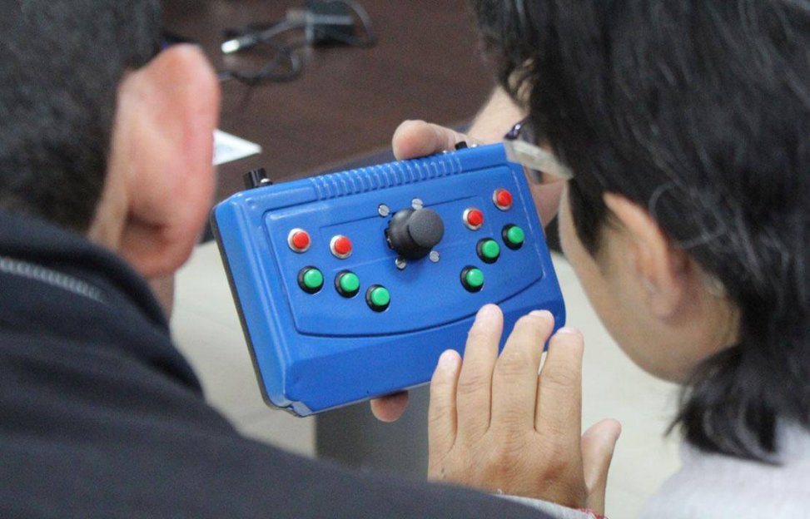
The Braille Hands device has six keys for direct braille entry, four keys for additional functions, and a joystick for navigating menus. When it is connected to the computer it is recognized as an ordinary keyboard, so any operating system accepts it, and the braille input is displayed on screen as standard print. You can input into any software.
There are currently three prototype models, all being tested and used. The USB model has a USB cable connection for computers and tablets. The Vibra model includes 6 microvibrators that individually correspond to each of the braille keys. This allows deafblind people to receive input letter-by-letter without requiring voice output. The third model is very low cost and connects to apps by Bluetooth.
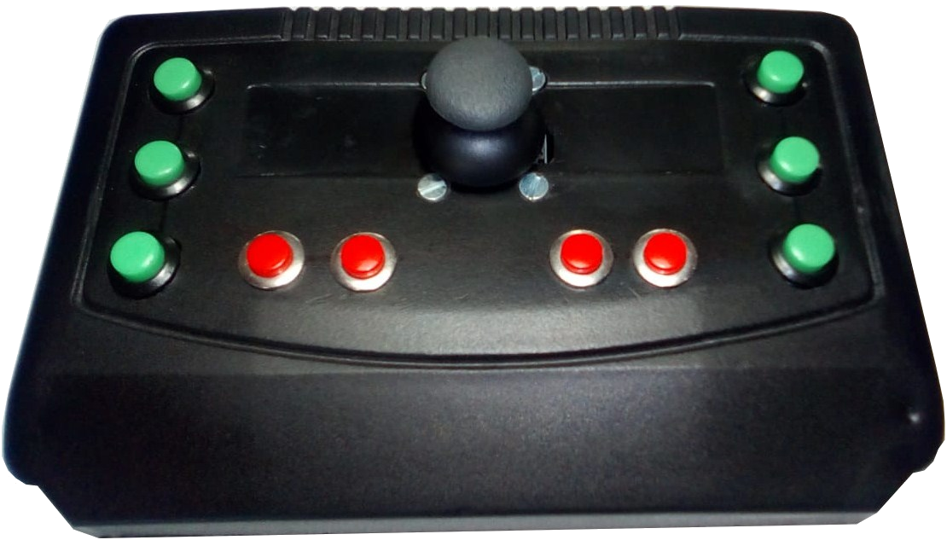
The Braille Hands Vibra model
Alongside the device, Mr Garcia has also developed a suite of apps that can be used with the Braille Hands device or other refreshable braille displays. The apps are designed to be fun while deepening knowledge and use of braille. The first three apps are already available for Android devices in Spanish and have been downloaded around 3,000 times worldwide. They can be accessed at the following links
- Braille Teacher: https://play.google.com/store/apps/details?id=appinventor.ai_inelsoft.Brailles_Teacher&hl=es_CO
- Braille Music: https://play.google.com/store/apps/details?id=appinventor.ai_commciso.Brailles_Music&hl=es_CO
- Braille Calc:
https://play.google.com/store/apps/details?id=appinventor.ai_inelsoft.Brailles_CalClock&hl=es_CO
A further four apps are under development: Braille Chess for playing chess online, Braille Quimic, Braille Note and BrailleGrama.
More information is available at http://commciso.simplesite.com/.
- With thanks to Mr Francisco Garcia, Braille Hands creator

NLS Braille e-reader pilot
The National Library Service for the Blind and Print Disabled (NLS) in the United States has launched a pilot test of a braille e-reader. The devices are being developed by two contractors, HumanWare and Zoomax.
Both devices have been developed to meet a lengthy set of requirements created by NLS. The braille e-reader has 20 cells, 20 cursor routing keys, an eight-dot braille keyboard, two USB ports, an SD card slot, and various navigation controls.
They can connect to Wi-Fi for direct download of books and magazines from the NLS online book service, BARD. They can also connect to a Bluetooth device such as a smartphone or a computer.
Pilot testing has begun in four regional libraries in Kentucky, New Jersey, Utah and Iowa, with more to be added in a few months. Efforts are being made to put these devices into the hands of a diverse group of users. This would include users with significant experience with braille displays and users who have never used an electronic device. Each library and user is being asked to complete several surveys during the course of the pilot so that NLS can make fully informed decisions in the future.
- Judy Dixon, National Library Service

Country Updates
In this new section of the ICEB newsletter, we share brief updates from around the world.

Australia
The Australian Braille Authority made the difficult decision that they are unable to offer the Trans-Tasman certificate of proficiency in Unified English Braille in 2020 due to continued lockdown restrictions. The National Braille Music Camp was also cancelled. Instead, a virtual concert was held online with blind musicians and students.

Canada
In June, Braille Literacy Canada (BLC) celebrated the 10th anniversary of their adoption of UEB. More recently, BLC has made a statement regarding access to braille during the COVID-19 pandemic. They have emphasised the essential requirements of braille for touch access and made recommendations for increased cleaning of braille signage.

New Zealand
The Braille Authority of New Zealand Aoteoroa Trust (BANZAT) held their Annual General Meeting this month, at which they celebrated their 10 year anniversary. The Trans-Tasman Certificate of Proficiency of UEB will be held in New Zealand in October.

United Kingdom
The UK Association for Accessible Formats (UKAAF) has been examining the requirements for logic symbols in braille and revising their guidelines on the use of grade 1 indicators.

USA
The Braille Authority of North America (BANA) is seeking feedback on its Provisional Guidance on Transcribing Mathematics in UEB.

People

In memoriam – Connie Aucamp
Sadly, Miss Connie Aucamp passed away in September 2020. She was a prominent figure internationally in the field of braille.
Connie Aucamp was the first blind student to study on campus at Stellenbosch University, from 1949 to 1950. She qualified as a teacher and taught until her retirement at the School for the Blind in Worcester, which later changed its name to Pioneer School for the Blind, until her retirement. Apart from teaching braille, she also taught Afrikaans (in which she had a master's degree), English and History. Towards the end of her career she also taught learners the use of assistive equipment, in particular, the VersaBraille.
Connie Aucamp was the first Chairperson of the South African Braille Authority (then known as Braille SA), which was formed after a meeting of herself, Dr William Rowland and Christo de Klerk took place at her home in Worcester in 1986. She served as Chairperson until the end of the 1990s. She also wrote the braille training manuals for South Africa, Six Dots and its Afrikaans counterpart, Ses Punte.
Miss Aucamp was a delegate at the founding meeting of the International Council on English Braille in Toronto in 1991, when she was elected as Vice President, serving until 1995. She was also appointed as Chair of ICEB’s Committee G on composition signs. She played a significant role in several ICEB committees in the development of the UEB.
Miss Aucamp had been bedridden for the past four years or so and passed away at the age of 93. Due to her frail health she could not participate in braille matters for some years. When she became no longer well enough, her stepping down was a big loss to the braille community.

In memoriam – AK Mittal
AK Mittal passed away on 22 September in Delhi. Mr Mittal was Secretary General of the World Blind Union and President of the All India Confederation of Blind (AICB) since 2007. He was also Director of NIVH, the National Institute for the Empowerment of Persons with Visual Disabilities, and a member of the World Braille Council.
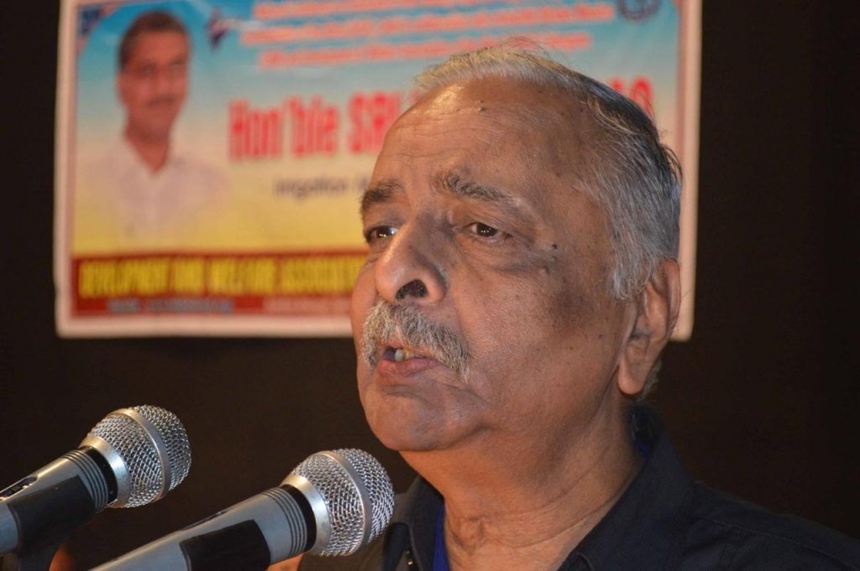
In India, Mr Mittal was well known for his work promoting the importance of braille and specialist teacher training. He was known for the refrain “Education is the key to empowerment”. One of his current contributions has been the establishment of an ICEVI-WBU project to promote braille for children who are greatly disadvantaged and marginalised due to the severity of their disabilities.
Under Mr Mittal’s leadership, the NIVH emerged as a leader in braille research and development. He was a proficient braille reader himself and was always up-to-date with the latest technology for accessing braille materials.
ICEB acknowledges and gives thanks for AK Mittal’s significant contributions to braille, education and technology for blind students. He will live on through his legacy of work to further braille in education.

In memoriam - Bette Gilmore
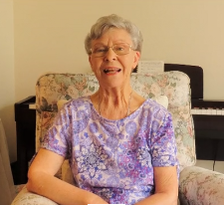
New Zealand are sad to report that Bette Lynette Gilmore died aged 81 on 23 July 2020. Bette received formal musical training including in singing from Dame Sister Mary Leo, who trained some of New Zealand’s most successful operatic vocalists. She spent some time in England, where she had an extraordinary career on the cabaret circuit, before returning to New Zealand in the late 1970s. Through contact with Julian Lee, New Zealand’s most famous and successful blind pianist, she learned about braille music and was inspired to become a transcriber. She quickly learned the code through the Foundation for the Blind.
In 1978 Bette took on the role of senior music teacher at Homai College, the school for the blind. Bette led the choir and produced the Braille Homai College songbooks. Former choir member, Jonathan Mosen, remembers “They would sometimes come literally hot off the press from the thermoform machine at the Transcription Department as we received periodic updates. Having easy access to the lyrics took the pressure off us so we could consult the lyrics while we committed a new tune to memory. It also acted as an incentive for us to hone our Braille skills, because some of the songs moved along at quite a clip, and we needed to keep up.”

In memoriam - Lillian Sit
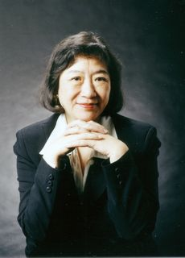
3 March 1947-15 August 2020
Born into a family of musicians, Lillian Sit was greatly influenced by her parents Chuan-Yi Xue and Hat Ho, who were both renowned classical singers. Following their musical footsteps, Lillian graduated from the Middle School of Central Conservatory of Music in China. Her music career took her to Hong Kong and Paris before she moved to Toronto in 1998, where she was a member of the Toronto Heliconian Club and founded the Alata Harmonia Chorus of Canada. She studied and obtained certificates in braille literary translation and music translation in order to welcome vision impaired individuals who share her love of music into Alata. Lillian was a dedicated volunteer for CNIB, producing music braille. She also organised a music concert for CNIB.

Calendar of Upcoming Events

CNIB Connecting the Dots – Canada, October 2020
CNIB holds an annual Connecting the Dots Conference on the topics of braille, technology and employment. The 2020 Conference will be held as a virtual conference on 7 & 8 October 2020 from Toronto Canada. Registration is now open.

National Braille Association – Online from USA, November 2020
The National Braille Association hosts a Professional Development Conference in the fall of each year. This year, the 2020 Conference will be held virtually with multiple online workshops each day of the week from Monday November 16 to Friday November 20. Workshop topics include Unified English Braille Literary, Unified English Braille Technical, Foreign Language Braille, Music Braille, Braille Formats and Computer Assisted Transcription. Registration is essential but is open to everyone at no cost. Further information is available at www.nationalbraille.org/what-we-do/professional-development-conference/.

SPEVI Virtual Conference – Online from Australia, January 2021
The South Pacific Educators in Vision Impairment are delighted to announce the 2021 SPEVI Virtual Conference with the theme “Celebrating Change”. The online event will run from 18 to 19 January 2021, hosted by RIDBC Renwick Centre. The keynote speakers are Emma Bennison, CEO of Blind Citizens Australia and Charlotte Cushman, who worked with Perkins Solutions and the Texas School for the Blind and Vision Impaired to produce the popular Paths to Literacy program. Registrations are now open and the full program is expected to be released in late October. Updated information will be available at www.speviconference.org.au.

CSUN Assistive Technology Conference – Online from USA, March 2021
The 2021 CSUN Assistive Technology conference is the world’s longest-running and largest conference devoted to assistive technology and the positive impact on people with disabilities. The conference will be held in a virtual format in 2021. They are currently soliciting proposals for presentations and pre-conference workshops in the general field of disability and technology. Submissions are due on September 29 2020 and the conference will be held in March 2021. Learn more and submit a proposal at www.csun.edu/cod/gcfp/overview.php.

Tactile Reading Conference – Online from Norway, April 2021
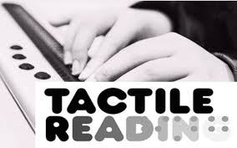
After a very successful first conference in Sweden in 2017, the Tactile Reading Conference returns in 2021. The conference will focus on braille and graphics, including digital aids for braille reading and the use of 3D-printed material. Topics will include early intervention and education for children, youth, and adults within the field of tactile reading. Keynote speakers include Silvija Seres on “New technology, new opportunities”, Mr Ajai Kumar Mittal on the enduring significance of braille, and Dr Diane Wormsley on the bumpy road to braille literacy. The event will be held as a Digital Conference on the 29th and 30th April 2021. See www.statped.no/tactilereading2021 for more information.

UEB Q&A
In answer to our earlier question, the lower wordsigns in contact with the dash should be brailled as was,-9
Explanation: The lower wordsign for "was" is not used when in contact with punctuation that has only lower dots. [RUEB 10.5.1] The lower wordsign for "in" is used provided the sequence includes a sign with an upper dot [10.5.3]. The provisions of the lower sign rule in 10.10.10 do not need to be applied in this case.

ICEB Contact Details
Website: www.iceb.org
Email: info@iceb.org
Twitter: @ICEBbraille
Facebook: www.facebook.com/ICEBbraille/
ICEB-announce list:
Send an email to iceb-announce+subscribe@groups.io to receive announcements from ICEB, including this newsletter and notifications regarding updates to Unified English Braille.

