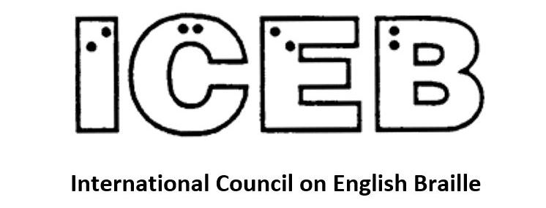

ICEB Newsletter
Issue 11
September 2021

In this issue, we introduce you to two new regular columns, one from the President's Desk and the other from the Chair of the ICEB Research Committee.

From the President's Desk
Judy Dixon writes:
Welcome to a very exciting edition of the ICEB Newsletter. Once again, this issue shows us how very vital and dynamic braille continues to be. Since assuming the role as President of ICEB in October 2020, we have been holding monthly meetings of ICEB's Executive Committee. This is being done in an effort to "pick up the pace." Our more frequent meeting schedule has proven to be very successful and you can see the results in this issue in the areas of code maintenance and braille research. You can look forward to hearing the exciting new developments from the ICEB Braille Music and Braille Technology committees in upcoming issues.
For many years, ICEB has maintained two listservs for the Code Maintenance Committee, one for the main UEB code and one for the technical code. But the committees have functioned jointly. In March, the ICEB Executive decided that in an effort to enhance the advancement of the technical code, the committees have been separated.
We welcome Donal Fitzpatrick of Ireland as the Chair of the Code Maintenance Committee for Technical Materials. Each member country has appointed a representative specifically for this new committee. Working collaboratively with the CMC Officer, the CMC for Technical Materials will begin working on the upcoming revision of the Guidelines for Technical Materials.
If you were not able to attend the Tactile Reading conference held in April, then I urge everyone to visit the archives. It was a very thought-provoking conference and it will be well worth your time.

World Blind Union and World Braille Council
Mary Schnackenberg writes:
We are delighted to congratulate Martine Abel-Williamson on her election as President of the World Blind Union. From New Zealand, Martine will serve in this role until 2025.
After the Second World War a number of international organisations were established to work towards regional and global co-operation. The United Nations was set up in 1945.
The World Braille Council was also set up. Its first Chairman was Sir Clutha Mackenzie, another New Zealander. He was the first editor of World Braille Usage, the “bible” of braille codes around the world which was published by UNESCO in 1952.
In 2012 the World Braille Council became a standing committee of the World Blind Union.
ICEB is a member of the World Braille Council. We have reached out to WBU President Martine. We look forward to decisions about the World Braille Council as WBU officers prepare their plan of work in their upcoming four-year term.
Martine Abel-Williamson, President of the World Blind Union

Code Maintenance Committee Update
Kathy Riessen writes:
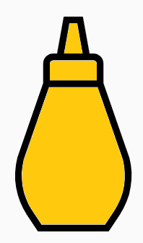
Since the last newsletter, four words have been added to the Rules of Unified English Braille 2013, Appendix 1: Shortforms List following a vote by the Code Maintenance Committee and endorsement of the ICEB Executive:
- Under “after” the words aftermentioned and aftertheater
- Under “before” the word beforementioned
- Under “must” the word mustardy
Notes:
“aftertheatre” with British spelling already exists on the list.
The similar words “abovementioned” and “belowmentioned” already exist on the list.
All updates which have been approved since publication of the Rules of Unified English Braille 2013 can be found at iceb.org/ueb.html.

UEB Q&A
Why is a grade 1 indicator needed in ⠰⠠⠠⠇⠇⠉ (LLC, Limited Liability Company) but not ⠠⠇⠇⠁⠝⠑⠇⠇⠊ (Llanelli)?
Check near the end of the newsletter for the answer.

Braille research
Natalie Martiniello, Ph.D, CVRT, President of Braille Literacy Canada, Chair of the ICEB Research committee writes:
Research on the reading and writing of braille continues to evolve alongside changes in code, technology, education and legislation. ICEB understands that these efforts provide critical evidence-based data to support on-the-ground initiatives for the promotion of braille.
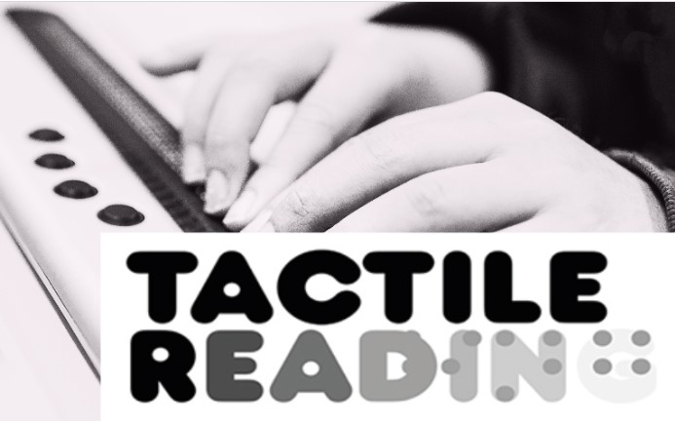
Despite the pandemic, 2021 is proving to be a productive year for braille research. The Tactile Reading conference brought together experts (including ICEB members) from around the world. Updates from the conference were shared through ICEB social media platforms and an archive including several recordings can be found here: https://www.statped.no/tactilereading2021. The next Tactile Reading conference will be held in the Netherlands in 2024.
The year began with newly published research on how to better support working-age and older adult braille learners. A study explored facilitators and barriers encountered by older braille learners, placing emphasis on the role of stigma towards braille and aging and the need to update regulations which often restrict the funding of braille devices to school-age learners. Another publication explored the role of refreshable braille technologies as an effective supplement to paper-based methods in adult braille instruction. Recognizing a need to consolidate existing resources, ICEB is compiling a list of adult braille learning resources used in English-speaking countries. Please write to president@blc-lbc.ca if you have information to share.
Earlier in the year, National Braille Press, LightHouse of San Francisco and the University of Alabama Huntsville Launched the Accessible Graphics Consortium. This collaboration brings together researchers, teachers and non-profits to explore best practices for producing, teaching, and learning to read tactile graphics. ICEB applauds such efforts which support greater equity and inclusion in STEM through braille and will continue to monitor these initiatives with great interest.
More recently, a publication in the British Journal of Visual Impairment authored by Mackenzie Savaiano and Devin M Kearns examined UEB and its efficiency in representing print. The authors found that it may be possible to approach the instruction of some shortform words differently, based on when they appear in school texts.
The ICEB research committee brings together representatives and observers from member countries who are engaged in braille research. To learn more or to become an observer, write to president@blc-lbc.ca
We acknowledge and extend our gratitude to all those who contribute to the advancement of braille research in so many domains.
https://www.tandfonline.com/doi/full/10.1080/09638288.2020.1833253
https://journals.sagepub.com/doi/full/10.1177/0264619621990702
https://www.prweb.com/releases/national_braille_press_lighthouse_of_san_francisco_university_of_alabama_huntsville_launch_the_accessible_graphics_consortium/prweb17768635.htm
https://journals.sagepub.com/doi/abs/10.1177/0264619620973710

Country Updates

Canada
Natalina Martiniello, the President of Braille Literacy Canada, writes:
Braille Literacy Canada is pleased to share that the recordings from our June symposium are now available. The transcripts for each presentation will be ready by end of August, but in the meantime, here is the link to the recordings.
https://www.brailleliteracycanada.ca/en/programs/workshops/symposium2021
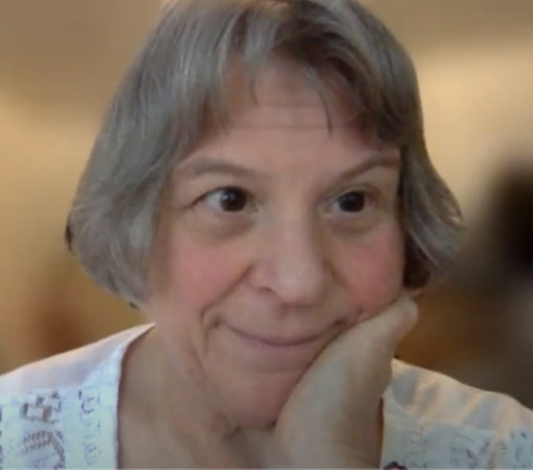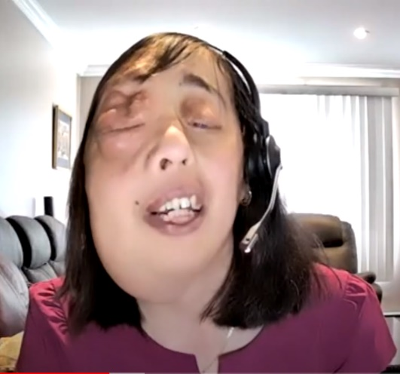
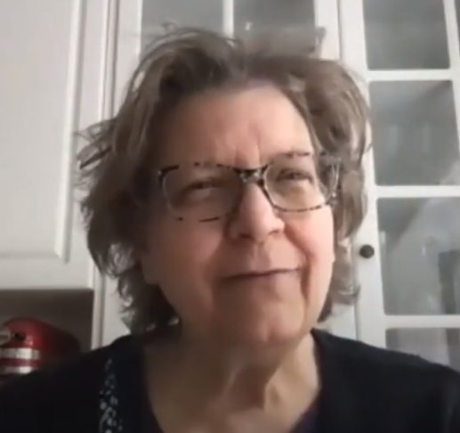
Frances-Mary d’Andrea, Natalie Martiniello,
Cay Holbrook and Michael Hudson
speaking at the BLC Symposium

Calendar of Upcoming Events

Getting in Touch with Literacy Conference 2021
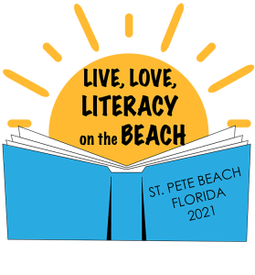
The Getting in Touch with Literacy Conference brings together the most current thinking on all forms of literacy for individuals who are blind or visually impaired, including print, braille, auditory, tactile graphics comprehension and the use of assistive technology. GITWL is a fantastic biennial professional conference for Teachers of Students with Visual Impairments and other blindness professionals, focusing on literacy (including braille). It is a great venue to learn about research and practice. The 2021 Conference will be held in person at St Pete Beach, Florida, USA from 1 to 4 December. For more information, see www.gettingintouchwithliteracy.org/.

Round Table Conference May 2022
The Round Table on Information Access for People with Print Disabilities brings together organisations and individuals in Australia and New Zealand. At its annual Conference producers, teachers, librarians, technology manufacturers and distributors and end users come together. Papers and presentations come from all around the world. The next conference is planned in Melbourne for May 2022. Keep up to date with what's happening at http://printdisability.org/conference/.

ICEB Mid-Term Executive Committee Meeting June 2022
ICEB is planning its Mid-Term Executive Committee meeting in Montreal, Canada. Observers are welcome. We are asked to arrive on Tuesday 31 May and sessions will continue until the morning of Saturday 4 June. Braille Literacy Canada is holding its Annual Meeting on the afternoon of Saturday 4 June.
COVID-19 may prevent an in-person meeting. We are advised not to book travel until the organising team can update us, by the end of this year.

Vision 2022 – Dublin, Ireland, July 2022
Vision 2022 is the 13th International Low Vision Conference by the International Society for Low Vision Research and Rehabilitation. After being postponed in 2020 and 2021, the Vision 2022 Conference will take place on 5-8 July 2022 in Dublin, Ireland. To stay up to date with registration and programme information go to https://vision2022dublin.com/.

UEB Q&A
In the Rules of Unified English Braille, 2013, Section 10.9.3 (c) states that the shortform for “little” is used if it begins a word and it is not followed by a vowel or “y”.
Consider the situation where the sequence “ll” occurs at the beginning of a word.
If “ll” is followed by a vowel or “y” as in the word Llanelli, the sequence cannot be read as “little” so no intervention is required.
If “ll” is followed by a consonant as in the acronym LLC, a grade 1 indicator is required to ensure that “ll” will not be read as “little” according to the rules.

ICEB Contact Details
Website: www.iceb.org
Email: info@iceb.org
Twitter: @ICEBbraille
Facebook: www.facebook.com/ICEBbraille/
ICEB-announce list:
Send an email to iceb-announce+subscribe@groups.io to receive announcements from ICEB, including this newsletter and notifications regarding updates to Unified English Braille.

