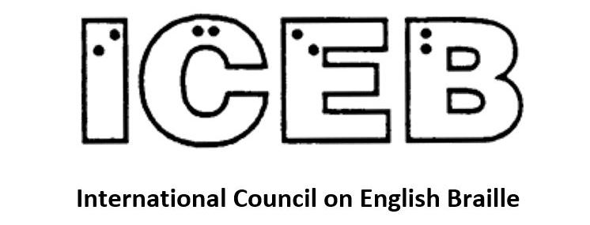

ICEB Newsletter
Issue 12
December 2021

From the President's Desk
Judy Dixon writes:
Welcome to another jam-packed edition of the ICEB Newsletter. In this issue, we hear about the latest happenings from the ICEB Braille Music and Braille Technology committees, and much more.
After the New Year, we will be focussing on planning for the upcoming Mid-Term Executive meeting to be held in June. In addition to organizational business, we will also have some interesting presentations on braille so be sure to put the dates on your calendar. You won't want to miss this one!
We would welcome more involvement from those who care about braille and want to help keep it a vital force in the lives of those who rely on it. If you are interested in helping out with such tasks as contributing to the newsletter, assisting with the website, and so forth, please write to info@iceb.org.
Keep braille alive.
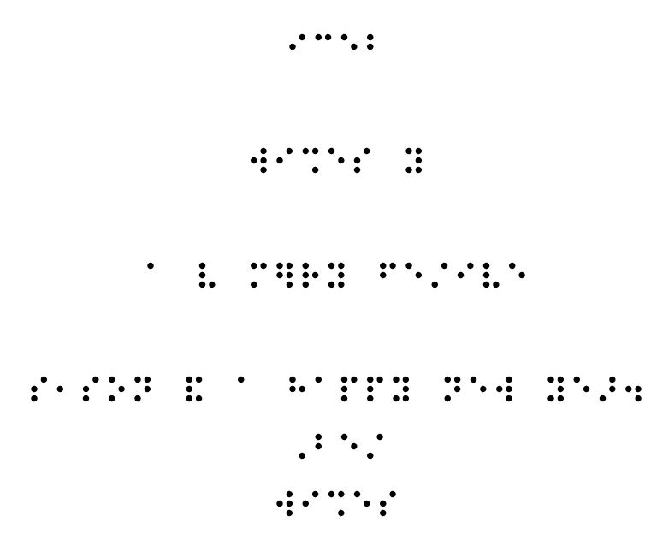

Code Maintenance Committee Update
Kathy Riessen writes:
The CMC continues its work revising the UEB Rulebook to meet the needs of the ever-evolving English language. A meeting was held in November of the representatives from each ICEB member country to begin finalising the revisions to three sections of the Rulebook which have resulted from allowing the use of shortforms in certain circumstances within longer words which have a medial capital.
Final drafts have been prepared and voting on these revisions will commence mid-January. Once revisions are voted on and ratified by the ICEB Executive Committee, a formal announcement will be posted on the ICEB-announce list (Information on how to join can be found at the end of this newsletter) as well as on the ICEB website https://iceb.org.
The work of CMC does not finish here. We are poised to begin the process of revising the Sections which relate to prefixes and bridging. Some rules are pronunciation or syllabic dependent. An example is “be” at the beginning of a word. One discussion relates to the word “beret” which can be pronounced in more than one way depending on where you live. There are also prefixes and syllables relating to scientific expressions, where the use of contractions across syllables may be inappropriate. Examples include aeroflight and disulphide. The rules will be carefully reviewed and revised to give greater clarity in contraction use.
Currently Appendix 2 is a list of example words found in Section 10, Contractions. The CMC will be expanding this Appendix to include known problem words. We will be reviewing individual words or sets of words one at a time and add them to the list as decisions are made. One word already decided on is “Beethoven”. We looked at the rules regarding strong contractions, and determined that the use of the “th” contraction would not distort the form of the word. The decision was that “Beethoven” should be brailled using the “th” contraction. Any words you would like to suggest for revision and inclusion in Appendix 2 can be forwarded to ueb@iceb.org.
Another project, is the preparation of an index for the Rulebook. This is a complex job and it is hoped to secure the expertise of a professional indexer for this important project.
It is anticipated that the next (3rd) edition of the Rulebook including an index will be ready for publication by the next General Assembly in 2024.

UEB Q&A
Did you know that the music signs for sharp, flat and natural have been assigned UEB equivalents when in a literary context? Try brailling:
Best of Beethoven: 1st B♭ trumpet.
Answer towards the end of this newsletter.
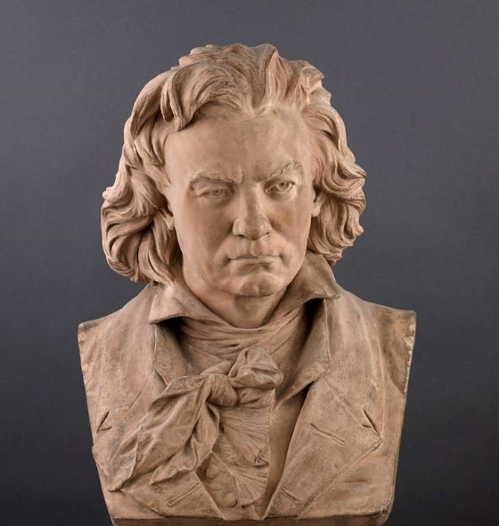
Beethoven

Save the Date: Mid-Term Executive Meeting of ICEB
The International Council on English Braille (ICEB) is pleased to confirm that its Mid-Term Executive Committee meeting will be held from Sunday 5 June to Thursday 9 June 2022. The event will be held daily online via Zoom at 20:00 UTC. The virtual meeting will bring the Executive Committee together to discuss ICEB business, including updates on work undertaken by ICEB committees. The meeting will include additional presentations on braille and reports from the member countries of ICEB. Observers are welcome to attend.
The deadline to register will be 13 May, 2022. Further details, including the agenda and registration instructions, are forthcoming shortly at: https://iceb.org. Those interested are also invited to follow @ICEBbraille on twitter and the hashtag #ICEB2022 for updates.
Thanks are extended to Braille Literacy Canada for hosting the meeting in collaboration with ICEB. We look forward to connecting with you all in a week dedicated to braille.
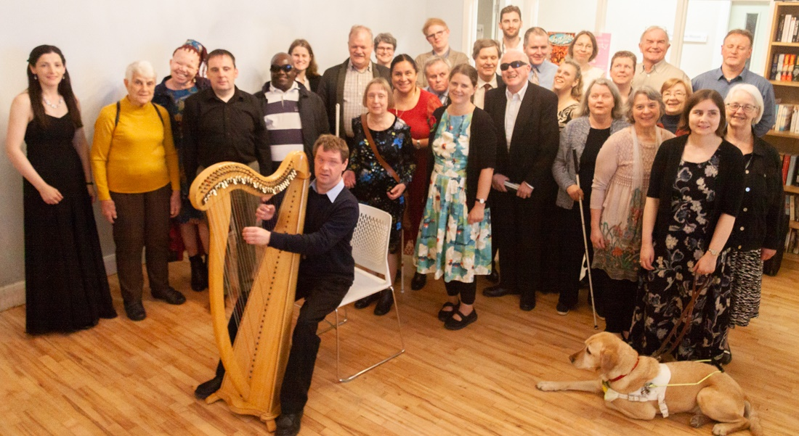
Attendees at the 2018 ICEB mid-term executive meeting in Ireland
The International Council on English Braille (ICEB) was formed in 1991 and provides a forum for international cooperation among those countries that use English-language braille by assisting countries to establish standard-setting bodies in relation to braille codes and practices; working towards the development and adoption of international minimum standards for the production and teaching of braille; and facilitating the exchange of braille materials between member countries. Its members currently include braille authorities from Australia, Canada, Ireland, New Zealand, South Africa, the United Kingdom, and the United States. To learn more about ICEB, visit https://iceb.org or write to info@iceb.org.

ICEB reaffirms the importance of braille during times of pandemic and international crises
As a result of Resolution 2 from the ICEB General Assembly in 2020, the following press release was issued.
October 26, 2021 -- The International Council on English Braille (ICEB) underscores the importance for governments and organizations to ensure that information shared with the public during times of pandemic and international crises is made equitable and accessible to those who use braille. Braille is literacy. Braille signage, elevator buttons, restaurant menus, and information in braille about health and other services provide equal access to information and are essential for millions of people who are blind, deafblind, or who have low vision.
The pandemic has served as a critical reminder of the need to improve equitable access to information during times of international crises, when those who read braille are too often left behind. Moreover, measures to ensure timely access to accessible information are highlighted in articles 11 and 21 of the United Nations Convention on the Rights of Persons with Disabilities (UNCRPD), now ratified in 182 countries: http://www.un.org/disabilities/documents/convention/crpd_english.doc.
ICEB calls upon governments and organizations to review their emergency preparedness plans to ensure that measures to provide timely access to information, including information in braille and tactile graphics, are put in place and remain a priority. Resources on the process for producing accessible information in braille can be obtained from a country's braille authority. A list of braille authorities for English-Speaking countries can be found at https://iceb.org/icontact.htm.

Braille Research Committee
Natalie Martiniello, Ph.D, CVRT, President of Braille Literacy Canada, Chair of the ICEB Research Committee writes:
The ICEB research committee provides members with an opportunity to share information about braille related research across ICEB member countries and globally. To learn more about this committee or to share information about any braille research that may be of interest to ICEB members, write to info@iceb.org. Below are a few research related updates that may interest you.
Joshua A. Miele, a U.S. based research scientist, won a prestigious MacArthur Foundation fellowship for his groundbreaking research on accessibility and assistive technology, including innovations that enhance access to braille. A braille reader himself, Miele worked at The Smith-Kettlewell Eye Research Institute in San Francisco for 15 years and is now an accessibility researcher with Amazon. Among his many projects, he developed TMAP (Tactile Map Automated Production), a web tool that makes it possible for blind people to get free, immediate tactile street maps of any place in the country, and a glove tool that allowed users to type braille onto any solid surface before the days of onscreen braille input. You can learn more about his many contributions to braille and accessibility research by visiting:
https://www.macfound.org/fellows/class-of-2021/joshua-miele
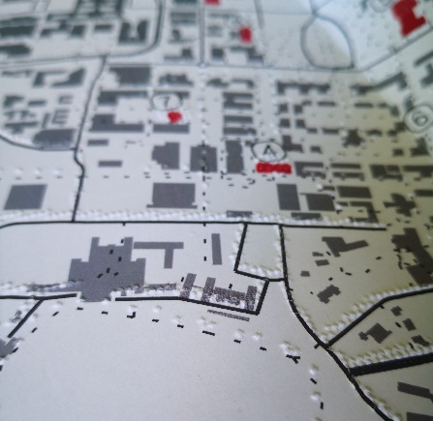
Tactile and clear print map created using TMAP
We applaud Josh for this prestigious achievement and are thrilled to see accessibility and braille research receive this global recognition.
In other braille related news, the most recent issue of the Journal of Visual Impairment and Blindness (JVIB) includes a practice report on configuring the Braille Note Touch Plus for students with visual impairments in a foreign language class. The authors describe how to configure the BNT for language learning and the benefits of having access to both speech output (for learning a language orally) and braille (for reading and writing):
https://doi.org/10.1177/0145482X211046695
Continuing on the technology theme, an article in the TeX Users Group's TUGboat publication, linked below, describes the "latex2nemeth" package, which allows for a blind user to translate a LaTeX source document containing mathematical and scientific material into a braille (Nemeth Code) document:
https://tug.org/TUGboat/tb42-2/tb131papasalouros-latex2nemeth.pdf
Finally, ICEB is in the process of compiling a list of resources (research, strategies, curricula) to support adult braille learning. We invite all contributions to help ICEB move forward on this initiative and look forward to learning more about the adult braille learning practices taking place where you are. Learn more here:
http://www.iceb.org/adult-braille-learning.html

Braille Technology Committee
The ICEB Braille Technology Committee is chaired by James Bowden from the UK. Each ICEB member country is represented on the committee together with several observers.
The committee has been working on Resolution 1 from the 2020 General Assembly about UEB Support in Digital Braille Tools. A letter is going out to manufacturers of braille displays and embossers as well as screen reader developers to urge them to stay up to date with the current versions of various braille translation programs. And we are praising those who already are as current as practical.
One piece of braille translation software is Liblouis. It is open source and relies on many volunteers and some paid staff from blindness organisations to update its code and test all new releases before they are let loose on end users. Several members of the Braille Technology Committee are among those assisting with the development of Liblouis, focusing on updates to the UEB code.
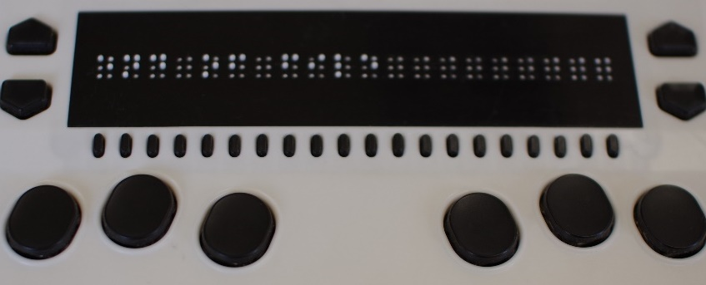
Users with electronic braille displays and transcribers of braille are familiar with BRF files. These are braille formatted files that drive the electronic displays and embossers. There is no easy way to navigate a BRF file heading by heading as you can search a Word file or a properly structured PDF file. The American Printing House for the Blind is working on a standard to create a navigable BRF file to be known as an eBRF file. The ICEB Executive Committee and the Braille Technology Committee are watching this development closely.

Music Committee
The ICEB Music Committee is chaired by Jordie Howell of Australia. As with all ICEB committees, there are voting members and observers from all ICEB member countries contributing to their work. Since the 2020 General Assembly they have been discussing their Charges (tasks) including the Resolutions adopted at the Assembly.
Resolution 8 asked the Committee to investigate an update of the New International Manual of Braille Music Notation (1996) by Bettye Krolick. The Music Committee does not have access to an electronic master of the manual.
After careful consideration, the Music Committee and the ICEB Executive Committee have agreed that it would be more productive to produce a supplement to the manual. The goal is to include new material not covered in the 1996 manual.
If you are a musician or transcriber, what are the musical gaps in the manuals you are using? If you have any suggestions for the supplement, please email Jordie Howell at jordina.howell@gmail.com.
The Music Committee is well aware that braille music is the only universal braille code. All around the world musicians, teachers and transcribers read, sing and play the same braille code, irrespective of country or language. The resolution calls on ICEB to develop a cooperative project with braille authorities and other braille-producing entities within and external to ICEB. The committee is reaching out to colleagues around the world and also to the DAISY Consortium which is leading a project to convert print and electronic music scores into braille music.
We look forward to bringing you more news of this important project in future newsletters.

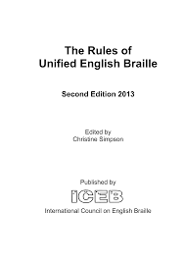
Hard copy versions of Rules, Guidelines and IPA Code
Rules of Unified English Braille, Second Edition, 2013 is the definitive UEB Rulebook produced by ICEB. Hard copies are available for purchase from RNIB in print and braille. The electronic files are available on the ICEB website for free download and can be printed or embossed for personal use. Go to https://iceb.org/ueb.html#Rulebook.
Guidelines for Technical Material was first produced in October 2008 by the Maths Focus Group, a subgroup of the former UEB Rules Committee during the UEB development phase. The purpose of this document was to give transcribers enough information and examples to produce Mathematics, Science and Computer notation in Unified English Braille.
In August 2014, a new version was produced to correct errors in the first edition. Hard copies of the 2014 version are available for purchase from RNIB in print and braille. Electronic versions are available for free download in print or braille from the ICEB website. Again for more information go to https://iceb.org/ueb.html#Rulebook.
IPA Braille is a braille code for the transcription of the International Phonetic Alphabet (as revised to 2005). It is based upon the 1934 braille code for IPA devised by W. Percy Merrick and W. Pothoff, brought up to date primarily through the efforts of Robert Englebretson, Ph.D., under the auspices of the ICEB's Unified English Braille Linguistics Committee, chaired by Jean Obi. Dr. Englebretson is the editor of the defining documents, entitled “IPA Braille”. Transcription to braille, and preparation of the tactile supplement and the various file formats, were carried out by CNIB (Canadian National Institute for the Blind).
IPA Braille was launched as an ICEB recommended code at the 4th ICEB General Assembly in Melbourne, Australia, in April 2008. Although IPA Braille is not part of UEB and employs a different prefix-root symbol pattern, it can be used in conjunction with UEB and other codes, and ICEB recommends its use generally for the transcription of IPA inclusions within non-IPA text.
Hard Copy Braille and Print Versions are available for purchase from the RNIB. Electronic files are available for download from the ICEB website. Go to https://iceb.org/icebipa.htm.

Purdys Chocolatier - First-of-its-kind box uses braille to make finding your favourite chocolate accessible to the blind community
VANCOUVER, BC, Dec. 14, 2021 /CNW/ – The Holiday Braille Box is an accessible box of Purdys chocolates designed specifically for, and with consultation from, the blind and partially sighted community.
The initial run of the box sold out online in a matter of hours but will be available again in time for last minute holiday shopping. Purdys also announced that they will re-release the box in the new year in response to the overwhelming demand.
The box features braille orientation tabs, a braille chocolate legend and a QR code that brings users who are blind or partially sighted to an accessible screen reader version of the legend.
“The braille on the Purdys box is about more than accessibility, it's about inclusion. It's about feeling seen, heard, and cared about as a consumer and frankly, as a person,” says Molly Burke, a leading digital creator in the blind and partially sighted community. “Imagine going 27 years without being able to pick your own chocolates without the help of another person or technology, that's been my life until now. This is more than a box of chocolates, it's the sign of change.”
To spread the joy even further, the full Purdys legend is also available in the 10 most spoken languages in Canada (English, French, Spanish, Italian, German, Mandarin, Cantonese, Punjabi, Tagalog and Arabic). The multilanguage legend is available to view at https://www.purdys.com/chocolate-legend.
Purdys has also made a $10,000 CAD donation to the CNIB Foundation through Purple Partnerships, their philanthropic initiative.
The Holiday Braille Box will be available again to buy online at purdys.com from December 15, 2021 or at select shops across Canada starting December 22, 2021.

People

Lloyd Gerald Rasmussen January 26, 1947—September 13, 2021
We were very sad to learn of the passing of Lloyd Rasmussen, especially those of us who were privileged to have met him.
Lloyd was born in Lohrville, Iowa, a town of approximately 300 people. He attended the Iowa Braille and Sight Saving School where he learned braille and acquired his lifelong love of reading. He obtained his novice amateur radio license when he was eight years old, one of the youngest people to do so. He encouraged many others, both blind and sighted, to obtain their licenses.
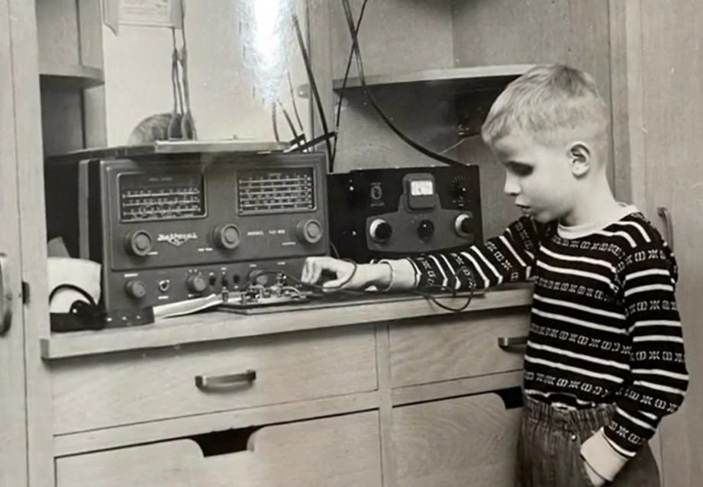
Lloyd attended Iowa State University and graduated with a Bachelor's degree in Electronics Engineering, one of the first blind people to be awarded a degree in this field. He used readers, braille graphs and slide rules to complete his complicated math classes. His first job was with Collins Radio where he tested instruments to help airplanes navigate in the fog.
Lloyd moved to Maryland in 1975 to work for the National Library Service for the Blind and Print Disabled. He helped to design talking book players, enabling thousands of blind people to read audio books. More recently, he was working on the design and testing of portable electronic braille reading devices. These devices allow blind people to download books in braille formatted files from the Library for the Blind and Print Disabled collection, as well as newspapers and other documents. He loved his work, and felt he was making a difference in people's lives, especially for newly blind people who thought they had lost the pleasure of reading.
For over 50 years, Lloyd was very active in the National Federation of the Blind. He held offices both at the state and local level, taught technology classes, as well as printed thousands of braille pages for seminars, children's programs, chapel services and conventions.
From 1983, Lloyd attended the Presbyterian Church of the Atonement. He served terms as both an elder and deacon, and sang in the choir among other roles.
Literacy and numeracy through braille allowed Lloyd to influence and support many.

Country Updates

South Africa

Introduction of Lego Braille Bricks in South Africa
Blind SA has joined the Lego Bricks Foundation to increase literacy among blind children through the use of Lego braille bricks. The project is being rolled out in various countries, with South Africa being the very first state in Africa on whose soil this project was kindled. The use of Lego braille bricks for reading will also be coupled with introducing reading through interactive play among children, regardless of whether they are visually impaired or not. The Lego braille bricks seeks to level the playing field in which fun and friendship with the mainstream children can be reached. In the long run, blind children will be empowered when they enter the open world.
This exciting project was exhibited during the 75th Anniversary Conference and Exhibitions on 10 to 12 November. Blind SA will facilitate the introduction of the Lego braille brick project in South Africa by engaging schools in two provinces. The two identified provinces, Gauteng and Western Cape, will be visited in 2022 and teachers will be presented with the project. We trust that the fun that goes with this will truly instil the culture of reading among children. Thanks to the Royal Danish Embassy for presenting this project to South Africa and thanks to Blind SA for taking up the challenging task of facilitating the introduction of the project to schools in South Africa.
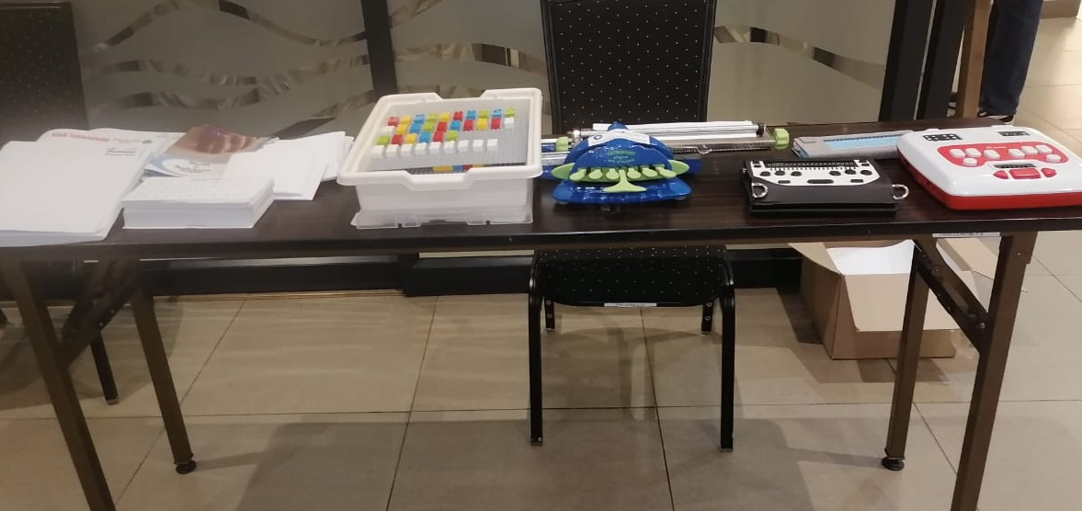
The Lego braille bricks have centre place
on the stand at the Blind SA exhibition.

Blind SA’s Medal of Honour Bestowed on Mr Christo de Klerk
In recognizing the role played by individuals on the lives of blind people both in South Africa and abroad, Blind SA quadrennially holds a function to bestow its medal of honour to the most deserving person. During its 75th anniversary celebrations, Blind SA recognized the services that Mr Christo de Klerk has rendered to the improvement of braille, among other things.
Christo de Klerk, a lawyer and computer programmer by profession, was notably instrumental in the debates that led to the ultimate formulation of Unified English Braille (UEB) which was re-coined to suit the South African circumstances as the Unified Braille Code (UBC). Mr de Klerk also propelled the introduction and the subsequent implementation of UBC in South Africa in mid 2000s.
In 2012, he facilitated the transition of the South African Braille Authority from its predecessor, Braille SA (in his position as the chairperson), and was elected first president of the Authority. He also worked very closely in the development of the braille codes for the different South African languages (work which he is still currently enjoying).
Mr. de Klerk has served as a member of Blind SA's Executive Committee for a very long time, and he is currently the Vice President of the organisation. Deservedly, Blind SA saw it fit to recognize and appreciate his role in the sector by bestowing the highest meritorious award on 10 November 2021.
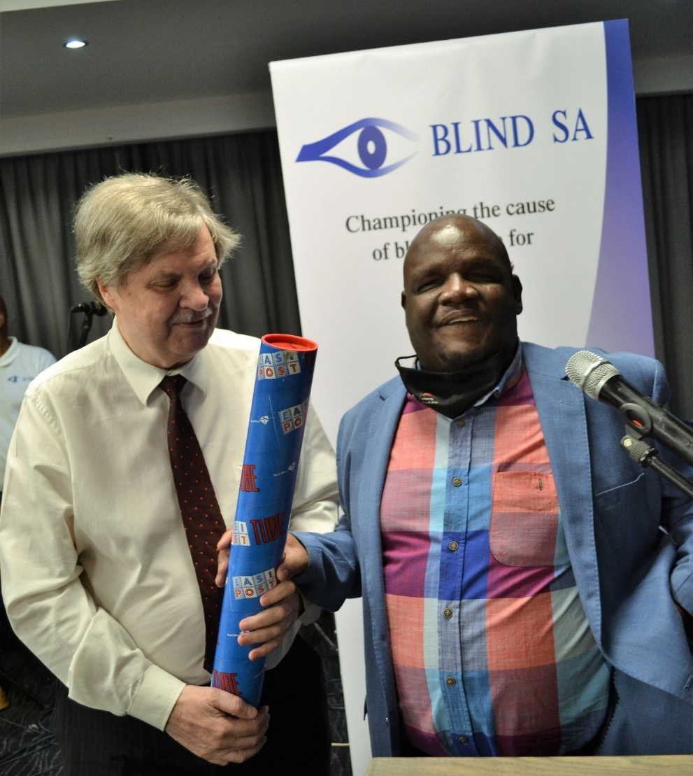
Blind SA President, Ntshavheni Netshituni (right) presenting
Vice-President Christo De Klerk (left) with his medal of honour.

Calendar of Upcoming Events

4 January, World Braille Day
World Braille Day is celebrated on January 4th each year, in commemoration of Louis Braille's birthday in 1809 and in recognition of the continuing importance of braille for literacy and independence for people who are blind, deafblind or have severe low vision throughout the world. World Braille Day was officially recognised by the United Nations in 2019.
ICEB encourages organisations and individuals to mark World Braille Day with celebrations and as an opportunity to share our love of braille.

Round Table Conference May 2022
The Round Table on Information Access for People with Print Disabilities brings together organisations and individuals in Australia and New Zealand. At its annual Conference producers, teachers, librarians, technology manufacturers and distributors and end users come together. Papers and presentations come from all around the world. The next conference will be held online on 16 and 17 May. The Australian Braille Authority, a committee of the Round Table, will hold its Annual Meeting on Saturday 14 May.
Keep up to date with what's happening at http://printdisability.org/conference/.

ICEB Mid-Term Executive Committee Meeting June 2022
ICEB is holding its Mid-Term Executive Committee meeting online from Sunday 5 to Thursday 9 June. More details coming soon.

Vision 2022 – Dublin, Ireland, July 2022
Vision 2022 is the 13th International Low Vision Conference by the International Society for Low Vision Research and Rehabilitation. After being postponed in 2020 and 2021, the Vision 2022 Conference will take place on 5-8 July 2022 in Dublin, Ireland. To stay up to date with registration and programme information go to https://vision2022dublin.com/.

UEB Q&A
⠠⠃⠑⠌⠀⠷⠀⠠⠃⠑⠑⠹⠕⠧⠢⠒⠀⠼⠁⠎⠞⠀⠠⠃⠼⠣⠀⠞⠗⠥⠍⠏⠑⠞⠲
Refer to Section 3.18 of the Rulebook.

ICEB Contact Details
Website: www.iceb.org
Email: info@iceb.org
Twitter: @ICEBbraille
Facebook: www.facebook.com/ICEBbraille/
ICEB-announce list:
Send an email to iceb-announce+subscribe@groups.io to receive announcements from ICEB, including this newsletter and notifications regarding updates to Unified English Braille.

