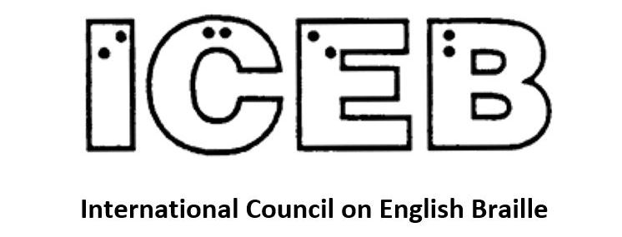

ICEB Newsletter
Issue 13
March 2022

In This Issue
From the President's Desk 3
Mid-Term Executive Meeting of ICEB 3
Code Maintenance Committee Update 4
UEB Q&A 5
New Chair of UEB Technical Materials Committee 6
Have We Had It Wrong All These Years? 9
Taking Control of Our Right to Read 11
Braille Research Committee 14
Braille Technology Committee 15
Music Committee 16
Blind Music Readers E-mail Group 17
Country Updates 18
Australia 18
Canada: World Braille Days 2022 19
South Africa 20
Calendar of Upcoming Events 23
UEB Q&A 24
ICEB Contact Details 24

From the President's Desk
Judy Dixon writes:
Once again, we have a jam-packed newsletter which demonstrates how busy we all have been and how much we are accomplishing. In addition to planning the Mid-Term Executive Committee meeting to be held virtually in June, we are moving forward with code development, and are pleased to welcome Clive Lansink, the new chair of the UEB Technical Committee. We will also hear from the chair of the ICEB Research Committee about new research recently published on the number of braille readers in the United States. It is very difficult to call for action on braille literacy without agreed-upon definitions and accurate and timely statistics. Perhaps, this will be a subject for a 2024 ICEB resolution.
We hear from two other ICEB committees, Braille Technology and Music. And then we are treated to a summary of the latest braille happenings in member countries. I hope everyone enjoys this terrific newsletter and I encourage all of you to let us know about any braille news that occurs in your corner of the world.

Mid-Term Executive Meeting of ICEB
The International Council on English Braille (ICEB) is pleased to confirm that the Mid-Term Meeting of the Executive Committee will be held from Sunday 5th June to Thursday 9th June 2022. The event will be held daily online via Zoom at 20:00 UTC. The virtual meeting will bring the Executive Committee together to discuss ICEB business, including updates on work undertaken by ICEB committees. The meeting will include additional presentations on braille and reports from the member country representatives to ICEB. Observers are welcome to attend.
The deadline to register is the 13th of May, 2022. The meeting agenda, as well as committee and country reports, will be provided to registrants in Word and BRF formats. Visit http://www.iceb.org/register to complete the registration form.
Those interested are also invited to follow @ICEBbraille on Twitter and the hashtag #ICEB2022 for updates.
Thanks are extended to Braille Literacy Canada (BLC) for hosting the meeting in collaboration with ICEB. We look forward to connecting with you all in a week dedicated to braille!
The International Council on English Braille (ICEB) was formed in 1991 and provides a forum for international cooperation among those countries that use English-language braille by assisting countries to establish standard-setting bodies in relation to braille codes and practices; working towards the development and adoption of international minimum standards for the production and teaching of braille; and facilitating the exchange of braille materials between member countries. Its members currently include braille authorities from Australia, Canada, Ireland, New Zealand, South Africa, the United Kingdom, and the United States. To learn more about ICEB, visit http://www.iceb.org or write to mailto:info@iceb.org.

Code Maintenance Committee Update
Kathy Riessen writes:
This has been a quiet time for the Code Maintenance Committee, due to some family health issues, but I now look forward to the downhill run towards the Mid-Term Executive Meeting, where we will have the opportunity to discuss and consolidate the ongoing work of the Code Maintenance Committee in ensuring the complex balance is maintained between the needs of readers, keeping rules as simple and concise as possible (which is not always easy), and maintaining the integrity of the basic premises on which UEB is based.
In the last newsletter I pre-empted the use of the “th” contraction in the word Beethoven. This has since been ratified by a vote taken by the committee members of the Code Maintenance Committee. The vote was not unanimous as there were conflicting views on how the rules should be applied to this name, mainly based on pronunciation. The majority vote was to contract “th”, and relevant examples will be included in the Rulebook.
This vote begins a process of looking at a number of words where the rules may be applied in more than one way, and making a decision on how to contract them. These words will form the basis of expanding Appendix 2 of the Rulebook to include words where the choice of contractions may not be obvious. If you have any words to suggest for this list, feel free to pass these on.
The committee has also begun looking at a UEB symbol for the German letter eszett or sharp S, basing it on its braille equivalent in the German Braille Code, with an added prefix. More on this later.

UEB Q&A
Is it an opening quote, question mark?
Read and decode the following.
⠦⠱⠁⠞
⠘⠦⠀⠱⠁⠞
⠰⠦⠀⠱⠁⠞
⠰⠦⠱⠁⠞
Answer on page 24 of this newsletter.

New Chair of UEB Technical Materials Committee
The Technical Materials Committee is responsible for the UEB symbols for math and science. The Committee's charge (task) is to keep current the Guidelines for Technical Materials (GTM).
Dr. Dónal Fitzpatrick from Ireland was appointed the Committee's Chair for this term. However a change in his work commitments has meant he has had to resign from the role.
The ICEB Executive Committee has been pleased to appoint Clive Lansink from New Zealand as the new Chair.
Writing to the UEB Technical Materials Committee, Clive Lansink said:
I am now at the end of a long career as a software developer and IT manager. I live in New Zealand and have been here all my life, except for living two years in the USA as a post grad university student on a Rotary fellowship award. I am in my mid sixties and now work from home in a more relaxed semi-retired life style. I am totally blind and have used braille all my life.
I remember as a child the introduction of the Nemeth maths code into New Zealand. I completed a bachelor degree in electrical engineering in 1976. Although course materials in braille were scarce, I relied heavily on Nemeth for reading course materials and writing exam and test answers. That is all well and truly in the past, and whereas nowadays I could still solve some problems such as a quadratic equation, I really don't have a good and current working knowledge of higher level mathematics. But I do fully grasp the need for braille to properly handle high level technical materials.
My degree in electrical engineering took me into developing software, computer programming as it was called in the late seventies, and later I took up more senior management roles.
However I became a bit disillusioned with this in the early days of the switch from character to graphical user interfaces. I decided on a major change, and I completed a law degree, graduating with honours. Though I can't compare myself really to the rather ill-disciplined youth I was when I got my first degree, it really did illustrate to me how technology had made a huge difference to the way blind people can access information to study to our full potential. There really was nothing I couldn't easily find and read, even in braille using a braille display, to support my study. Graduating with honours led me to work as a judge's clerk for two years in the High Court in Auckland, New Zealand. My ultimate plan was to practice law on my own account.
But in the end I didn't step completely away from software development. I ended up working on a project with HumanWare to demonstrate how talking books could be delivered directly to DAISY players in a completely automated way so they would just be there for clients to read. That work led me to chairing the committee developing the DAISY Online Protocol for the DAISY Consortium. I had to quickly step away from that role when I started working full time in the High Court.
My spare time life has been rather dominated by playing blind sports and being part of New Zealand's blindness advocacy movement. I have the honour of serving for the longest time as the President of our main blindness advocacy organisation, now called Blind Citizens NZ, and leading the process of change to improve life for blind New Zealanders in a number of important ways.
As fate would have it, after finishing my term as a judge's clerk, I picked up another significant software development contract with our local blindness agency. As I was working for myself, I had more control over my IT environment and I realised that things had rather improved in those years. My partner Mary Schnackenberg, who many of you will know, had been made redundant a couple of years earlier, and together we started our own business. We started doing disability consulting and then I supported Mary as she developed her interest in production of braille and other accessible formats. I never practised law, but my knowledge of law has been invaluable in the other things I do.
I remember the change to UEB and was a strong advocate for it, also representing New Zealand on some of the working committees.
Turning now to the Technical Committee, I understand from talking to people that we need to focus on updating UEB to properly handle modern technical materials. I'm sure some of you will know better than I do where the biggest stress points are and you may even have ideas on what to do to make the best progress. In order to get started, I will be calling a meeting on Zoom probably in April.
Perhaps it is just as well that I don't have a strong personal view on what changes we should make to UEB to make it cope better with modern technical materials. It means my focus as Chair will be on ensuring everyone has a fair say in our discussions, crystalising and recording our agreements, and keeping us moving towards the goal. I'm really hoping to hear from each of the ICEB braille authorities so we know what is important to you in this area right now.
Finally I want to say that I think all of us on this committee are keen to resolve any significant problems that are holding back the progress of UEB. I look forward to working with you all to make that happen for technical materials.

Have We Had It Wrong All These Years?
Judy Dixon Writes:
Even those braille readers with only a passing familiarity with the history of braille will almost certainly have heard that a soldier came to Louis Braille's school and showed the students examples of “night writing”, a system of dots that had been developed allowing the military to communicate at night. Louis was inspired by these dots and created a system of writing for blind people that is now used worldwide for reading hundreds of languages by touch.
But, is this true? A recent article in the Spring 2021 issue of the Disability Studies Quarterly published by the Ohio State University Libraries in partnership with the Society of Disability Studies entitled: Charles Barbier: A hidden story by Philippa Campsie paints a very different picture. After examining original correspondence and primary source documents, she concludes that “(1) the method that inspired Louis Braille was never intended for the military but was specifically designed for blind people; (2) Barbier did not demonstrate it at the Institution Royale des Jeunes Aveugles (IRJA); (3) it was not used at the school in a phonetic version; and (4) Barbier and Braille met only after Braille had published his own system.”
For those of us who have closely studied the history of braille, these revelations are shocking.
Campsie examines the books written about Louis Braille and his invention and traces where our long-held notions originated. She uses a collection of Barbier's papers donated in 2001 to the museum at Association Valentin Haüy in Paris and some of Barbier's writings now available as Google books to piece together a more accurate timeline.
She tells us that Barbier was a captain in the French army for only two days in May of 1792; he moved to the United States in September of 1792, first living in Baltimore then moving to Kentucky in 1795. He returned to France in the early 1800s and published several documents about shorthand systems.
In 1815, he published a book describing a writing system called Point Writing that could be represented with dots. This twelve-dot system was based on a 5-by-5 grid of letters. He proposed two forms of this system, one phonetic and one using the traditional French alphabet. He specifically mentions blind people as those who might benefit. He sent his system to IRJA in 1815 but the idea was rejected by its director. In 1821, Barbier again sent information about his method to the school's new director. This time, the director had someone become familiar with the system and the students began using the alphabetical version of it.
She says there is no evidence that Louis Braille met Barbier until 1833 when Barbier learned of Braille's system. Braille had published a description of his writing system four years earlier. After that, they corresponded over the next few years.
While it is true that Louis Braille's creation was inspired by a system of writing using dots developed by Barbier, there are many aspects that differ from what is portrayed in most accounts of Louis Braille's life. The details in this article are fascinating and definitely change our view of the history of braille.
Philippa Campsie is an adjunct professor in the Department of Geography and Planning at the University of Toronto and a freelance writer and researcher who specializes in urban and municipal affairs.
In addition to the article, there is an episode of the Disability History Association podcast released on August 5, 2021. Podcast Episode 30 – The Real Origins of Raised-Point Writing.
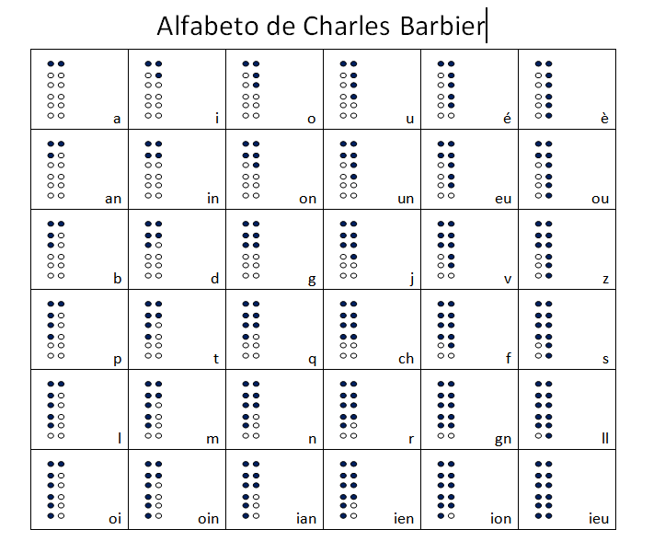
Charles Barbier's tactile alphabet

Taking Control of Our Right to Read
About the author: Martine Abel-Williamson QSM is President of the World Blind Union.
(Reprinted from The UN Chronicle)
Today—4 January 2022—we commemorate the 213th birthday of Louis Braille, the inventor of the tactile system many of us use as our prime literacy tool.
But in today's era of advanced technology, social media options and possible information overload, many are still experiencing a “book famine”, a lack of access to hundreds of thousands of titles, just because we cannot agree on how to collaborate to get information to each and every person in the world. We humans are supposed to be the most evolved species on earth, certainly the brightest, and yet, after having finally agreed to the Marrakesh Treaty to Facilitate Access to Published Works for Persons Who Are Blind, Visually Impaired or Otherwise Print Disabled in 2013, implementation and true action is happening at a grindingly slow pace. The Treaty is meant to bring together authors, print disabled persons, and library and learning institutions from around the world to make print information available and accessible to all. It is a great step forward, but we now need more than awareness-raising and reliance on goodwill.
When young Louis Braille invented the braille code in 1824, I'm sure his thoughts at the time weren't centred around a purist view of the right to access information, thus the right to read. He knew what he wanted and took action, took control of a dire situation instead of simply holding a hand out to receive charity. In those days, and sadly, in many places today, begging for charity is still the most basic way of “receiving help” in the community, even at the governmental level.
Awareness of our rights is great, and the United Nations and other structures and institutions should never underestimate the power of knowledge and awareness, but what we now need as never before is more action, for more of us to roll up our sleeves and get our hands dirty, for more of us to disrupt the current systems, intervene in the machinery of bureaucracy and play an innovative role.
The time is now for the United Nations and the World Intellectual Property Organization (WIPO), working through its Accessible Books Consortium, to step up the pace, to accelerate the availability of educational, recreational and any other information source, for if knowledge is power and if the pen is mightier than the sword, the power of the word will be at the fingertips of us all.
We shouldn't expect it to go swimmingly, however! During his lifetime, Louis Braille didn't receive recognition for his amazing, enlightening invention—he actually got ridiculed for it, as is often and sadly the case when we do have disrupters, interveners and innovators among us. People fear change; just remember what happened in the pre-industrial era when the spinning wheel was invented.
Now is the time for the United Nations and similar entities to make funding and capacity-building support available so that more scientists and even ordinary people can invest time into developing creative solutions, whether in the fields of e-book readers, mobile apps, smart home options and so much more—solutions I can't even imagine at present.
I don't simply want to pay tribute to Louis Braille by remembering what he has done for us, but to challenge everyone to accelerate their efforts, as the work is not yet done. While I have access to at least five technological options for accessing information in braille and synthesized speech, in the community of 253 million blind and low vision persons, so many still cannot make use of those tools, either because great opportunities and solutions are not affordable, or where they might actually be available at a limited cost, awareness of such availability hasn't reached everyone. Knowledge of what governments, corporations and the United Nations can do to facilitate further access remains limited.
The COVID-19 pandemic has shown us just what can happen when the science and medical fraternities collaborate with the corporate sector: never before have effective vaccines been developed so quickly. We have also proved to be resilient and flexible in getting on with life, which included utilizing e-solutions to meet with each other! Why can't we do the same when it comes to access to information?
So, in conclusion, I still wish to say thank you, Louis Braille, not just for inventing your liberating code but also for challenging all of us to take up the responsibility of advancing access to literacy.

Braille Research Committee
Natalie Martiniello, Ph.D, CVRT, President of Braille Literacy Canada, Chair of the ICEB Research Committee writes:
The ICEB Research Committee provides ICEB member countries with a platform to share information about braille related research and to remain updated about key braille issues and priorities. To learn more about this committee or to share details about any braille research, write to info@iceb.org. We also encourage you to follow ICEB on twitter, where links to braille related news and research is often posted: @icebbraille.
In this update, I would like to draw your attention to a recently published article in the Journal of Visual Impairment and Blindness entitled “How Many Braille Readers? Policy, Politics, and Perception”. This critical research, co-authored by Frances Mary D’Andrea, Rebecca Sheffield, the late Val Morrash, and Sarah Chatfield, tackles the question we are all often asked: what is the current braille literacy rate? While the often cited 10% statistic continues to be referenced, in the United States, this number can often be traced back to two primary sources: a National Library Service report from 1979 and the American Printing House for the Blind (APH) Federal Quota data. Neither of these reports should be used as sources for braille literacy rates, and getting to an accurate braille literacy rate is far more complex. It is important to consider how braille literacy is being defined, who is included (and excluded) from these surveys, and how these rates are being interpreted (and misinterpreted). There is currently no source of data that comprehensively measures braille literacy rates in the United States, nor any comprehensive data that demonstrate whether braille literacy rates have changed over time. You can read the full article and the implications for practice here: https://journals.sagepub.com/doi/abs/10.1177/0145482X211071125
Additional research investigates the role of the cerebellum during braille reading and other non-visual processing tasks:
https://www.sciencedirect.com/science/article/pii/S2666441022000085
We look forward to providing additional updates in future newsletter issues.

Braille Technology Committee
James Bowden writes:
The ICEB Technology Committee has representatives from all ICEB countries and looks at braille technology products. Our main tasks are looking at ways to improve braille translation in such products and staying up-to-date with current developments. We recently sent a letter to manufacturers known to use the popular Liblouis translation system, encouraging them to stay up-to-date as new versions of Liblouis are released every three months. Staying up-to-date ensures that the latest fixes and improvements are made available.
Another exciting project is the EBRF standard, looking at ways to enhance what can be done with electronic braille files. The EBRF project is still at an early stage, but promises to enrich the reading experience for braille books on braille displays.

Music Committee
Jordie Howell writes:
The Music Committee works to align Unified English Braille to the international music braille code. We achieve this through discussions on an email list comprising a voting member from each ICEB member country. We are also joined by observers who are very much part of our conversation.
At the ICEB seventh General Assembly, there were two resolutions pertaining to music that were passed.
The first is on the topic of the preservation of music braille available only as hardcopy. ICEB calls upon member countries and agencies to invest time and resources into the digitization of hardcopy music braille. We found that the US and Canada are the main players in the digitization of music braille, and are investing considerable resources and time in scanning and proofreading hard copies. Australia, New Zealand and the UK have indicated that their time is specifically devoted to working on new editions.
The second resolution involving music braille concerns investigating updating the New International Manual of Braille Music Notation (1996) by Bettye Krolick. Through discussions with specialists in the field, we agreed to investigate collating a supplement containing material not covered in the current manual.
The Music Committee's webpage contains a list of resources produced by member countries in Braille Music and UEB.
http://iceb.org/music.html
Each country lists resources and their developments in technology in both braille music production, distribution and rehearsal practices.
I do hope that you will attend the ICEB Mid-Term meeting to hear and perhaps take part in the music discussions touched on here. We may also talk about how the teaching of braille music has been affected by the pandemic. The progress of the MakeBraille software through the DAISY Music Braille Project will also be touched on and how automated music translation processes are improving.

Blind Music Readers E-mail Group
Jeanie Willis from New Zealand writes:
I've created a group for those of us who read music whether by braille or adaptive tech and want to share resources and test out new software and ways to read, share and write music. However, I would specify it is in English only.
I did a search on groups.io and found nothing like this. So don't think I am duplicating anyone else's forum.
The description of the group is:
A group for blind & partially sighted musicians, music teachers and students who use braille music or any form of adaptive tech to read and write music. With a particular focus on resourcing teachers and students.
You can subscribe by sending an e-mail to the address below:
Blind-music-readers+subscribe@groups.io
Just send a blank e-mail. You may have to put a space in the message field before some devices will let you send.
Then when you receive a confirmation e-mail from the group just hit reply and then send.
If you have any questions feel free to get in touch with me directly by email to jeaniewillis@gmail.com.

Country Updates

Australia

Braille Letter Songs Now Available
This announcement was posted by Christine Casey, Head of Department, Braille Advisory Service, Statewide Vision Impairment Services, State Schools - Disability and Inclusion, Department of Education, email cjcas1@eq.edu.au
The Queensland Department of Education's Statewide Vision Impairment Services team is pleased to announce that our Braille Letter Songs are now available online. The 26 Braille letter songs include the braille dot numbers and alphabetic word sign contractions for each letter of the English alphabet. Dot numbers are linked to consistent musical pitches to ensure that each song has a unique melody and to assist with the memorisation of each letter's braille formation.
The songs can be found at:
https://soundcloud.com/dete-4/sets/queensland-department-of-education-braille-letter-song/s-VSutmGrt9np
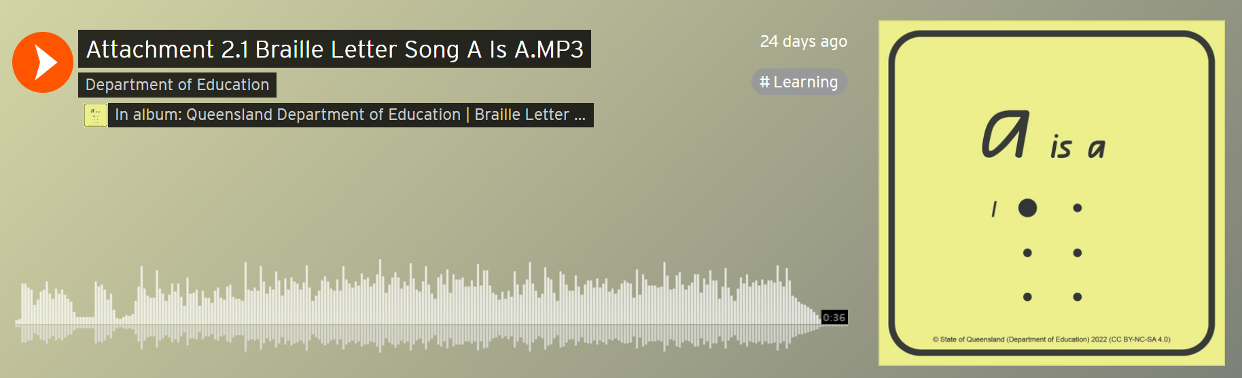

Canada: World Braille Days 2022
By Riane Lapaire, Braille & Accessibility Testing Coordinator, NNELS
What do you get when you put Braille Literacy Canada, the Canadian Council of the Blind, the CNIB Foundation, the Centre for Equitable Library Access, the National Network for Equitable Library Service, and the Provincial Resource Centre for the Visually Impaired in a room together? The boundless love of braille, a lot of laughter, and a series of nationwide World Braille Day events throughout January.
The first of the four events kicked off with the panel session “Looking Through the Crystal Ball: Innovations in Braille Technology for the 21st Century and Beyond” on January 8th. Panellists shared their expertise in many areas, including their early experiences with braille, tactile graphics, braille devices, what tools they use now, some best practices, and their braille hopes for the future.
The second event, “Building Braille Inclusion in Libraries”, which took place on January 13th, featured a live reading of the print-braille book My City Speaks followed by strategies for inclusive library programming, makerspaces, games, book clubs, and a demonstration of a refreshable braille display.
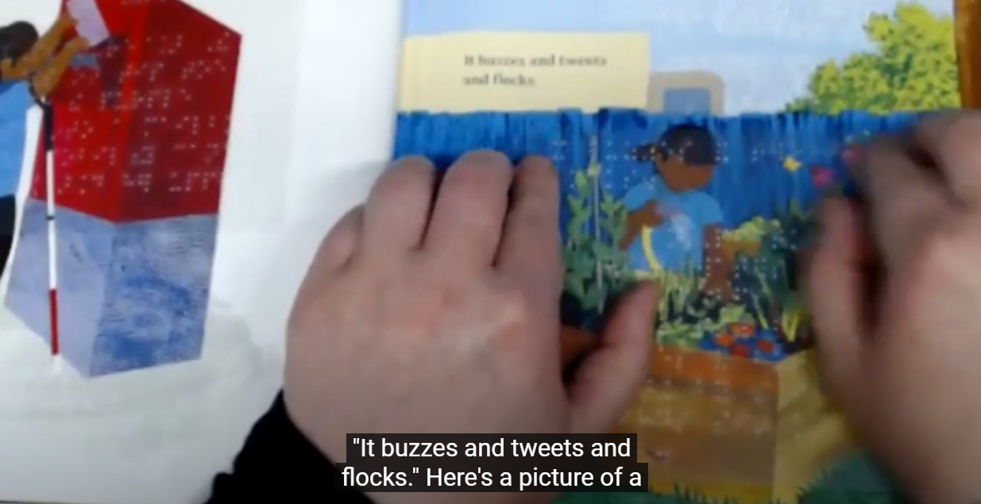
The January 20th session, “Tools for Your Toolbox: Braille Resources for French Speakers of All Ages” gathered a plethora of hard-to-find and highly desirable French braille resources into one place. Attendees could overflow their toolboxes with so many goodies; it was almost like it was someone’s birthday party…
To conclude the month-long celebration of braille, a session emphasizing braille awareness activities and the importance of braille in accessible design took place on January 27th. “Refreshing and Rethinking Braille Awareness Presentations with a Focus on Equity and Accessibility” shared strategies around co-designing classroom or community-based presentations with braille users and how to engage students in the broader accessibility, equity, and inclusion conversations.
For those who were unable to attend or would like to re-watch the events, the recordings for all four events are available for countless viewing pleasures on Braille Literacy Canada’s YouTube Channel.
BLC, CCB, CNIB Foundation, CELA, NNELS, and PRCVI would like to thank everyone who attended and supported World Braille Days 2022; and give specific thanks to the guest speakers and panellists for their generous contributions. World Braille Days 2022 wouldn’t have been successful without each of you. We look forward to seeing you at next year’s events!

South Africa
Christo de Klerk has shared the following:
Blind SA and Section27 ask Constitutional Court to End the Book Famine with new Court Papers
18 February, Johannesburg.
Blind SA and Section27 have filed papers with the Constitutional Court to ask the Court to confirm the Copyright Act of 1978 as unconstitutional for violating the rights of persons who are blind or visually disabled.
This follows our 21 September 2021 court victory where the High Court of South Africa (Gauteng Division) declared the Copyright Act unconstitutional because of the barriers it imposes on persons who are blind or visually disabled in accessing accessibly formatted reading materials. The court challenge showed how South Africa's current Copyright regime fails to allow people who are blind or visually impaired to convert published works, such as books, into accessible formats without first securing the permission of the copyright holder, which can take a long time or can be rejected.
Elsewhere in the world, many countries have exceptions into their Copyright law for persons with disabilities. In the absence of such an exception here, persons who are blind or visually disabled experience a Book Famine, with fewer than 0,5% of published works in South Africa made available in accessible formats such as braille.
In the High Court, Blind SA argued the Copyright Act has violated the rights of people who are blind or visually impaired since 1978, in particular the rights to dignity, equality, education, access to information, and participation in the cultural life of one's choice.
The High Court ordered the following:
• A declaratory order declaring the current Copyright Act invalid and unconstitutional because it limits/prevents people with visual disabilities from accessing works under copyright in formats that they can read, and does not include provisions designed to enable access to works under copyright as envisaged by the Marrakesh Treaty;
• A “reading in” – or inclusion – of the proposed section 19D of the Copyright Amendment Bill (CAB) to the current Copyright Act to allow an exception to copyright for people with disabilities so that they can convert published works into accessible formats like braille, large print, Digital Accessible Information System (DAISY).
The Constitutional Court has the mandate to confirm the High Court's order and amend Copyright Act to be more inclusive to persons who are blind or visually disabled. Blind SA and Section27 believe that confirming the Copyright Act as unconstitutional will further the values enshrined in our Constitution and reverse decades long discrimination against people with visual disabilities.
The Constitutional Court case is an important part of the process towards meaningful copyright reform so that people who are blind or visually impaired can access libraries of published works in formats that are accessible for them. While Parliament continues to debate the CAB through a drawn out and very politically charged process, a confirmation of the unconstitutionality of the Copyright Act regarding access to reading materials for persons who are blind or visually disabled from the Constitutional Court will help the community to access reading materials immediately.
The Constitutional Court will hear the matter on 12 May 2022. More details about the court hearing, and Blind SA and Section27's campaign to End The Book Famine will follow soon.

Calendar of Upcoming Events
12-14 May 2022, 1st Deafblind International Africa Conference
The 1st Deafblind International Africa Conference will be hosted by Deafblind International DbI at the Kenya Institute of Special Education, Nairobi, Kenya. The conference theme is “The Deafblind Reality in Africa: Meeting the SDG Opportunities & Challenges”. Registrations are now open. See www.deafblindinternational.org/conferences/africa/
14-18 May, Round Table Conference 2022
The Round Table on Information Access for People with Print Disabilities brings together organisations and individuals in Australia and New Zealand. At its annual Conference producers, teachers, librarians, technology manufacturers and distributors and end users come together. Papers and presentations come from all around the world. The next conference will be held online on 16 and 17 May. The Australian Braille Authority, a committee of the Round Table, will hold its Annual Meeting on Saturday 14 May. Workshops and the Annual General Meeting take place on 18 May. See http://printdisability.org/conference/.
5-9 June, ICEB Mid-Term Executive Committee Meeting 2022
ICEB is holding its Mid-Term Executive Committee meeting online from Sunday 5 to Thursday 9 June. To register go to http://www.iceb.org/register
5-8 July, Vision 2022 Dublin, Ireland
Vision 2022 is the 13th International Low Vision Conference by the International Society for Low Vision Research and Rehabilitation. The Vision 2022 Conference will take place on 5-8 July 2022 in Dublin, Ireland. See https://vision2022dublin.com/

UEB Q&A
The four examples in order are read:
open quote “what”
open quote, space, “what” [Refer to 7.6.8 of the updated Rules on Quotation Marks and Apostrophe available at iceb.org/ueb.html for an opening quote standing alone]
question mark, space, “what” [The grade 1 indicator is required so the question mark is not read as “his”]
question mark, no space, “what” [The grade 1 indicator is required so the question mark is not read as an open quote]

ICEB Contact Details
Website: www.iceb.org
Email: info@iceb.org
Twitter: @ICEBbraille
Facebook: www.facebook.com/ICEBbraille/
ICEB-announce list:
Send an email to iceb-announce+subscribe@groups.io to receive announcements from ICEB, including this newsletter and notifications regarding updates to Unified English Braille.

