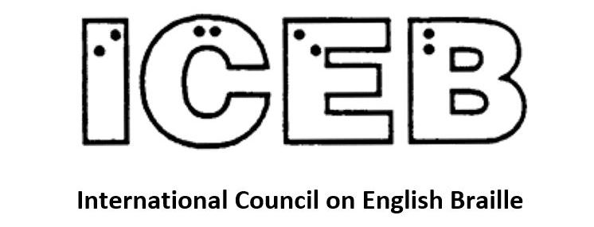

ICEB Newsletter
Issue 9
December 2020

Special Issue:
ICEB General Assembly

In this issue, we focus on outcomes from the ICEB General Assembly, held online in October 2020.

ICEB General Assembly 2020
This was the first General Assembly to be held solely online. Despite not being able to “socialise” at the end of the day, feedback rated the Assembly a real success.
The Assembly ran over five days from 18 to 22 October with a three-hour Zoom session each day. Some 194 individuals registered with between 60 and 87 participating on Zoom plus another 25 or so following on the live stream. Remarkable planning by the organisers made sure the Zoom worked extremely well throughout.
Day 1 featured a Keynote Address from Dr. Aubrey Webson, Ambassador to the United Nations for Antigua and Barbuda. As a blind person who has headed up UNICEF and worked previously for Perkins School for the Blind, he brought a unique international perspective. He urged ICEB braille authorities to honour World Braille Day on 4 January and promote literacy through braille. Reflecting on COVID-19 he commented that when blind people explore our world through touch the pandemic has stepped in the way, invading, almost disabling our sense of exploration. And he brought our minds to the poverty of so many blind and low vision people in today's world, speaking about education and employment, gender equality and more.
The assembly considered and adopted several reports from the President and others. One highlight was the country reports which ranged across braille-related developments that were new to many of us.
Day 2 had the theme of braille music when we received four papers. The music braille code is international and musicians and braille music producers around the world are co-operating to keep current the international code and improve automation of music braille from electronic music files. Information was exchanged about available resources for teaching music braille to blind users as well as sighted teachers. Among the ICEB business reports there was one from the outgoing Public Relations Officer, Leona Holloway, whose newsletters have significantly raised the profile of ICEB's work.
On day 3 the theme was Braille and Technology when we considered six papers about translation software and braille devices. We also received the report from the outgoing Code Maintenance Officer, Phyllis Landon, whose committees have been updating UEB to keep up with changes in the world of print.
The theme of Day 4 was braille literacy and learning when we considered eight papers. Topics included teaching braille to youngsters as well as adults, motivational techniques and the barriers to learning braille.
Day 5 drew the Assembly to a close with the report of the Resolutions Committee and the introduction of the incoming President and Executive Committee.
An innovation for this Assembly was the audio postcards about different cities and areas across the UK. There were brief presentations about the history of electronic braille displays, braille slates and tactile money.
All materials relating to the General Assembly are now available from the ICEB 2020 page at http://iceb.org/GA20.html, including live stream recordings, reports, paper presentations and resolutions.
Our very warm thanks are extended to UKAAF (UK Association for Accessible Formats) and RNIB (Royal National Institute of Blind People) for organising and hosting the virtual event in partnership with Academy London, Google's dedicated learning space.

ICEB Executive Committee
We welcome our newly elected Executive Committee of Judy Dixon (President), Christo de Klerk (Immediate Past President), Ilka Staeglin (Vice President, Ireland), Frances Mary d'Andrea (Secretary, USA), Jen Goulden (Treasurer, Canada), Kathy Riessen (UEB Code Maintenance Committee Chair), Maria Stevens (Public Relations Officer, New Zealand) and Members-at-Large James Bowden (UK), Jordie Howell (Australia) and Ntshavheni Netshituni (South Africa). At its first Executive Committee meeting following the Assembly, the ExCo exercised an option under the Constitution to add “an invited expert”, Mary Schnackenberg (New Zealand).
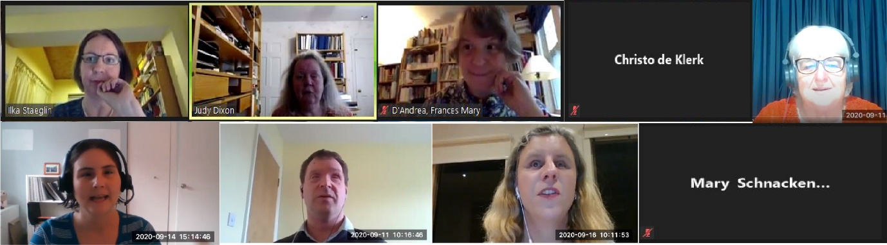
New to the ExCo are Kathy Riessen as the UEB Code Maintenance Officer and Jordie Howell as a Member-at-Large. Kathy is a very experienced sighted transcriber from Adelaide in South Australia who has recently led her first Zoom meeting of the Code Maintenance Committee members and observers. Jordie is a blind musician, braille teacher and music transcriber from Melbourne, Australia, who is Chair of the ICEB Music Committee. Mary Schnackenberg is back after a four-year break having served on the ICEB ExCo from 2004 to 2016.
We very warmly thank two members who have left the Executive Committee. Phyllis Landon has led the UEB code maintenance work since 2010 with her extensive knowledge of UEB as a sighted transcriber and her patience with the many and varied views we have about braille. Leona Holloway has served since 2016 as the ICEB Public Relations Officer, lifting the profile of ICEB across social media, the website and by starting this newsletter. Both Phyllis and Leona are generously continuing their support of ICEB's work.
Talking to the Assembly on Day 5, incoming President Judy Dixon said she had three goals for the next four-year term. They are to increase the visibility of ICEB, expand its capacity and grow its financial base. She wants the next generations of braille users, teachers and producers to be able to enjoy all the benefits our generation has received.

Resolutions
Each ICEB General Assembly agrees a set of resolutions which the incoming Executive Committee is asked to action. Because the assembly was not in-person this year, the incoming President, Judy Dixon, convened a committee of delegates from the seven member-countries who drafted the resolutions which were distributed with the papers ahead of time for the assembly's delegates to consider and amend or adopt.
Resolution 1 called on ICEB to work with manufacturers and software developers to improve support for UEB in digital tools.
Resolution 2 called for the availability of braille during times of national and international crises.
Resolution 3 affirmed the importance of braille for adults and older adults with acquired visual impairment and asked ICEB to develop a list of resource materials to support these new braille learners.
Resolution 4 dealt with preserving Music Braille presently available only as hardcopy braille.
Resolution 5 called on ICEB to document shorthand braille codes in an online resource.
Resolution 6 asked ICEB to work with like-minded organisations to foster the implementation of the Marrakesh Treaty throughout the world.
Resolution 7 asked ICEB to work with the World Blind Union to revitalise the World Braille Council.
Resolution 8 asked ICEB to investigate a cooperative project with braille authorities and other braille-producing entities within and external to the International Council on English Braille to update the New International Manual of Braille Music Notation (1996) by Bettye Krolick.
The full text of the resolutions is at http://iceb.org/GA20resolutions.html.

Unified English Braille

Code Maintenance Committee Update
Under the new leadership of Kathy Riessen, the Code Maintenance Committee (CMC) continues to consider how best UEB can meet the needs of the modern reader as print and technology are constantly changing. Discussion occurs via email listservs and is separated into two areas, Rules of UEB (UEB-CMC listserv) and the revision of the Guidelines for Technical Material (UEB-Tech listserv). Each member country has an official voting representative on the committee appointed by their respective braille authority as well as nominated observers, giving a wide range of expertise which includes blind and sighted braille readers, transcribers, educators and technology experts.
Current discussion on the UEB-CMC list is shortforms in longer words which contain medial capitals. DeafBlind has already been approved as a special case, and the committee is looking at if and how the rules may be updated for the general case.
The UEB-Tech list continues its work on the Guidelines for Technical Material revision and currently are looking at the section of omissions in technical expressions.
Updates which have already been approved since publication of the Rules of Unified English Braille 2013 and Guidelines for Technical Material 2014 can be found at http://iceb.org/ueb.html.
Queries or concerns with UEB can be referred either through your local representative or direct to the chair at ueb@iceb.org.

UEB Q&A
What quotation marks should be used for the following sentence?
Hit the "*" key.
Check near the end of the newsletter for the answer.

Braille research

ASSETS 2020
ASSETS is the ACM SIGACCESS Conference on Computers and Accessibility. It was held virtually this year in October. Research relying on touch access to tactile reading materials was restricted due to the COVID-19 pandemic, however there were still some projects of interest to the braille-reading community.
“Smooth Sailing: Autoethnography of a blind traveller” was a full paper presented by Kate Stephens of Monash University, Melbourne. Kate planned and embarked upon a 28-day cruise around Australia which was cancelled mid-way in response to the COVID-19 crisis. Analysis of Kate’s planning documents and travel diary revealed five key themes: information access, orientation and mobility, tools and technology, cultural and societal issues, and person-centred issues. A series of lists, tactile maps and 3D printed models were created by the research team to assist with independent orientation and mobility around the ship. These materials allowed Kate to develop cognitive maps before the trip, assisting with confidence during the cruise. Access to printed materials was also a strong theme, with Kate needing to press hard for electronic versions of newsletters and documentation so she could access them in braille/synthetic speech.
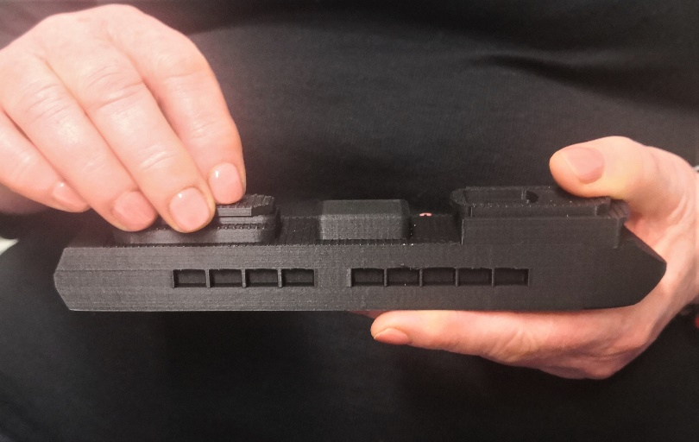
3D printed model of the cruise ship
Also from Monash University, Kirsten Ellis and fellow researchers teamed up with braille user Ross deVent for the design and creation of a one-handed braille keyboard that Ross could use for transcription of braille music. The study highlights the value of maker technology and a co-design approach for the creation of bespoke technologies for people with multiple disabilities or unique requirements.
TIP-Toy is the work of Giulia Barbareschi at the UCL Interaction Centre and the Global Disability Innovation Hub in London. TIP-Toy is a toolkit for multi-modal, accessible learning of computational concepts. It is open-source, enabling anyone to create their own TIP-Toy kit at low cost. Instructions are given at https://bitbucket. org/ecostanza/tip-toy/.
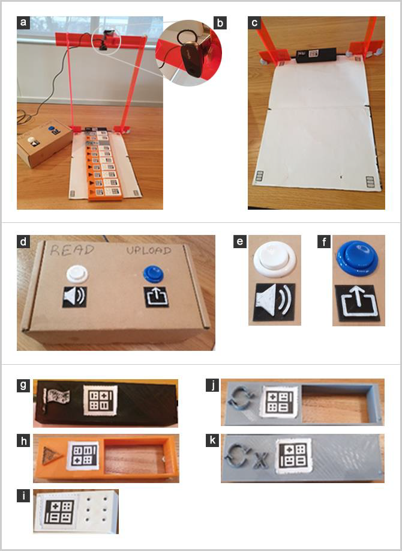
Left: Image of TIP-Toy components (a) The complete set-up of TIP-Toy, featuring the white A3 size workspace the U-shaped stand for the webcam and a series of blocks positioned on the workspace; (b) The webcam mounted on the custom made U-shaped stand is oriented downwards; (c) The TIP-Toy workspace as seen by the webcam showing the 4 calibration markers at the corner of the page and the start block at the top of the page; (d) Cardboard box with “read aloud” and “upload” buttons, in different colours and each with a tactile marker; (e) The “read aloud” button with a tactile marker of a stereo speaker; (f) The “upload” button with a tactile marker of a box with an arrow pointing upwards; (g) The black "Start" block with a tactile marker of a flag; (h) An orange “Play” block with a tactile marker of a triangle pointing towards the right; (i) A white “Variable block” smaller in size and with 6 dots to indicate the value of the variable; (j) A grey “Start Loop” block with a tactile marker of 2 arrows making a circle; (k) A grey “End Loop” block with a tactile marker of 2 arrows making a circle and an X at the bottom.
Jiangtao Gong and her colleagues at Tsinghua University, the Institute of Psychology – Chinese Academy of Sciences and Lenovo Research developed a measure for tactile recognition of images, presented in their paper “I can’t name it but I can perceive it”. Based on their field study with 20 blind and 10 blindfolded adults exploring 242 tactile images, they were able to make the following recommendations for design of tactile graphics:
- Avoid using 3D perspectives such as foreshortening or showing multiple faces of the object. Instead, use a parallel perspective or cut slices.
- Do not break the main outlines. Avoid occlusion.
- An appropriate size is required.
- If depicting a symmetric object, preserve the symmetry information in the tactile image.

Braille learning for adults
Natalie Martiniello, the President of Braille Literacy Canada, has been conducting research on adults learning braille. She presented a paper with an overview of her research at the ICEB General Assembly and more detail is available in an academic paper titled “Enablers and barriers encountered by working age and older adults with vision impairment who pursue braille training, which can be accessed free online from the Journal of Disability and Rehabilitation at https://www.tandfonline.com/doi/full/10.1080/09638288.2020.1833253.
Interviews with 14 Canadians who learned braille between the ages of 33 and 67 revealed a range of personal, societal and institutional factors that influenced their journey to braille literacy. Adult braille learners highlighted the role of prior identity and experience, the impact of access to resources and the cost of materials and devices needed to maintain braille skills. Also important were the role of societal perceptions towards braille, the level of support provided by family and friends, and the influence of unconscious biases towards braille and aging held by both adult learners and those around them.
In response to Natalie’s research in this important but often neglected area, ICEB formed a Resolution at the 2020 General Assembly to work to identify learning resources suitable for adult braille learners. It is also hoped that heightened awareness of the potential barriers will encourage blindness agencies and others to adopt appropriate measures to assist older adults in gaining braille literacy and independence. For example, family members require greater access to resources and support during the training process, there is a need to address misconceptions about braille and blindness, and other braille readers can serve as positive role models.

Braille technology and products

Reach & Match Learning Kit
Reach & Match is a multi-award winning holistic learning program that has been designed through focused research and user testing to support early braille development and the inclusion of children with vision impairment and other disabilities in schools and homes. The kit consists of 4 large double-sided sensory mats with textures on one side and shape cut-outs on the other. Twenty six double-sided shaped blocks fit into the mats, with braille and print on one side and textures on the other side. A carry bag, cushion and a copy of the Reach & Match learning program are also provided. The learning program is an innovative, inclusive play-based program for children of all abilities with 40 activities that focus on seven learning outcomes: Braille and Print Learning, Cognitive Skills, Sensory Integration, Sense of Satisfaction, Language Enrichment, Body Movement and Social Interaction.
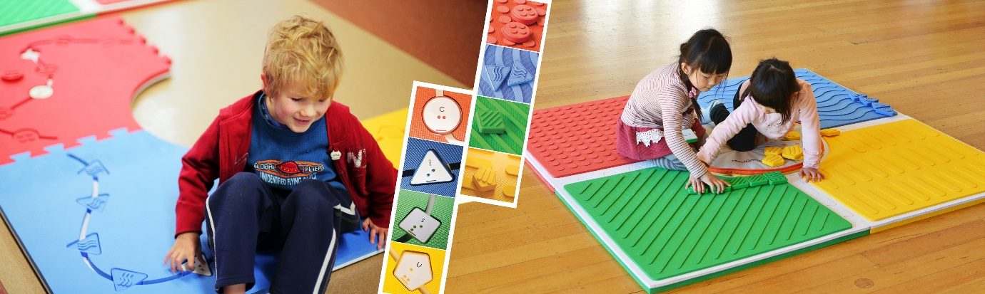
Reach & Match Learning Kit was the result of founder Mandy Lau’s master’s research, which received the Monash University’s Vice Chancellor’s Social Inclusion Award in 2011. Through years of collaboration and research with a wide range of stakeholders including schools, parents, organisations and governments, the Reach & Match has been proven as an effective educational tool that supports children’s physical, cognitive, language and social-emotional development.
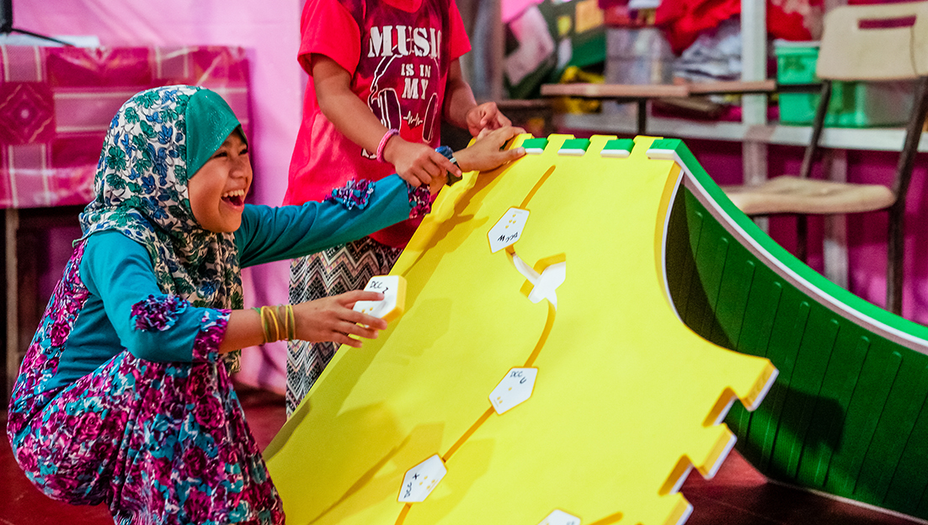
Reach & Match has partnered with Save the Children and Plan International to deliver educational and therapeutic support for thousands of children in emergencies. In 2019, the Australian Government DFAT’s InnovationXchange endorsed the Reach & Match program for its positive impact on children’s learning. More information is available from www.reachandmatch.com.

Country Updates

Ireland
Uncertainty about possible price rises following Brexit has caused some stockpiling of braille paper and related technology.

New Zealand
The Braille Authority of New Zealand Aotearoa Trust (BANZAT) celebrated its tenth anniversary on 17 November. The event was hosted by Blind and Low Vision Education Network NZ (BLENNZ), one of the five founding organisations of BANZAT.
A moving highlight of the celebration was a performance by blind adult musicians who, as part of their learning braille, had asked to be taught braille music. Violin, viola and flute players performed and sang, all their parts having been learned from scores written in braille music.

People

Joe Sullivan
We hear that Joe Sullivan is having a significant birthday in December 2020. Joe is the founder of Duxbury Systems Inc. and the developer of the Duxbury Braille Translator used by many of us around the world.
Joe, all your braille readers, transcribers and teachers of braille warmly wish you many happy returns.

How a Grass Roots User Group is Connecting and Empowering the Braille Community
The Braillists Foundation is a relatively new UK charity with a simple mission statement: "more braille!" Since March, it has held over a hundred Zoom meetings to keep the braille community connected during the Coronavirus pandemic, including an extremely successful "Braille for Beginners" series and live discussions with high profile figures from the world of braille.
The first meeting of 2021 will be held on World Braille Day (4 January). Following this, meetings will have a greater focus on training, with a new series of "Braille for Beginners" starting on Monday 11 January, and a new series entitled "Braille for Academic and Career Development" starting on Tuesday 12 January. Topics covered in these Tuesday "masterclasses" will include:
- Making the most of your braille display (Windows and iOS)
- Effective braille note taking for yourself and others
- Using braille to confidently deliver powerful presentations
The masterclasses will be delivered by experts in their field, will be recorded and uploaded to the Braillists website for on-demand listening, and will be completely free of charge thanks to a generous grant from the Winston Churchill Memorial Trust.
For more information, please visit the Events page on the Braillists website at www.braillists.org/events or sign up to the Braillists newsletter at www.braillists.org/newsletter/signup
N.B. sessions take place at 19:00 or 19:30 in the UK, but international participants are very welcome. Please email help@braillists.org for help with time zone conversions.

Calendar of Upcoming Events

World Braille Day – January 4
World Braille Day is celebrated on January 4th each year, in commemoration of Louis Braille’s birthday in 1809 and in recognition of the continuing importance of braille for literacy and independence for people who are blind, deafblind or have severe low vision throughout the world. World Braille Day was officially recognised by the United Nations in 2019. ICEB encourages organisations and individuals to mark World Braille Day with celebrations and as an opportunity to share your love of braille.

SPEVI Virtual Conference – Online from Australia, January 2021
The South Pacific Educators in Vision Impairment are delighted to announce the 2021 SPEVI Virtual Conference with the theme “Celebrating Change”. The online event will run from 18 to 19 January 2021, hosted by RIDBC Renwick Centre. The keynote speakers are Emma Bennison, CEO of Blind Citizens Australia and Charlotte Cushman, who worked with Perkins Solutions and the Texas School for the Blind and Vision Impaired to produce the popular Paths to Literacy program. Registrations are now open. Updated information is available at www.speviconference.org.au.

CSUN Assistive Technology Conference – Online from USA, March 2021
The 2021 CSUN Assistive Technology conference is the world’s longest-running and largest conference devoted to assistive technology and the positive impact on people with disabilities. The conference will be held in a virtual format in March 2021. Learn more at www.csun.edu/cod/conference/sessions/.

Tactile Reading Conference – Online from Norway, April 2021
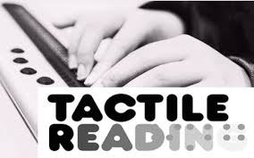
After a very successful first conference in Sweden in 2017, the Tactile Reading Conference returns in 2021. The conference will focus on braille and graphics, including digital aids for braille reading and the use of 3D-printed material. Topics will include early intervention and education for children, youth, and adults within the field of tactile reading. Keynote speakers include Silvija Seres on “New technology, new opportunities”, Mr Ajai Kumar Mittal on the enduring significance of braille, and Dr Diane Wormsley on the bumpy road to braille literacy. The event will be held as a Digital Conference on the 29th and 30th April 2021. See www.statped.no/tactilereading2021 for more information.

Round Table Conference – Australia, May 2021
The Round Table on Information Access for People with Print Disabilities is an umbrella organisation for members throughout Australia and New Zealand with the mission to facilitate and influence the production and use of quality alternative formats for people with print disabilities. The 2021 Round Table Conference will be held online from Monday 17 May to Tuesday 18 May 2021. Workshops will be held on Wednesday 19 May with the Annual General Meeting at 4pm on 19 May. The Annual Meeting of the Australian Braille Authority will take place on Saturday 15 May. More information is available at http://printdisability.org/conference/2020-round-table-conference/.

World Blindness Summit – Madrid, Spain, June 2021
The World Blindness Summit is the combined General Assemblies of the World Blind Union and the International Council for Education of People with Vision Impairment (ICEVI). Bringing together leading experts and organisation concerning visual disability from 190 participating countries, the World Blindness Summit will be held from June 28 to 30 in Madrid. Registrations are now open at https://www.worldblindnesssummit.com/en.

Vision 2020⁺¹ – Dublin, Ireland, July 2021
Vision 2020 is the 13th International Low Vision Conference by the International Society for Low Vision Research and Rehabilitation. After being postponed in 2020, the Vision 2020⁺¹ Conference will take place on 11-15 July 2021 in Dublin, Ireland. Registrations and abstract guidelines are now available at https://vision2020dublin.com/.

UEB Q&A
In answer to our earlier question, a string of lower punctuation signs is allowed [7.1.4]. Thus, the sentence can be brailled as:
⠠⠓⠊⠞⠀⠮⠀⠦⠐⠔⠴⠀⠅⠑⠽⠲

Next Newsletter
The next ICEB Newsletter is due in March 2021. We will call for contributions in February 2021 and we would like them by the beginning of March please.

ICEB Contact Details
Website: www.iceb.org
Email: info@iceb.org
Twitter: @ICEBbraille
Facebook: www.facebook.com/ICEBbraille/
ICEB-announce list:
Send an email to iceb-announce+subscribe@groups.io to receive announcements from ICEB, including this newsletter and notifications regarding updates to Unified English Braille.

