ICEB logo
International Council on English Braille

**ICEB Newsletter   
Issue 2, March 2019**

# ICEB

## ICEB announce list

ICEB has set up a new one-way email listserv for the purpose of distributing important announcements. For example, this newsletter will be sent to the list along with updates to the Guidelines on Technical Materials and new UEB symbols or rules for their use. To join, simply send an email to   
 [iceb-announce+subscribe@groups.io](mailto:iceb-announce+subscribe@groups.io).

The [ICEB facebook page](http://www.facebook.com/ICEBbraille/) and twitter account (@ICEBbraille) also offer great ways to find out about ICEB activities, with more regular postings that include up-to-date braille news, products, events and tidbits.

## ICEB membership forms

ICEB welcomes new members, whether they be Full Members representing countries with a Braille Authority, or Associate Members representing organisations and individuals. All members are welcome to participate in ICEB discussions and activities. Full Members also have the right to send a delegation to the ICEB General Assembly and appoint voting members to the ICEB Executive Committee and working committees. New membership forms can be downloaded via <http://iceb.org/ICEB_Membership-Full.docx> and <http://iceb.org/ICEB_Membership-Associate.docx>.

# Unified English Braille

Unified English Braille (UEB) is a single set of braille symbols that can be used for the representation of literary, technical and computing material. Detailed information about UEB, including rules, new symbols, and training materials, can be found at <http://iceb.org/UEB.html>.

## UEB usage survey



ICEB is conducting a survey to find out more about the use of Unified English Braille and other codes around the world. So far, we have heard that UEB is used in Australia, Canada, Ireland, Nepal, New Zealand, Nigeria, South Africa, Tanzania, UK and USA.

If you can provide information about UEB use in another country, please visit at [surveymonkey.com/r/VKPXR7H](https://www.surveymonkey.com/r/VKPXR7H) or contact us at [info@iceb.org](mailto:info@iceb.org).

## UEB Online Training Programs



The Royal Institute for Deaf and Blind Children (RIDBC, Australia) will be launching “UEB Mathematics Online” at the May 2019 [Conference of the Round Table on Information Access for People with Print Disabilities](http://printdisability.org/conference/) in Brisbane, Australia. The Round Table launch will also recognise the fifth anniversary of the launch of RIDBC’s “UEB Online” for sighted people, and the fourth anniversary of the launch of “Accessible UEB Online” for people with vision impairment or other print disabilities – see <http://uebonline.org/> and <http://accessible.uebonline.org/>.

UEB Mathematics Online has a similar structure to UEB Online, with the sequential introduction of mathematics concepts in braille in two modules. Module 1 presents primary school mathematics (school entry to Year 6) and Module 2 presents secondary school mathematics (Years 7 to 12). Professionals and families supporting secondary school students should complete both modules, as the content of Module 2 builds on the content of Module 1. Prior knowledge of the UEB literary code is considered essential in order to build an understanding of the braille mathematics content of both modules.

The UEB Online training programs are suitable for policy makers, administrators, education and allied health professionals, families and classmates. The free online registration process involves creating a profile and personal password using a Windows PC, Mac or laptop. Once registered, the braille learners work at their own pace through set lessons, with the option of paying a small fee for a completion certificate. An important component of the lessons is that learners are notified when a braille error is made, and each error must be corrected before the program allows the learner to proceed to the next lesson.

To date, UEB Online and Accessible UEB Online have attracted 18,000 learners of braille from around the world. The success of UEB Online was recognised by the World Braille Council (WBC) at its meeting in Ottawa, Canada in May 2018. The WBC has resolved to partner with the World Blind Union and the International Council for Education of People with Visual Impairment (ICEVI) to promote the uptake of UEB Online in developing countries where access to braille instruction is limited, and to also promote the development of similar online braille training programs for other languages.

RIDBC acknowledges the contribution of Craig Cashmore of PeppaCode P/L. Craig has been instrumental in the design and development of UEB Online, Accessible UEB Online and UEB Mathematics Online - see <http://peppacode.com.au>. RIDBC also acknowledges with thanks the content writers, Josie Howse, Leona Holloway and Kathy Reissen; and the philanthropic support received from RIDBC donors that has enabled program development.

* *Frances Gentle, RIDBC Renwick Centre*

# UEB Q&A

## Why did UEB remove the sign for BLE?

English braille codes prior to Unified English Braille included a strong contraction sign for the letter group “ble” in the middle or end of a word. This sign was dots 3456 #, the same as the numeric indicator.

As the name suggests, the primary aim of Unified English Braille was to develop a single braille code that could be shared across countries and that would use the same set of symbols for literary and technical braille. Another goal was to reduce ambiguities in the code to assist with learning, reading and automatically translating braille. Given the increasing use of numbers within words, particularly in web and email addresses, it was agreed that the BLE sign could cause too many confusions and should be abolished.

With the introduction of UEB, no longer can “bumblebee” be misread as “bum255” in braille!

## Test your UEB knowledge

How do you braille the following examples? Is a grade 1 indicator required before the letter d when preceded by the section symbol or the paragraph symbol?







  

!

"#$%&'#(###)

'**

+  

,,-  #.

,,/

,/

#(##"+0,-

-    ,12

3$%&'##2),+

4141+--,-

5/$%&'4#

§d ¶d

Check near the end of the newsletter for the answer.

# Recent events

## Braille Music retreat in Auckland, New Zealand

From 17-20 January this year, the second Trans-Tasman Braille Music Retreat took place in Auckland, New Zealand at the BLENNZ Homai Campus. This is unique because it's the only event we know of around the world where braille-reading adults get together to make and use music completely from braille scores. The retreat organising committee is made up of a group of volunteers from New Zealand and Australia who are passionate about braille music and want to create an environment where adults can benefit just as much as children who attend braille music camps.

During the year, a working group carefully selected a mixture of both sacred and secular choral repertoire which was transcribed in New Zealand. Braille scores and audio files were then sent to retreat participants just prior to Christmas 2018 for pre-learning.

Retreat participants were drawn from the Braille Music reading community around New Zealand and Australia: 16 New Zealanders and four Australians, including four sighted singers with a particular Braille Music focus. Sighted members assisted in the logistical side of the retreat but participated equally with the singing and playing. The three and a half days together gave singers time to workshop music and deepen friendships, although most of us did not want the weekend to end!

The initial concept for the retreat was devised and promoted by Lisette Wesseling, a singer, braille music user and teacher, who sadly died three months before the inaugural retreat was held in January 2017. At the first singing session, Music Director Ken Joblin led a time of reflection, recalling the life and inspiration of Lisette.

The retreat began on the Thursday afternoon with registration, familiarisation with our surroundings and dinner for humans and guide dogs. Friday and Saturday saw singing and socialising and sessions included work in the evening. Often informal singing was enjoyed over a cup of tea after the day had ended.

The retreat was directed by braille music readers from Australia and New Zealand and accompaniment was provided by retreat participants. Along with the BLENNZ music facilities, we very much enjoyed making use of the in-door swimming pool complex for two of our pieces. This enabled us to take advantage of the reverberant acoustics provided by what is effectively a concrete bunker complete with water sound effects. I’m happy to report that no one fell into the pool! We were visited by music education specialists from the University of Auckland who were interested in the uniqueness of a braille music community coming together to make music off the braille page. We were also joined by a music teacher who has an interest in braille music.

Saturday evening was set aside for mutual talent sharing in an in-house concert. This was an opportunity to share our unique musical gifts and often make music with people who only met over the past few days. Sunday morning was the final day of the retreat and spent recording our work for an audio memento. Most of the songs were recorded in the hallway of the administration building with two pieces recorded in what became known as the Swimming Pool Cathedral. Eight tracks were made in two hours.

Work is already underway planning for BMR 2021.

* *Jordie Howell, ICEB Braille Music Committee Chair  
  Ken Joblin  
  Chantelle Griffiths*

## World Read Aloud Day in South Africa

[World Read Aloud Day](http://www.litworld.org/wrad/) is celebrated on 1 February each year. People around the globe read aloud together and share stories to advocate for literacy as a human right.

Joining the world in commemorating the World Read Aloud Day, Nali-Bali, Blind SA and SABA coordinated 2019 edition of the Read Aloud Day. This is the event that started in 2018. During this period, only a handful of schools participated, largely from Gauteng.

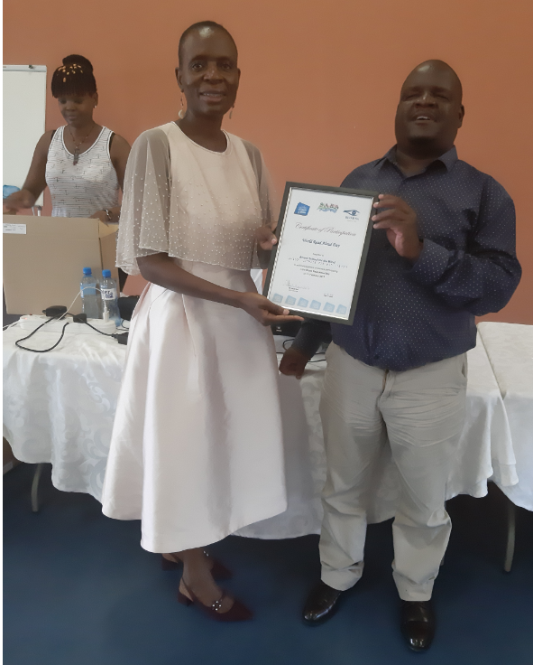The 2019 edition attracted 14 schools and 508 learners who participated in 8 different languages. This was a milestone in that the event took place across five provinces. Coinciding with International Mother Tongue Day, the event was held on 21 February. Since the rules of the competition are not steadfast, some teachers had to improvise for their events to cater for their learners. The most exciting of the categories of the competition was a “treasure hunt”. Many schools deviated from the rules in order to increase excitement and to suit the school environment. Learners were expected to search for a card on which different instructions were written and they needed to play out the instruction. You should have heard chairs and tables shuffled around in search of the treasure!

With the assistance of Givaudan, three schools benefited a great deal by sharing 41 Tatrapoints. We believe these machines will help in further stimulating a need for learners to read and write braille.

We hope to coordinate an even more involving and appealing version in 2020.

* *Ntshavheni Netshituni, South African Braille Authority President*

# Braille technology

## Liblouis

LibLouis is an open-source braille translator, back-translator and formatter for a large number of languages and braille codes. It is the underlying translator for programs such as APH’s free Braille Blaster software, Benetech’s Bookshare and ViewPlus assistive technology. It is also used in screenreaders such as JAWS, NVDA, Orca and BrailleBack, thereby providing the braille translation for connected refreshable braille displays.

Chair of ICEB’s Braille Technology Committee, James Bowden from RNIB, has been hard at work checking the Liblouis table for Unified English Braille. With this initial check complete, a small group of volunteers from ICEB is now working to implement the necessary fixes to ensure that Liblouis can provide the best quality UEB translation.

James writes:

"It's interesting to note that there are already rules for many words and symbols in the UEB Liblouis tables, but sometimes, just going slightly beyond those specific rules will cause a braille error. To give an example, the word 'afford' is fine, but 'unaffordable' is not. Likewise, those who use UEB input on a phone will notice that you can correctly input the word 'it's', but not 'it'll'. So our current task is to try and fix as many of these errors that we can. We are very grateful for the assistance of the ICEB Code Maintenance Committee for their input when it's not clear how certain unusual words should be contracted.

"At the same time as this table development, colleagues from APH continue busily working on the actual code of Liblouis. One of the main reasons for this is to increase accuracy for mathematics. Some problems, like the correct use and placement of, say, grade 1 indicators, cannot simply be programmed in the table alone. So the APH work is also tremendously important.

"We hope these improvements in the code and tables will better equip Liblouis users all over the world to have more accurate braille translations as we move forward."

# People

## In memoriam – Dr Susan J. Spungin (1941-2019)

In remembrance of Dr Susan J. Spungin, who will be familiar to many of you as an internationally renowned expert on the education of children who are blind or have low vision.

Amongst her many achievements over a 44 year career, Dr Spungin was a passionate advocate for braille literacy. As vice president of programs at the American Foundation for the Blind (AFB) she wrote the 1990 pamphlet, [Braille literacy: Issues for blind persons, families and producers of braille](https://archive.org/details/brailleliteracyi00susa/) and co-authored a chapter on braille literacy for the book [Braille: Into the Next Millennium](https://archive.org/details/brailleintonextm00edit) for the National Library Service for the Blind and Physically Handicapped. She also contributed to the U.S. Office of Special Education Programs (OSEP) Guidelines to promote the teaching of braille to students with visual impairments and legislative efforts in support of braille literacy, and a national campaign to ensure the timely delivery of braille instructional materials to school children in the United States.

Dr Spungin was a past Chair of the Braille Authority of North America (BANA) and also held roles in the World Blind Union (WBU) and the International Council for Education for People with Vision Impairment (ICEVI).

Dr Spungin was honoured with numerous awards, including the 2009 Migel Medal and the AFB 1993 Equality of Access and Opportunity Award, for her work in braille literacy. She was inducted into the [APH Hall of Fame](https://www.aph.org/hall/inductees/susan-j-spungin/) in 2018.

ICEB extend our heartfelt condolences to her family, friends and colleagues.

## Award - Dorothy Hamilton, OAM

Congratulations to Dorothy Hamilton, who was recently awarded a Medal of the Order of Australia for her service to music.

Dorothy developed an early love of music. She was the first blind woman to earn a Bachelor of Music in the Southern Hemisphere, going on to teach music at a mainstream school.

In 1985, Dorothy was one of the people instrumental in establishing Australia's annual National Braille Camp. She also taught students unable to attend the camp. Dorothy began her braille music transcription career as a proofreader for the Royal Victorian Institute for the Blind and is still transcribing for Vision Australia at 92 years of age.

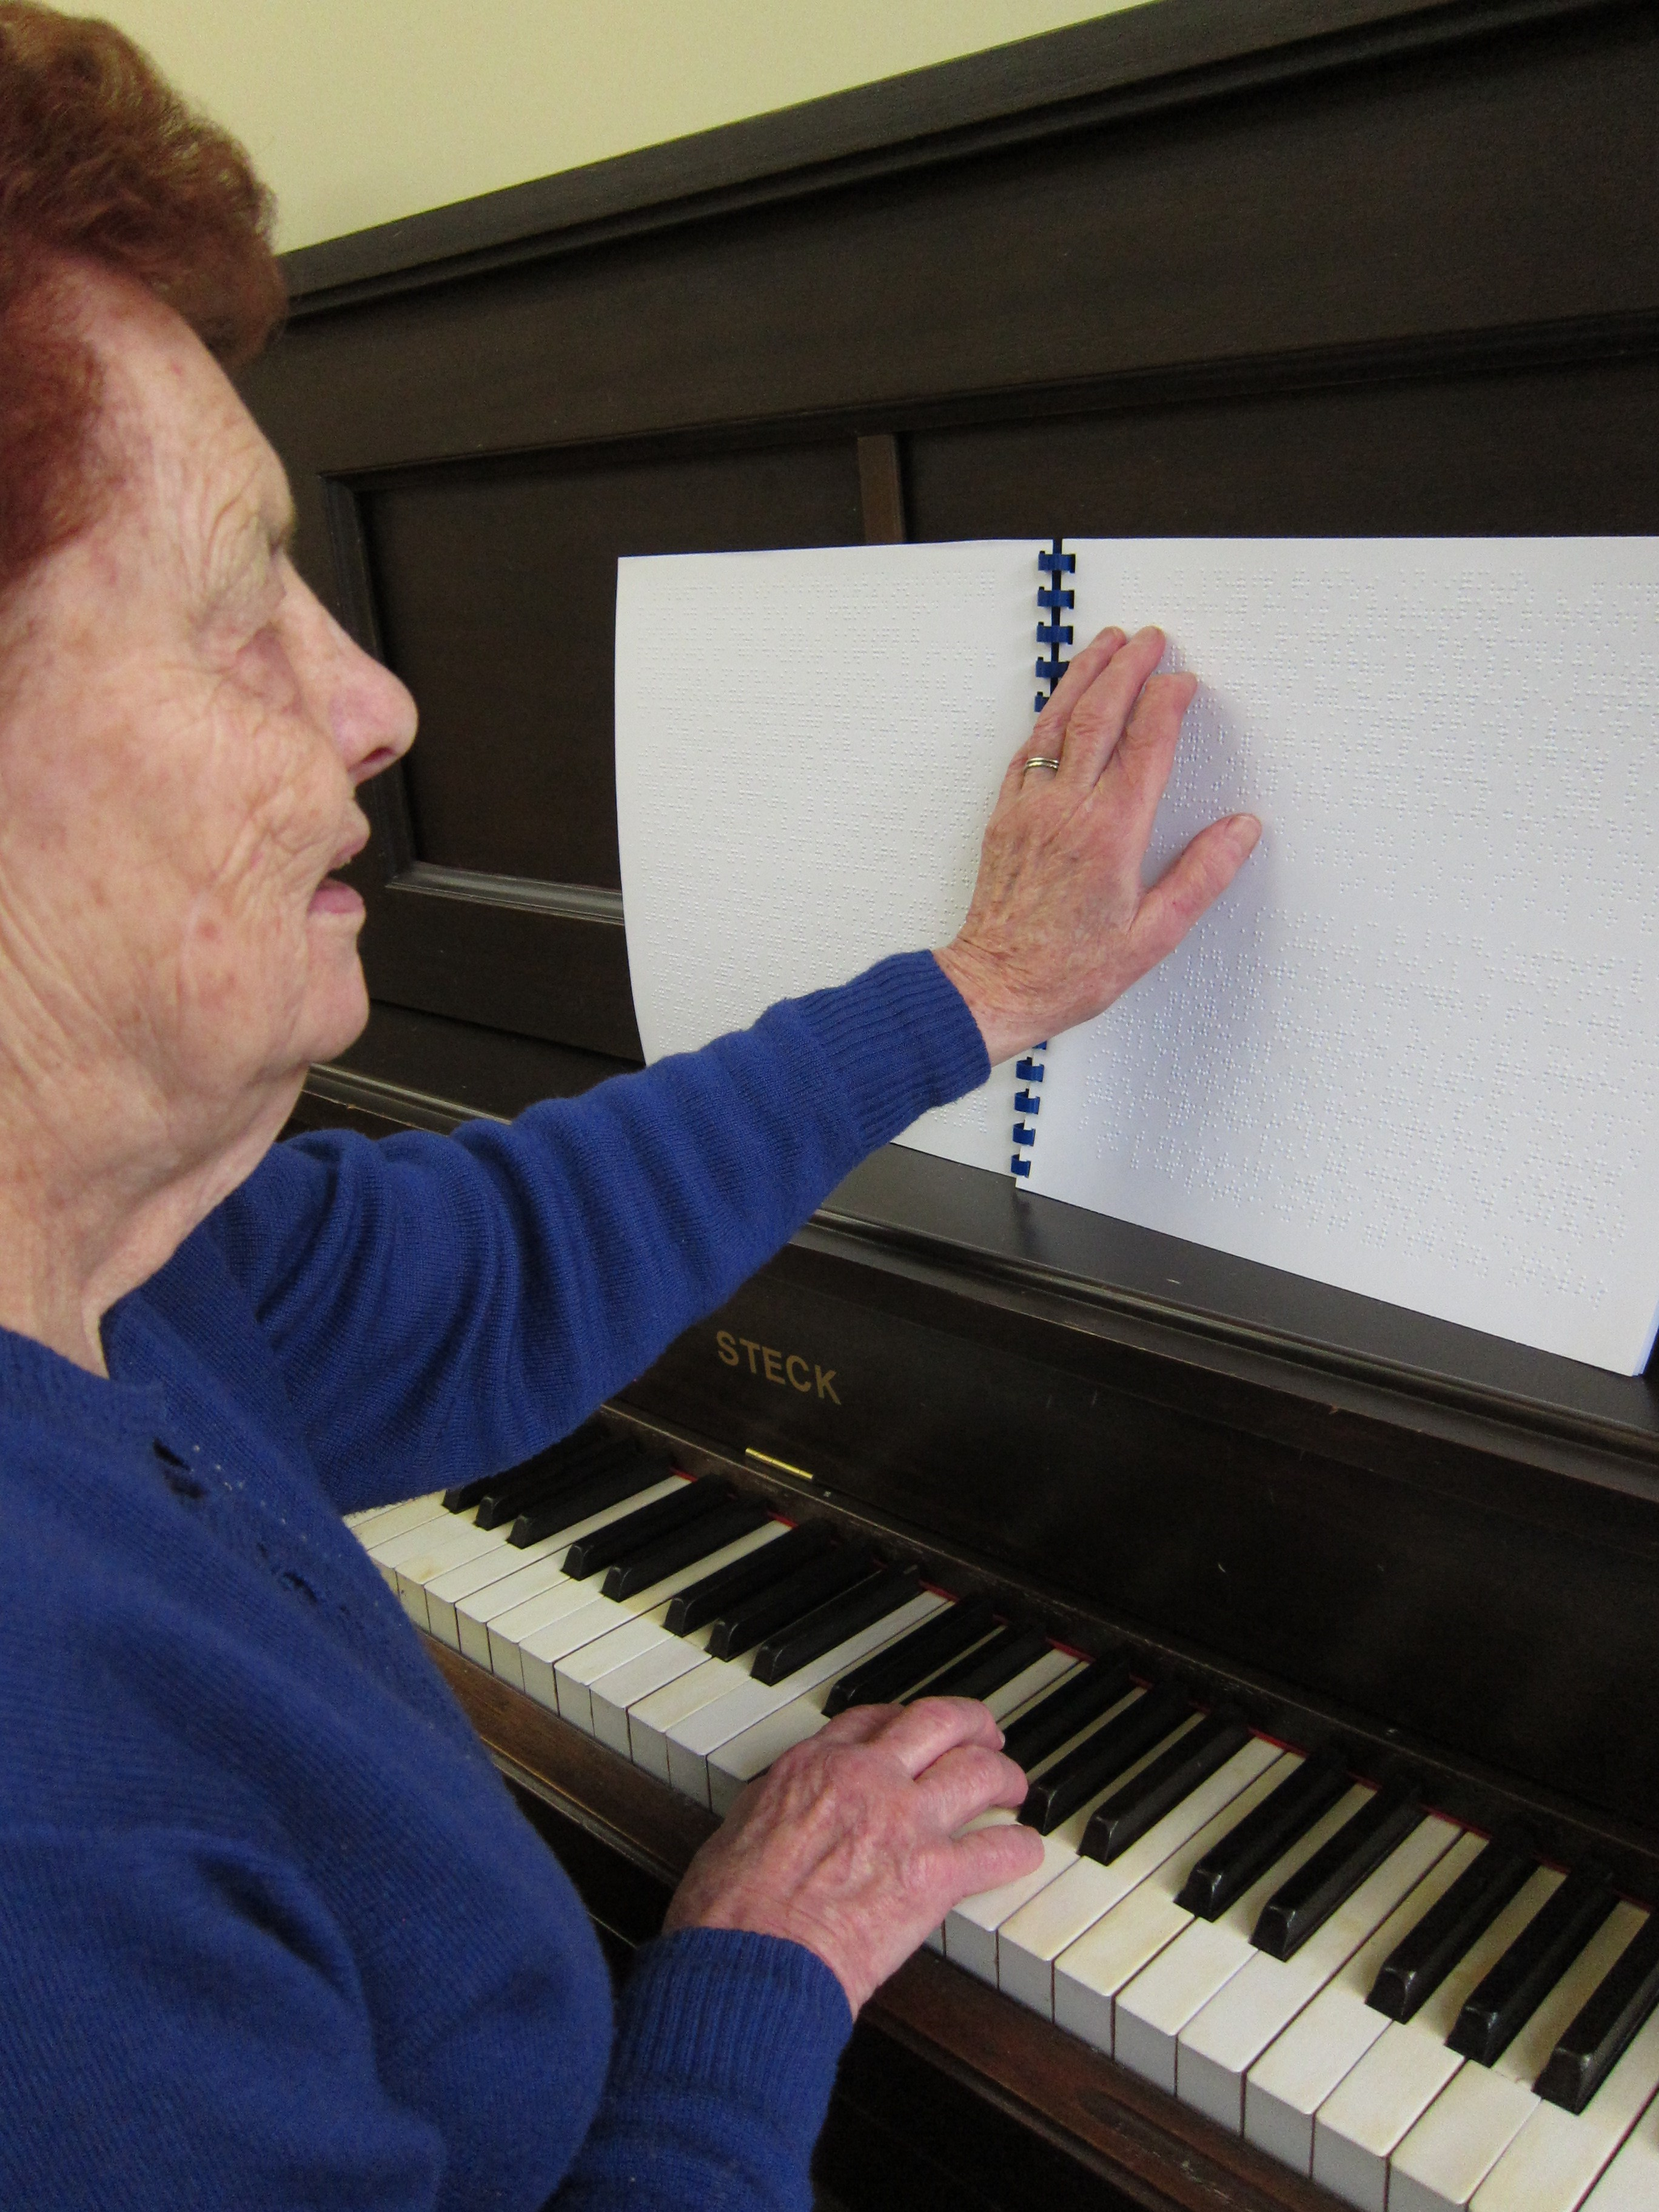

When asked what motivates her tireless work furthering braille music, Dorothy explained "I love my music. I'm passionate about learning it correctly. I could learn it by ear but I want to learn it as it has been written and I can't always wait for someone else to teach it to me. Braille music allows that. I want to pass it on to others."

Upon hearing news of her award, many Australians have reached out to Dorothy to thank her for doing so as a teacher, mentor and role model.

# Calendar of Upcoming Events

## 60th annual CTEBVI Conference – California USA, April 2019

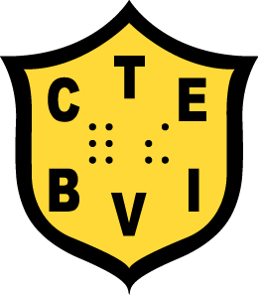The California Transcribers and Educators of the Blind And Visually Impaired, Inc. is proud to present its 60th annual Conference for transcribers, teachers, paraprofessionals, rehabilitation specialists, orientation & mobility specialists, students, and parents. The theme of the Conference is “Braille Redux in the Digital World”. It will be held April 11-14, 2019 at San Francisco Airport Marriott. See <http://www.ctevh.org/conference.html> for more information.

## DAISY Music Braille meeting – Geneva, Switzerland, May 2019

The DAISY Consortium are exploring options for improvements in MusicXML to allow better automated translation to music braille. The DAISY Music Braille project is a cross-sector collaboration to deliver improvements so that music scores are more readily available to blind musicians worldwide. The next meeting will be held in Geneva from 28 to 29 May 2019. Visit [www.daisy.org/project/daisy-music-braille](http://www.daisy.org/project/daisy-music-braille) for more information or email [musicbraille@daisy.org](mailto:musicbraille@daisy.org) to join the mailing or become an active member.

## Round Table Conference – Brisbane, Australia, May 2019

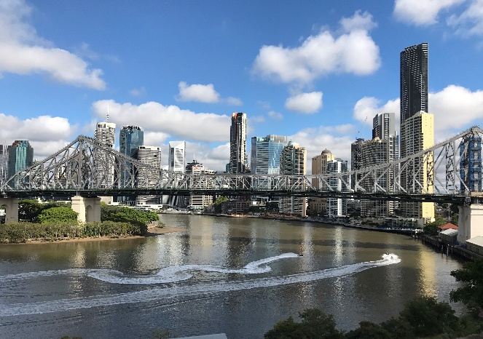The Round Table on Information Access for People with Print Disabilities Inc. is an umbrella organisation encompassing more than 30 organisations in the fields of education, government, accessible format production, community and disability across Australia and New Zealand. Round Table holds an annual 3 day Conference preceded by a full day meeting of the Australian Braille Authority.

The conference will be held from Saturday 4 to Tuesday 7 May 2019 in Brisbane, Australia. The theme for 2019 is “**The Changing Landscape for Accessible Information**”. Registrations are now open online at [printdisability.org/conference/2019-round-table-conference/](http://printdisability.org/conference/2019-round-table-conference/).

## Africa Forum – Addis Ababa, Ethiopia, October 2019

Africa Forum is Africa’s premiere conference for blindness activists, leaders and community. The conference is open to any individual or organisation with an interest in blindness in Africa. It offers opportunities to learn, network and contribute to the future of disability advocacy in Africa.

The 7th Africa Forum is scheduled for 7-11 October 2019 in Addis Ababa, Ethiopia.

## NBA Professional Development Conference – Arizona USA, October 2019

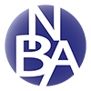The National Braille Association holds annual Professional Development Conferences with workshops to learn more about braille code revisions, new techniques, software, hardware and production equipment. The next Conference will be held in Phoenix, Arizona on October 30, 31 and November 1. See <https://www.nationalbraille.org/professional-development-conference/> for updates.

## Getting in Touch with Literacy – USA, November 2019

Getting in Touch with Literacy is a national conference on all forms of literacy, including print, braille, auditory, tactile graphics comprehension and the use of assistive technology. The proceedings include presentations, workshops and poster sessions.

The 2019 Conference will be held from 13-17 November in Seattle, Washington. Further information, including the Call for Proposals and Registration, is available at <http://gettingintouchwithliteracy.org/>

## ICEB General Assembly – London, England, May 2020

ICEB holds a General Assembly once every four years. The next General Assembly will be held in London at RNIB. The main meetings will be held at RNIB from 11-15 May, with an open day to be held at Quaker House on Wednesday 13 May.

More details on the General Assembly, along with a call for papers, will be distributed via the ICEB communication channels as listed at the end of this newsletter.

## WBU-ICEVI Joint Assembly – Madrid, Spain, June 2020

The World Blind Union (WBU) and International Council for Education of People with Vision Impairment (ICEVI) will hold their third joint General Assembly at the Hotel Marriott in Madrid, Spain, from 19 to 24 June 2020. The proceedings will include two days of paper presentations from 21 to 22 June. The call for abstracts will be released shortly through the [WBU](http://www.worldblindunion.org) and [ICEVI](http://icevi.org/) websites.

# UEB Q&A

In answer to our earlier question, §d ¶d should be brailled as

^sd ^pd

In each instance, the letter "d" is not standing alone and will therefore not be read as the alphabetic wordsign for "do". The letter would be considered to be standing alone only when preceded by the common punctuation signs and indicators listed in 2.6.2. Also, the sequences will not be confused with the shortforms "said" or "paid" because the dots 45 character is a prefix (refer to the *Rules of UEB* 1.2.5) and is combined with the root characters, dots 234 and dots 1234, which follow to form the braille signs for section and paragraph respectively (refer to the *Rules of UEB* 3.20).

# ICEB Contact Details

Website: [www.iceb.org](http://www.iceb.org)

Email: [info@iceb.org](mailto:info@iceb.org)

Twitter: @ICEBbraille

Facebook: [www.facebook.com/ICEBbraille/](http://www.facebook.com/ICEBbraille/)

ICEB-announce list:   
Send an email to  [iceb-announce+subscribe@groups.io](mailto:iceb-announce+subscribe@groups.io) to receive announcements from ICEB, including this email and notifications regarding updates to Unified English Braille.