ICEB logo
International Council on English Braille

**ICEB Newsletter   
Issue 4, Sept 2019**

# Welcome

In this issue, we are pleased to present a special focus on braille in museums and galleries.

# Unified English Braille

## Updates from the UEB Code Maintenance Committee

The UEB Code Maintenance Committee (CMC) is responsible for clarifying and reviewing UEB symbols and rules, as well as producing updates to the **Rules of Unified English Braille** and the **Guidelines for Technical Materials**.

After extensive debate and consideration on the representation of apostrophes and quotation marks in braille, the CMC is now voting on this complex issue. We hope to be able to make an announcement very soon via the [ICEB website](http://iceb.org), social media and announce list, as given at the end of this newsletter.

## The Rules of Unified English Braille (aka The UEB Rulebook)

The [Rules of Unified English Braille](http://iceb.org/ueb.html#Rulebook) (commonly known as the UEB Rulebook) is the primary and authoritative book detailing the UEB code and its rules for use. Note that the Rulebook is a technical reference book; it is not intended as a teaching resource. The Rulebook is available for free download in print or braille from ICEB’s website at [iceb.org/ueb.html](http://iceb.org/ueb.html).

Updates and minor corrections made since the 2013 edition of the Rulebook have been published on the ICEB website at [iceb.org/ueb.html](http://iceb.org/ueb.html). In response to your requests, the updates are now also available for download as a single document in print or braille format.

Did you know that the UEB Rulebook is also available in French? It was translated with assistance from the Government of Canada and can also be downloaded from [iceb.org/ueb.html](http://iceb.org/ueb.html). Translation of the UEB Rulebook into Japanese is now underway. Please contact ICEB if you would like to seek permission to translate the UEB Rulebook into another language.

## Actual Tactuals

You may have already heard about the new book entitled "Unified English Braille (UEB) Practice Sentences." This is a book designed to teach braille contractions to anyone (child or adult) who is learning to read or write braille, once they know the braille alphabet. The pre-cursor of this book (in EBAE) was written by Phil Mangold and myself in the early 1990's and was used until UEB was adopted.

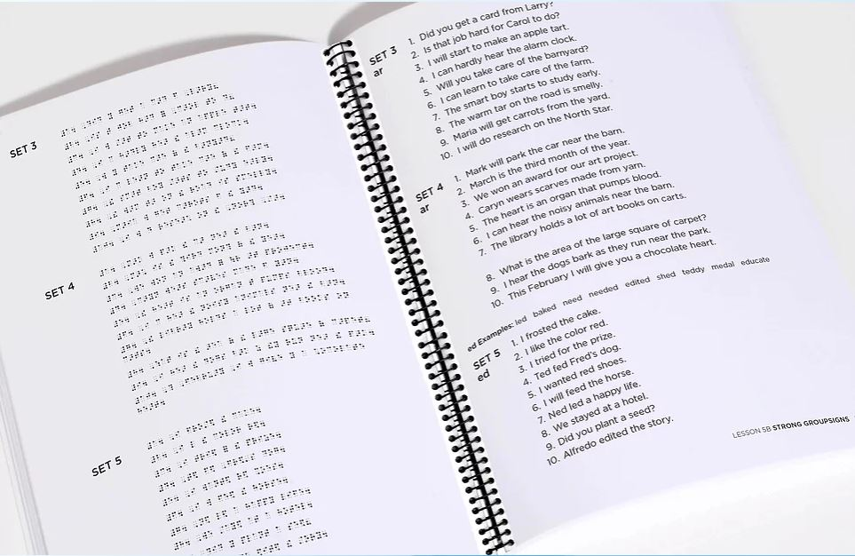

Since the EBAE book became obsolete due to the adoption of UEB, it was necessary to write this new, up-to-date book to help increase braille literacy. This new book helps teach all of the UEB contractions in a systematic way that is easy for the teacher to use and easy for the students to learn. It was also necessary to introduce some of the more commonly used new symbols and UEB methods of writing internet addresses. Adding simulated braille to this book helps teachers and transcribers, and also allows anyone who is unfamiliar with braille to work with students. So now, not only teachers, but educational assistants and parents can read/write with the students and help to check their work. Additionally, the hard-copy braille student's companion book was necessary so that students could gain practice reading, have a good model of what the braille should look like, and have a way to self-check their work.

Interestingly enough, I was very lucky to make contact with Christo de Klerk, President of ICEB, through the internet! After giving me permission to quote ICEB rules in my book, he became a wonderful tutor for me, helping me to better understand many of the rules. I would email him a lot of questions and he would painstakingly respond to clarify things for me so that I could explain them in this book. Aside from braille, we even got to share a few cooking ideas!

If you would like further information about this book and how to purchase it, please visit my website at [www.ActualTactuals.com](https://l.facebook.com/l.php?u=http%3A%2F%2Fwww.ActualTactuals.com%2F%3Ffbclid%3DIwAR12ht08RHTSUJY5ztk4ZaqALDD1neD8IFgKWtB4DJ9dpr5zJzmhhHiu50w&h=AT1Bngm2eo-8CD-lqhPeuoDH8ZsGvddWuxs9UaWn0yK9v5SDMpkJzAh5XZtboSolEFqbowTkNjdeKE7F5lPoM3ouEDbOBumCKUkJF0x66-EnT-BUJBY1iT5JJfoG6HWPeos).

*– Roberta Becker, author of Actual Tactuals*

## Braille Puzzle – Word Search

As specified in the Rules for Unified English Braille section 5, grade 1 passage indicators can be used to set grade 1 mode when the grade 1 meaning of a symbol could be misread as a contraction meaning or a numeric meaning.

One such example is in a word search puzzle, when individual letters do not represent wordsigns. Can you find the following words in the word search on the next page?

book - braille - code - contraction - dots - english - event

ICEB - literacy - music - reading - research - rule - sharing

success - tactile - technology - unified

;;;

m p y e l i t c a t q i

d u h c b o o k g t c o

r e s e a r c h l e o m

s d i i v r q m b c z t

s o l o c e e r t h u t

e c g b z m n t m n g i

c o n t r a c t i o n o

c f e m s a t f n l i c

u q s h a r i n g o d d

s t o d u e g l j g a j

l k k l d i p y l y e u

g v e s i g n a g e r m

;'

# UEB Q&A

## Problem words – the ONE contraction

In issue 3 of this newsletter, we reported that work is being done to confirm the correct UEB contraction of some tricky words. Most of these are uncommon, scientific words. This issue, we look whether the ONE contraction be used in the following words:

comedones, daimones, dapsone, desamenthasone, dexamethasone, ecdysone, glutathione, menadione, mucrones, methasone, pantalone, sone, telamones.

According to the [Rules of Unified English Braille](http://iceb.org/ueb.html#Rulebook) 10.7.6, the initial-letter contraction for ONE can be used when the letters it represents are pronounced as one syllable, or are in a word ending with the letters "oney", or are in the words "honest" or "monetary" and their derivatives. However, the contraction should not be used when preceded by the letter "o".

Therefore the ONE contraction can be used in the words:   
dapsONE, dexameTHasONE, ecdysONE, glutaTHiONE, mENadiONE, meTHasONE, sONE.

However, it cannot be used in the following words, in which the letters “one” are pronounced with two syllables as “o-nay”: comEDones, diamones, mucrones, pantalone, telamones.

## Test your UEB knowledge!

Question: How do you transcribe a bidirectional vertical arrow?

Example: ↕

Check near the end of the newsletter for the answer.

# Special Feature: Braille in Museums and Galleries

## Braille in Canadian Museums

Earlier this year, my parents and two of my nieces came for a visit. We took the girls to the Canadian Museum of Science and Technology, which is fun and informative for people of any age. Although I enjoy museums I have often found them very frustrating as a braille reader. I appreciate my sighted family and friends who have read aloud to me over the years, but of course it is not the same as being able to read the information myself. So much content, so little access! Thankfully, this is starting to change. Several museums here in Ottawa and across the country are making a concerted effort to include braille as part of their plans for making their exhibits more accessible. Kim Kilpatrick, who represents the Canadian Council for the Blind on the Braille Literacy Canada board of directors, has worked extensively with museums in the National Capital Region to improve accessibility for blind and partially-sighted patrons.

Some museums have incorporated braille by ensuring that buttons on interactive exhibits have braille labels. The Canadian Aviation and Space Museum has put together a braille booklet containing all of the text for its recent Health in Space exhibit. The booklet also includes detailed directions for navigating the area where the exhibit is housed. Both the Canadian Museum of Science and Technology and the Canadian Museum of History have set up displays that showcase the braille code and braille writing devices. One of my personal favourites is an exhibit at the Science and Tech museum where you can touch a 3D-printed model of an internal organ, try to guess what it is and then read the braille label beside it.

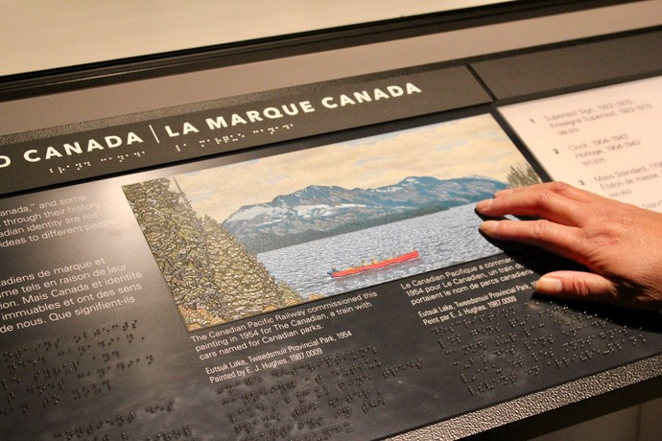

© Image courtesy of Edmund Li RGD, Reich+Petch

Over the last several months the Royal BC (British Columbia) Museum has been working on an initiative to modernise both its facilities and its exhibits. It held online and in-person consultations throughout the province, and Braille Literacy Canada participated by providing feedback from our members on ways to improve accessibility (with a focus on braille). These are just some examples of efforts made to improve braille access in Canadian museums.

As I walked through the Science and Tech museum with my nieces they excitedly pointed out each instance of braille that they saw. Not only do these braille labels and panels make the content more accessible, but they also demonstrate that braille is literacy and that it is a normal and necessary part of everyday life.

*– Jen Goulden, Past President of Braille Literacy Canada*

## Museum of the American Printing House for the Blind

Founded in 1994, the Museum of the American Printing House for the Blind in Louisville, Kentucky celebrates over 225 years of the history of literacy, learning, and rehabilitation for people who are blind. Rare copies of the first books in raised letters and braille rest near classic printing equipment, classroom aids, and modern scanners, magnifiers, refreshable braille displays, and synthetic speech devices. The origins of Orientation and Mobility are documented through dozens of long canes, electronic travel aids, and the first dog guide harness worn by Morris Frank’s dog Buddy. The Museum is accessible, with labels in braille, large print, and audio, and many original items and reproductions are available for touching. While visiting the museum, you can tour the production floor at the Printing House, the largest company of its type in the world.

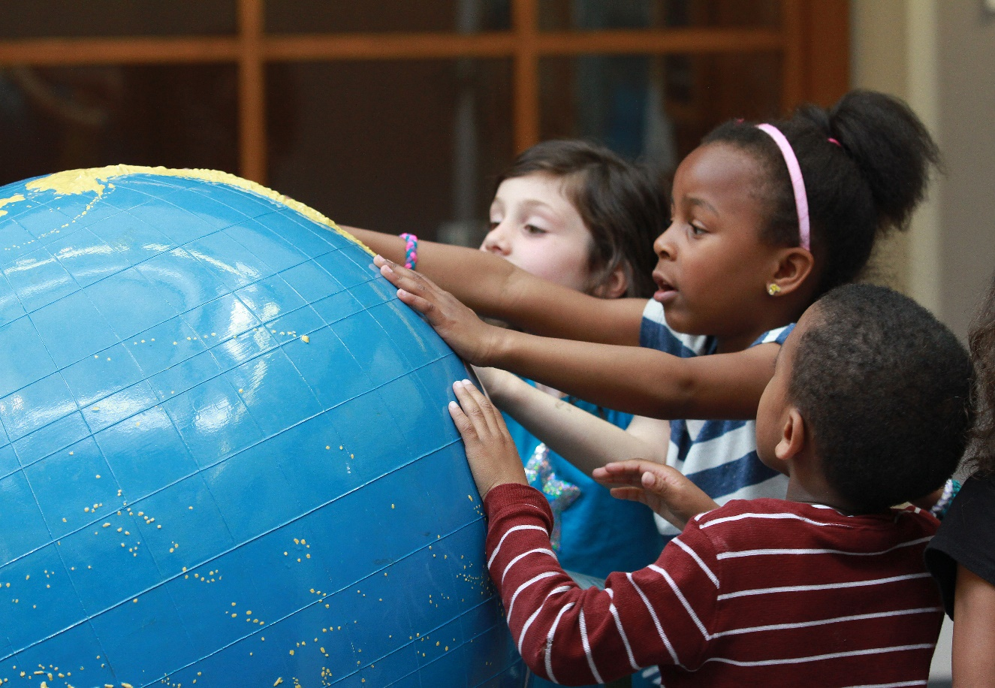

© Image courtesy of APH

Online, the APH Museum offers exhibits, links to thousands of scanned documents, and a searchable database of its collection, including its incomparable collection of braille writers. APH also offers four travelling exhibitions and several loan kits, available for display in museums, libraries, and schools. To schedule a tour or learn more, visit <https://sites.aph.org/museum/>.

*– Michael Hudson, Museum Director, American Printing House for the Blind*

## Braille Museum Planned for South Africa

The Josey Wood Braille Museum will be a milestone which South Africa’s braille users and those interested in braille will find joy in visiting at the South African National Council for the Blind. A Task team comprising Christo de Klerk, Allan Small, Manny Moodley and Ntshahveni Netshituni is working on a Memorandum of Understanding which will be submitted to the South African Braille Authority and the SA Council for the Blind early in October 2019 for adoption.

The South African Braille Authority calls on individuals, organisations or institutions who still keep braille artefacts, and who would want to donate, to kindly contact Mr. Deenadayalan Moodley at [moodld@unisa.ac.za](mailto:moodld@unisa.ac.za) or [deenadayalan.moodley@gmail.com](mailto:deenadayalan.moodley@gmail.com), or Ntshavheni Netshituni at [netshns@gmail.com](mailto:netshns@gmail.com), [president@sabrailleauthority.org.za](mailto:president@sabrailleauthority.org.za) or [netshns@unisa.ac.za](mailto:netshns@unisa.ac.za).

*– Ntshavheni Netshituni, South African Braille Authority President*

## Research: Value-Sensitive Accessibility in an Art Gallery

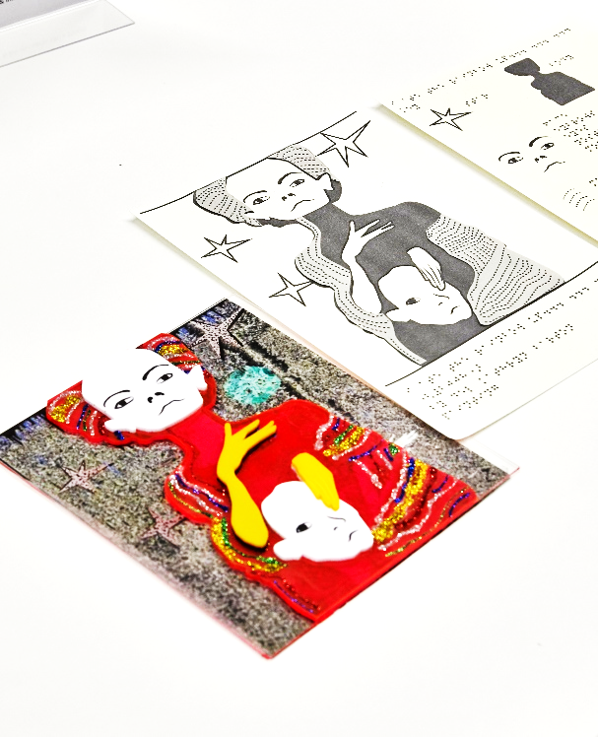In Australia, researchers from Monash University have been working with Bendigo Art Gallery to explore the potential role of emerging technologies to share gallery content with a wider audience, particularly those who are blind or have low vision. A range of materials were produced and shared with touch readers, people with low vision, gallery staff, artists and local residents. 3D printing was found to be an effective medium for sculptures too large or delicate to touch, while laser printing, props and soundscapes are engaging ways of exploring paintings. Provision of materials is recommended in a wide variety of formats, including braille and online text that can be accessed with large font, a screen reader or refreshable braille display.

More information is given in the paper [Making Sense of Art: Access for Gallery Visitors with Vision Impairments](https://doi.org/10.1145/3290605.3300250) and our website at [accessiblegraphics.org](http://accessiblegraphics.org/).

*– Leona Holloway, Inclusive Technologies, Monash University*

# Braille technology

## NLS Braille eReaders

The National Library Service (NLS) will launch a pilot of braille eReaders in the summer of 2020. The pilot will involve two devices: One manufactured by Humanware and one manufactured by Zoomax. The purpose of the pilot is to test the functionality of both eReader devices, collect feedback from pilot patrons, and validate distribution processes at selected network libraries.

During fall 2019, NLS will conduct a design review of the proposed hardware and software for the units in preparation for distribution. The selected eReader will be designed for distribution to thousands of NLS patrons who will be able to read library books on a refreshable braille display rather than relying on hard copy braille. NLS will provide periodic status updates throughout the planning and implementation phases of the pilot project.

# People

We are sad to report on the recent passing of two South Africans who made a lasting contribution to braille on an international level.

## Photograph of Antonnette BothaTribute to Antonnette Botha

After completing her studies in music at the University of Stellenbosch, Antonnette Botha joined the staff of the School for the Blind (now the Pioneer School) in Worcester as a music teacher. She taught practical piano and recorder as well as music theory. During the 1980s she took over management of the new music braille library at the school.

Besides knowing music braille in depth, other braille codes were also her passion. She taught braille shorthand and its Afrikaans equivalent, snelskrif. For many years she served on the school’s committee of braille experts.

Antonnette became a member of Braille SA, South Africa’s first braille authority of which she became the chairperson until 2007. She also became an active delegate in the new braille authority, the South African Braille Authority (SABA). She served as a member of the Braille Committee of Blind SA for many years.

Antonnette was the first Chair of the Rules Committee (Committee VI of the UEB Project of ICEB), which was established in 1993. She was a strong advocate for braille and for the adoption of the UEB in particular and she played a leading role in that process. Her thoughtful wording and examples are still evident throughout the UEB Rulebook. In recognition of her outstanding work, Antonnette received a Fellowship of the International Braille Research Center in 1999.

She will be dearly missed for her friendly, always humble personality as well as for her unparalleled knowledge of all braille codes used in South Africa. Her tragic and untimely passing on 24 August is a devastating loss for the braille community internationally.

*– Christo de Klerk, ICEB President*

## Tribute to Reinette Popplestone

Sadly, Reinette Popplestone passed away on 25 July after a long illness.

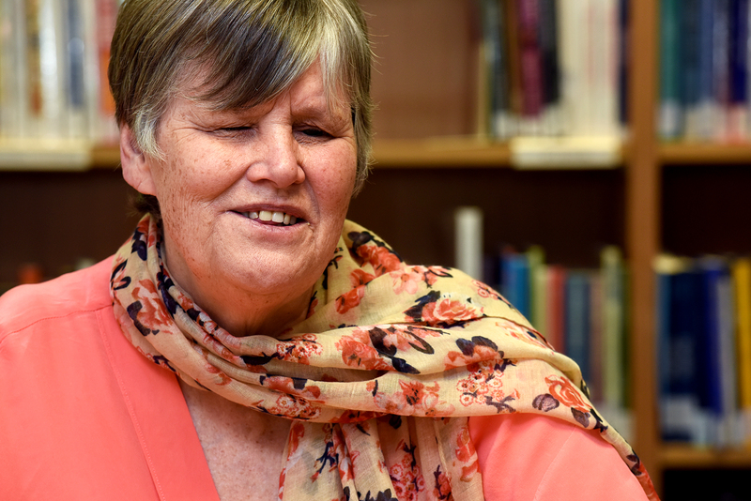

Reinette Popplestone, born du Plessis, was educated at the Pioneer School, Worcester, after which she studied physiotherapy in London, England at the Royal National Institute for the Blind School of Physiotherapy. On returning home after the course, she settled in Cape Town where she practised physiotherapy in one of the larger state hospitals and also met and married Tony. They had two children, a daughter nowadays a successful professional person, and a son who died when he was a mere toddler. Fourteen years ago she and Tony took a severely disabled baby boy into foster care and raised him as their own.

She was the first South African Braille Consultant, engaged by the partnership of the SANCB, the SALB, the SABWO and the Institute for the Blind, Worcester. This was the fore-runner of SABA, the SA Braille Authority.

Subsequently she joined the University of Cape Town, where she headed the Disability Unit and retired from there a year or two ago.

As a volunteer, Reinette proof read braille for the SA Library for the Blind for many years. She was interested in everything related to braille and also served (until the time of her passing) as the Deputy Chairperson of SABA and a very knowledgeable vocal and active member of several of its committees. Internationally, she participated in the activities of the International Council on English Braille.

Reinette was the author of “Hands On”, the only braille teaching manual for any of our 11 official languages in South Africa.

She was a hard-working, gifted person who had flair and a deep love of serving others. She will be sorely missed by literally thousands, not only for what she did, but for who she was.

*– Christo de Klerk, ICEB President*

# Recent events

## National Braille Music Camp, Australia

In mid-winter, the southern highlands of New South Wales comes alive as the National Braille Music Camp begins at Frensham Girls’ School. Around 30 braille reading students from around Australia from ages 9 to 18 come together to enjoy six days of singing, playing and learning braille music. This is a unique opportunity for blind children, not only because it is the largest gathering of braille music users in the country, but because they are all in integrated school settings during the year and can join with friends who are blind for one week of the year and in a place where braille is the norm and blind is the majority. We have also hosted students from New Zealand, Fiji, Malaysia, and this year one boy from Thailand attended. At music camp, both blind and sighted teachers work in partnership to deliver a wide variety of music programs, however the camp is run by the blind and for the blind. After breakfast, each day begins with a choir rehearsal. Students are taught by a conductor who is a braille reading musician, and everyone works from a braille score. They learn braille music in individually tailored music classes, form ensembles such as a jazz band, junior and senior choir or orchestra, and in the evenings we are treated to a concert where students can perform what they have learnt during the year or on camp. The final night of camp is the showcase concert which the students have worked towards all week. The camp choir performs as well as all the ensembles, and solo and small group items.

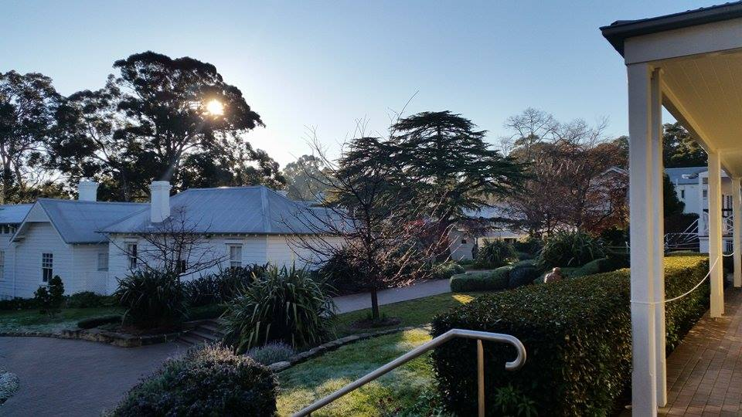

Image of Frensham Girls’ School with rope guides for campers

Because of this unique camp, lifelong friendships form across the country. In the past, braille letters and tapes travelled Australia’s postal system, however now Facebook and WhatsApp provide real-time communication channels. Students who live in remote areas are able to learn from teachers via Facetime during the year if there is no braille music specialist in their area.

At the age of 12, I attended my first braille music camp. Although I loved music and thought I’d probably end up working in the field, it was hearing what other older blind music students were doing with their music at university and beyond that cemented my resolve to sing professionally. They used their braille music to sing in choirs, learn orchestral parts or even conduct their own ensembles, and it was that sense of collaboration with sighted musicians that I wanted to be part of.

This year, the 34th National Braille Music Camp was held. It was my first absence since my first camp, a very strange feeling. It was exciting though to see the next generation of blind teachers stepping up to direct the choirs and ensembles, organise concerts and mentor the younger campers who experienced the magic of music camp for the first time.

*– Jordie Howell, ICEB Braille Music Committee Chair*

## South African Braille Authority activities

The South African National Council for the Blind (SANCB), together with the South African Braille Authority (SABA) will be hosting the Braille Cup Competition on 7 September 2019. The event will take place at the SANCB premises, followed by a gala dinner where certificates and prizes for the winners will be handed over. Thirty-nine learners from nine schools are expected to participate in a packed programme with five categories and three divisions.

Due to the loss of the Deputy President of SABA, Mrs Reinette Popplestone, the Executive of SABA met on 27 August and elected Mr. Christo de Klerk to the position of Deputy President. The committee then co-opted Ms Shani Little to the position of additional member of the Executive committee. Shani will be responsible for the publicity of the Authority as well. On behalf of the Authority, I welcome Christo as deputy president and a special welcome to Shani Little to the role she will take up as a new kid on the block.

*– Ntshavheni Netshituni, South African Braille Authority President*

# Calendar of Upcoming Events

## Connecting the Dots – Canada, October 2019

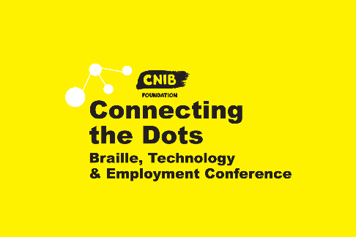For over 40 years, the CNIB Foundation has hosted a variety of successful technology trade shows, conferences and seminars across the country for people who are blind or partially sighted.

The Braille Conference in Toronto gathered clients, braille transcribers, educators and staff to discuss the latest advance in Literacy. In Quebec, TechnoVision+ was the largest trade show in the country dedicated to adapted technology and services for people living with sight loss. Attendees and exhibitors included clients, educators, healthcare professionals, technology vendors, and community organizations.

This year, these regional events have been combined to create a bigger, better, and more inclusive conference that combines initiatives from our strategic plan to boost participation in the world of work, unleash the power of technology and drive achievement and equality.

CNIB’s new nationwide conference, **Connecting the Dots,** is Canada’s largest educational and professional development experience focused on technology, employment and literacy for people with sight loss.

With over 40 workshops, this two-day conference will provide opportunities for attendees to:

* Learn more about current trends and innovations in the sight loss community at thought-provoking panel discussions;
* Network with industry experts and connect with other like-minded professionals;
* Experience the latest technological advancements in braille and assistive technologies;
* Gain essential practical experience from industry experts to aid in career advancement.

The 2019 Conference will take place on October 29 and 30 in Toronto. Further dates for Vancouver and Montreal are yet to be announced. See [cnib.ca/connectingthedots](https://cnib.ca/connectingthedots) for further details.

## Africa Forum – Addis Ababa, Ethiopia, October 2019

Africa Forum is Africa’s premiere conference for blindness activists, leaders and community. The conference is open to any individual or organisation with an interest in blindness in Africa. It offers opportunities to learn, network and contribute to the future of disability advocacy in Africa.

The 7th Africa Forum will focus on achieving equality in education through innovation, access and lifelong learning. It is scheduled for 7-11 October 2019 in Addis Ababa, Ethiopia.

There has already been such a high number of registrations that a larger new venue has been booked. Information and a link to registration are available at [www.perkins.org/get-involved/events/africa-forum](https://www.perkins.org/get-involved/events/africa-forum).

## NBA Professional Development Conference – USA, October 2019

The National Braille Association holds an annual Professional Development Conference with workshops to learn more about braille code revisions, new techniques, software, hardware and production equipment. The next Conference will be held in Phoenix, Arizona from October 30 to November 1. Registration is now open at [www.nationalbraille.org/professional-development-conference/](https://www.nationalbraille.org/professional-development-conference/).

## Getting in Touch with Literacy – USA, November 2019

Getting in Touch with Literacy is a national conference on all forms of literacy, including print, braille, auditory, tactile graphics comprehension and the use of assistive technology. The proceedings include presentations, workshops and poster sessions.

The 2019 Conference will be held from 13-17 November in Seattle, Washington. Registration is now open at [gettingintouchwithliteracy.org/](http://gettingintouchwithliteracy.org/).

## SPEVI Conference – Adelaide, Australia, January 2020

The South Pacific Educators in Vision Impairment (SPEVI) hold a Biennial Conference offering Australian, New Zealand, Pacific Island and international leaders, professionals and parents/carers the opportunity to share information and ideas about current and emerging services, programs, technologies and resources for children and adults who are blind, have low vision, deaf-blindness, or additional disabilities.

The next SPEVI Conference will be held in Adelaide, South Australia, from 12-15 January 2020. Registrations are now open at [synergyevents.eventsair.com/spevi-2020/](https://synergyevents.eventsair.com/spevi-2020/).

## ATiA 2019 – Orlando, Florida USA, January-February 2020

The Assistive Technology Industry Association holds an annual conference at the Caribe Royale Hotel and Convention Center in Orlando, Florida. The 2020 Conference will begin with pre-conference seminars from 28-29 January, to be followed by the Conference itself from 29 January to 1 February. Online registrations are now open, with earlybird rates available until 29 September. More information is available from [www.atia.org/](https://www.atia.org/).

## West Asia Conference on Visual Impairment and Deafblindness – Lalitpur, Nepal, February 2020

Jointly organised by ICEVI West Asia and Sense International India, the West Asia Conference on Visual Impairment and Deafblindness has the theme “Inclusive Education: Leaving No One Behind”.

The conference will be held at the Nepal Administrative Staff College, Lalitpur from 16 to 18 February 2020. Please note that only 300 registration places are available.

More information is available at [iceviwestasia.in/icevi-sense-india-national-conference/](http://iceviwestasia.in/icevi-sense-india-national-conference/).

## CSUN Assistive Technology Conference – Anaheim, USA, March 2020

CSUN is the largest conference of its kind, attracting more than 5,000 visitors annually. It provides an inclusive setting for researchers, practitioners, exhibitors and end users to sare knowledge and best practice in the field of assistive technology.

The 35th Conference will be held in Anaheim from 9-13 March 2020. The General Call for Presenations and the Call for Pre-Conference Workshops are open until Tuesday 1 October. See [csun.edu/cod/conference/sessions/](http://csun.edu/cod/conference/sessions/) for more information

## Round Table Conference – Melbourne, May 2020

The Round Table on Information Access for People with Print Disabilities is an umbrella organisation for members from the print disability sector in Australia and New Zealand including blindness service providers, equipment suppliers, educators, libraries and public institutions. Their next annual conference will be held at Bayview Eden Melbourne from Saturday 2 May to Tuesday 5 May. Proceedings will include the annual meeting of the Australian Braille Authority, workshops and presentations. The call for abstracts is now open; closing Friday 29 November 2019. More information is available at [printdisability.org/conference/](http://printdisability.org/conference/).

## ICEB General Assembly – London, England, May 2020

ICEB holds a General Assembly once every four years. The next General Assembly will be held in London from 11 to 15 May 2020. Each member country of ICEB will be represented by up to four delegates, of whom at least 50% must be touch readers. Observers are also welcome.

More details on the General Assembly, along with a call for papers, will be made available in the first week of October. Please check the ICEB website, social media or announce list, as given at the end of this newsletter.

## WBU-ICEVI Joint Assembly – Madrid, Spain, June 2020

The World Blind Union (WBU) and International Council for Education of People with Vision Impairment (ICEVI) will hold their third joint General Assembly at the Hotel Marriott in Madrid, Spain, from 19 to 24 June 2020. The proceedings will include two days of paper presentations from 23 to 24 June, with abstract submissions due by 30 September 2019. For more information and registration, see [icevi.org/wbu-icevi-general-assemblies-2020/](http://icevi.org/wbu-icevi-general-assemblies-2020/).

# UEB Q&A

In answer to our earlier question, the vertical bidirectional arrow is brailled as: ;\wr+

Explanation: \ is the arrow indicator (which must be in grade 1 mode, 13.1). To decide which arrow terminator to use, we determine that the head of the arrow is deemed to be at the top for a strictly vertical arrow (13.3, point 3 at the bottom of page 62). + is the closing indicator for an up pointing arrow. This decision also tells us which order to use for the two tips (the tail first and the head second (13.3, point 2 at the top of page 63). w and r show that there are two tips, the second (the head) in the line of direction (up) and the first (the tail) counter to the line of direction (13.3). Citations are from **Guidelines for Technical Material**, available for free download from [iceb.org/ueb.html](http://iceb.org/ueb.html).

# ICEB Contact Details

Website: [www.iceb.org](http://www.iceb.org)

Email: [info@iceb.org](mailto:info@iceb.org)

Twitter: @ICEBbraille

Facebook: [www.facebook.com/ICEBbraille/](http://www.facebook.com/ICEBbraille/)

ICEB-announce list:   
Send an email to  [iceb-announce+subscribe@groups.io](mailto:iceb-announce+subscribe@groups.io) to receive announcements from ICEB, including this newsletter and notifications regarding updates to Unified English Braille.